Received 00th January 20xx,
- Biomaterials, Biomechanics and Tissue Engineering Group, Dept. of Materials Science and Metallurgy, Universitat Politècnica de Catalunya, Barcelona, Spain. E-mail: jose.maria.manero@upc.edu, carles.mas.moruno@upc.edu
- Barcelona Research Center in Multiscale Science and Engineering, Universitat Politècnica de Catalunya, Barcelona, Spain
- Institute for Advanced Study - Center for Integrated Protein Science, Department Chemie, Technische Universität München, Garching, Germany
- Universitat Internacional de Catalunya, Sant Cugat del Vallès, Spain
- Institute of Tissue Regeneration Engineering and Department of Nanobiomedical Science & BK21 PLUS NBM Global Research Center for Regenerative Medicine, Dankook University, Cheonan, Republic of Korea
- Institute for Bioengineering of Catalonia, Barcelona, 08028, Spain
Electronic Supplementary Information (ESI) available: Experimental methods and additional physicochemical, in vitro and in vivo data. See DOI: 10.1039/x0xx00000x
Accepted 00th January 20xx
DOI: 10.1039/x0xx00000x
www.rsc.org/
Control of Stem Cell Response and Bone Growth on Biomaterials by Fully Non-Peptidic Integrin Selective Ligands
R. Fraioli,^{a,b} S. Neubauer,^{c} F. Rechenmacher,^{c} B. M. Bosch,^{d} K. Dashnyam,^{e} J.-H. Kim,^{e} R. A. Perez,^{d,e} H.-W. Kim,^{e} F. J. Gil,^{a,d} M. P. Ginebra,^{a,b,f} J. M. Manero,^{a,b}* H. Kessler^{c} and C. Mas-Moruno^{a,b}*

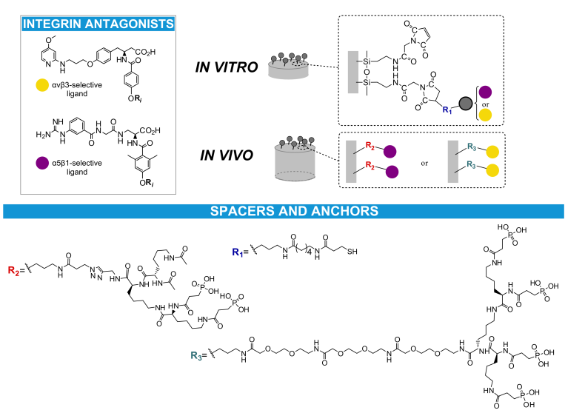
In this communication we report that anchoring αvβ3 or α5β1 integrin-selective RGD peptidomimetics to titanium efficiently tunes mesenchymal stem cell response in vitro and bone growth in rat calvarial defects. Our results demonstrate that this molecular chemistry-derived approach could be successful to engineer instructive coatings for orthopedic applications.
Interactions between biomaterials and tissues at the surface level are critical to ensure the functionality of medical implants. For instance, an incomplete osteointegration is regarded as a major contributor to implant failure.^{[1]} To deal with this issue, cell-instructive coatings have been proposed as a solution to promote osteointegration by stimulating direct bone growth on the implant.^{[1]} A common strategy has focused on integrin binding biomolecules from the extracellular matrix (ECM) of bone.^{[2]} However, the clinical translation of peptides and proteins has been limited, often due to modest profiles of biological activity and poor stability in physiological conditions.^{[3]} In this regard, the use of totally non-peptidic integrin antagonists as surface-coating molecules holds high potential, as these ligands can be designed to be highly active and subtype selective and display good pharmacokinetic profiles (e.g. higher stability to enzymatic degradation).^{[4]} In particular, we have recently described two RGD-based peptidomimetics with high affinity and selectivity for either integrins αvβ3 or α5β1 (Figure 1), being >100 times more active than linear RGD and capable of mediating very effectively integrin-specific cell adhesion.^{[4,5]} Integrins αvβ3 and α5β1 have been identified as prominent receptors in the adhesion and osteogenic differentiation of osteoblasts and mesenchymal stem cells (MSCs).^{[4,6]} Accordingly, we have shown in recent reports that the incorporation of these peptidomimetics on biomaterials modulates osteoblast behavior^{[7]} and proves useful to rescue MSC adhesion on low adhesive high aspect ratio antibacterial topographies.^{[8]} However, the effect of these two molecules on MSC function has not been fully characterized and their potential in vivo is unknown. Thus, in this report we studied for the first time the effect of grafting the RGD-based fully non-peptidic mimetics on titanium (Ti) both at the in vitro and in vivo level, as a first approach to ascertain the potential of these organic molecules to enhance the osteointegration of bone-replacing implants.
Figure 1. Chemical structure of the integrin (αvβ3 or α5β1)-selective antagonists, spacers and anchor groups, and schematic representation of the functionalization strategy. Peptidomimetics were anchored via thiol group for the in vitro assays (R₁ spacer and anchor), and directly tethered via phosphonic acid for the in vivo study (either R₂ or R₃ spacers and anchors).

Peptidomimetic design and surface functionalization
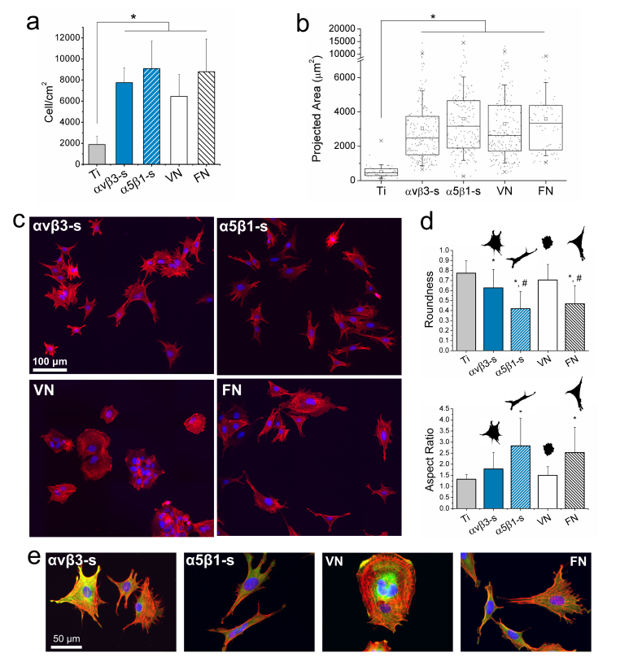
The peptidomimetics were synthesized and characterized as described in previous reports,^{[5a,b]} and their complete chemical structures are provided in the Supporting Information (Figure S1). As schematized in Figure 1, the molecules were designed according to two functionalization strategies: i) for in vitro studies, a mercaptopropionic acid was incorporated as terminal group on the ligands, which allows their grafting to the metallic surface through a Michael addition (Figure S2a); ii) for in vivo tests, a direct binding of the mimetics to the biomaterial was preferred, and therefore the use of phosphonic acids was exploited (Figure S2b). This method (i.e. chemisorption) reduces the number of steps and manipulation of implant materials and would be more appropriate than silanization in a clinical setting.
Thus, to conduct in vitro cellular studies Ti surfaces were functionalized with the peptidomimetics via silanization. This protocol, well-established in the literature,^{[2c,7,9]} was successful in grafting the integrin-binding ligands and rendered a comparable surface coverage for both molecules, as characterized by contact angle measurements, fluorescent labeling, X-ray photoelectron spectroscopy (XPS) and quartz crystal microbalance with dissipation monitoring (QCM-D) (Table S1).^{[7]}
In vitro cell response
By functionalizing Ti with either the αvβ3- or α5β1-selective peptidomimetics (αvβ3-s or α5β1-s surfaces, respectively), adhesion of MSCs on the substrates was significantly (p<0.01) increased after 6 h of incubation (Figure 2a), to the same extent as full length proteins vitronectin (VN) and fibronectin (FN). No statistical difference was observed between the number of cells adhering to the integrin-selective compounds and the proteins. Following the same behavior, MSCs spread significantly more (p<0.01) on all integrin-binding substrates, compared to the uncoated metal (Figure 2b). Nevertheless, cell shape was found to be ligand-dependent (Figures 2c, 2d, 2e). When no functionalization was done, cells remained small and rounded. On VN cells were highly rounded and almost no cytoskeletal elongation was observed; the distribution of actin fibers was either parallel to the cell boundary or centrifugal, i.e. from the nucleus to cell edges. On the contrary, many cytoskeletal elongations were observed on FN, where cells also reached a less rounded morphology; actin fibers in this case distributed mostly parallel to cell edges. On both mimetic-coated surfaces, MSCs developed elongations. However, these were more numerous on αvβ3-s, with no preferential direction, giving a star-like shape. On the α5β1-s cells attained a much more elongated shape, with few elongations per cell distributed in one preferential direction. Overall, these observations translated in statistically lower values of roundness and higher values of aspect ratio on FN and α5β1-s, compared to all other conditions (p<0.05) (Figure 2d).
Figure 2. (a) Cell attachment is significantly increased on coated Ti, irrespectively of the specific ligand presented. * means p<0.01. (b) Cell projected area is increased by all ligands. Dots represent individual cells, the boxes represent the 25th and 75th percentile, the middle line is the median, the whiskers are one standard deviation, □ is the average, × correspond to the 99% and 1% of the values. * means p<0.01. (c) Immunostaining of actin fibers and nuclei. Cell shape, number and direction of cytoskeletal elongations depends on the ligand anchored to Ti. (d) Values of mean roundness and aspect ratio of cells seeded on the functionalized substrates. * means p<0.05 vs. Ti, # means p<0.05 vs. αvβ3-s. (e) Immunostaining of actin fibers, vinculin and nuclei. All assays were done after 6 hours of incubation in serum-free medium.

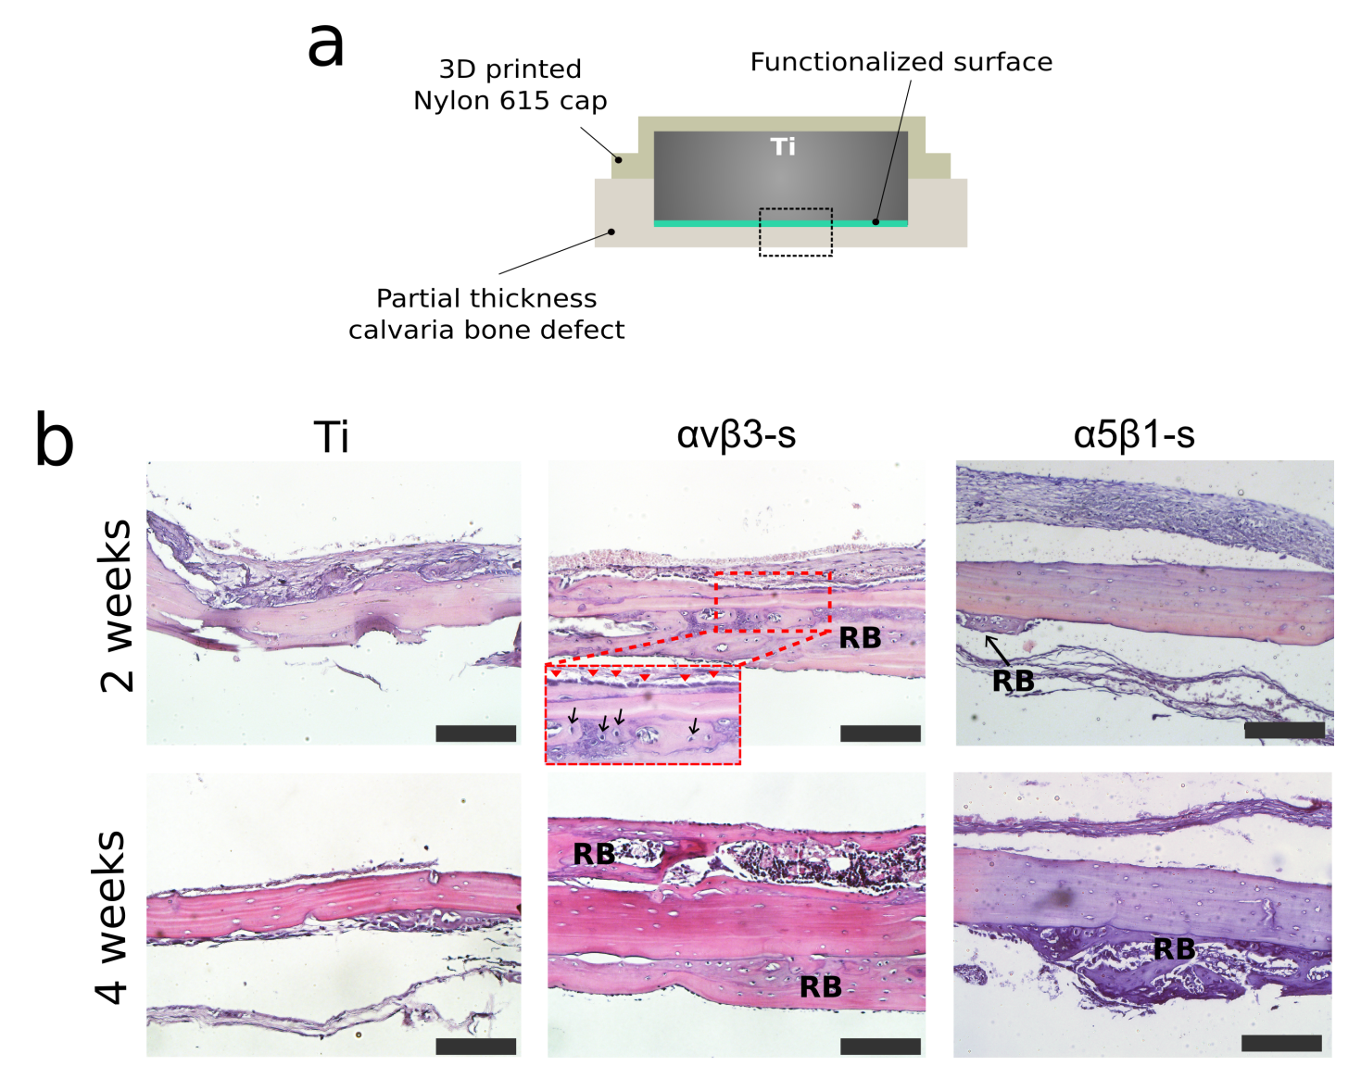
Response at long term was also ligand-dependent: cell growth was higher on all functionalized surfaces over an 8-day period, compared to uncoated Ti (p<0.01), with FN-coated Ti being the surface promoting the highest proliferation among all conditions (p<0.01) (Figure S3a). Of note, α5β1-s supported the same proliferation as VN at all time points and statistically higher values than αvβ3-s at 3 and 6 days of incubation (p<0.01). The trend of cell growth observed (Ti<αbβ3-s<α5β1-s≈VN<FN) indicates a positive role for α5β1 in proliferation. We could observe a similar behavior with human osteoblast-like cells in a previous work.^{[7]} Nevertheless, hMSCs proliferate significantly more on FN than on the α5β1-selective surface. This behavior could stem from the promiscuity of the full length glycoprotein, which, apart from having high affinity for integrin α5β1, has multiple domains that interact with other cell receptors and growth factors.^{[10]} The commitment of cells to the osteoblastic lineage was investigated by RT-PCR, evaluating gene expression of two markers of osteogenic differentiation (Figure S3b). After 7 days of incubation in basal medium, the expression of both RUNX2 and osteocalcin (OCN) was statistically (p<0.05) increased on αvβ3-s, compared to uncoated Ti. Moreover, expression of RUNX2 on this surface was the highest among all other functionalized substrates (p<0.05). Enhanced levels of osteogenic genes upon αvβ3 stimulation were also reported in previous studies^{[6a,8]} and may be related to increased cell contractility on αvβ3-s, i.e. star-like shape, which has been associated with osteogenesis.^{[11]} The osteogenic potential of the αvβ3-binding peptidomimetic was corroborated by Western blot analysis (Figure S4), which showed statistically increased expression of RUNX2 and OCN at early and late timepoints, respectively (p<0.05). In these tests, the α5β1-ligand also promoted the osteodifferentiation of MSCs, in agreement with previous reports.^{[2a,2e,4,6b]} Interestingly, comparable values of OCN expression were achieved at day 18 on peptidomimetic-coated samples, compared to the ECM proteins controls.
Figure 3. (a) Implantation scheme: the dashed area represents the area shown in the histological images in (b). (b) Representative H&E staining histological images. Scale bar = 150 μm. The bottom part of the images is the dural side of the calvaria. Increased new bone growth (regenerated bone, RB) is observed in presence of the αvβ3-s coated Ti implant (the inset shows aligned osteoblasts), while less new bone is observed adjacent to the α5β1-s.
In vivo testing
To verify the potential of this strategy in the in vivo scenario, we tested the capacity of the mimetics to improve bone growth in a partial thickness calvarial defect in rats. For this study direct binding of phosphonic acid groups to Ti implants was used. This is a simple one-step process; however, it should be noted that coupling of these types of anchors to the bioactive sequence is synthetically more demanding than incorporating one thiol group.^{[5b,12]} According to XPS data, phosphorous (P 2p), only present in traces on the uncoated Ti surface, was detected after binding the two mimetics, and its atomic percentage increased proportionally to concentration, until reaching a plateau at 100 μM, which was chosen as the coating concentration (Figure S5). This signal corresponds to the Ti-O-P bond.^{[5b]} Moreover, the coating was proved to be stable to ultrasonication treatments (Figure S5). The density of molecule attachment was found to be comparable for both mimetics (Table S2).
Thus, mimetic-functionalized cylindrical implants were inserted in cranial defects and the extent of bone formation investigated after 2 and 4 weeks of implantation (Figure 3). Confirming in vitro observations, the substrates functionalized with the peptidomimetics promoted increased new bone growth at the defect site compared to control Ti implants. This effect was clearly observed for the substrates with high affinity for integrin αvβ3 (Figure 3b) with presence of moderate to substantial new bone in 5/6 animals 4 weeks post-implantation (histological observations are summarized in Table S3 and representative examples provided in Figure S6). For these samples, newly formed bone showing woven features and osteoblasts aligning on the surface of bone were visible (a higher size image clearly showing these features is presented in Figure S7). These findings may be attributed to the high binding activity of the mimetic towards αvβ3 (IC₅₀ of 0.65 nM),^{[5c]} supporting the osteogenic role of this integrin.^{[4,6a,8]} Previous in vivo studies evaluating Ti implants coated with cyclic c(RGDfK) (IC₅₀ of 2.25 nM for αvβ3)^{[5b,13]} also reported significant increase in bone formation, and observed reduced fibrous tissue surrounding the implant and, therefore, increased implant fixation due to the peptidic coating.^{[14]} However, the use of less affine RGD linear peptides generally showed little to none capacity to form bone in vivo.^{[3]} Bone formation was also increased in α5β1-s samples compared to uncoated Ti, though to a lower extent than αvβ3-s (Table S3). These results could stem from the distinctive biological roles described for these two receptors.^{[15]} Stimulation of α5β1 has been shown to promote bone formation in previous studies using FN mimics (e.g. the FN-III₇₋₁₀ fragment);^{[2a,2e]} however, the same remarkable effect was not observed in our in vivo model. Differences among the ligands in terms of binding affinity and specificity, as well as coating density, may explain the distinct behaviors. Furthermore, different binding modes towards other relevant integrins such as αvβ5, αvβ6 or αvβ8,^{[5c]} which are often neglected in the literature, could also account for the observed differences.
Conclusions
In conclusion, our work shows that custom-made synthetic peptidomimetics represent coating molecules with potential to improve the bioactivity of implantable devices. Immobilization to Ti via either thiol or phosphonic acid was proved efficient, confirming the versatility of the approach: by selecting the proper anchor unit, biomolecules suitable for different coating procedures or materials can be easily envisaged. Noteworthy, small and selective ligands could often attain the same cell response as complex full-length ECM proteins, statistically improving the adhesion, proliferation and differentiation of MSCs compared to Ti control. In particular, the αvβ3-selective surface fostered MSCs osteogenesis in vitro and new bone formation in vivo, e.g. accelerated bone repair adjacent to the αvβ3-s implants was evident at early time points (2 weeks); which is of relevance because early bone fixation is critical to guarantee orthopedic and dental implant success.^{[16]} Further studies in animal models are currently in progress and will shed more light on the osteointegrative potential of these ligands.
Acknowledgements
This work has been funded by the Spanish Government (Ramon y Cajal grant of C.M.-M., and projects MAT2015-67183-R and MAT2017-83905-R (MINECO/FEDER)), the Government of Catalonia (2017 SGR-116533 and predoctoral (R.F.) and ICREA academia (M.-P.G.) fellowships) and the EU's Seventh Framework Programme (FP7-PEOPLE-2012-CIG, 321985). Financial support from the government of Korea is also acknowledged (grants no. 2009-0093829 & 2015032163). Dr. M. Dominguez is acknowledged for conducting XPS measurements.
Notes and references
- a) S. B. Goodman, Z. Yao, M. Keeney and F. Yang, Biomaterials 2013, 34, 3174; b) J. Raphel, M. Holodniy, S. B. Goodman, and S. C. Heilshorn, Biomaterials 2016, 84, 301; c) C. Mas-Moruno, B. Su and M. J. Dalby, Adv. Healthcare Mater. 2018, 1801103.
- a) R. Agarwal, C. González-García, B. Torstrick, R. E. Guldberg, M. Salmerón-Sánchez and A. J. García, Biomaterials 2015, 63, 137; b) C. Mas-Moruno, R. Fraioli, F. Albericio, J. M. Manero and F. J. Gil, ACS Appl. Mater. Interfaces 2014, 6, 6525; c) R. Fraioli, K. Dashnyam, J. H. Kim, R. A. Perez, H. W. Kim, J. Gil, M. P. Ginebra, J. M. Manero and C. Mas-Moruno, Acta Biomater. 2016, 43, 269; d) M. Pagel, R. Hassert, T. John, K. Braun, M. Wießler, B. Abel and A. G. Beck-Sickinger, Angew. Chemie Int. Ed. 2016, 55, 4826; e) T. A. Petrie, J. E. Raynor, C. D. Reyes, K. L. Burns, D. M. Collard and A. J. García, Biomaterials, 2008, 29, 2849.
- a) C. Mas-Moruno, in Peptides and Proteins as Biomaterials for Tissue Regeneration and Repair (Eds: M. A. Barbosa and M. C. L. Martins), Woodhead Publishing, Elsevier, UK, 2018, pp. 73-100; b) D. F. Williams, Biomaterials 2011, 32, 4195.
- C. Mas-Moruno, R. Fraioli, F. Rechenmacher, S. Neubauer, T. G. Kapp and H. Kessler, Angew. Chemie Int. Ed. 2016, 55, 7048.
- a) F. Rechenmacher, S. Neubauer, J. Polleux, C. Mas-Moruno, M. De Simone, E. A. Cavalcanti-Adam, J. P. Spatz, R. Fässler and H. Kessler, Angew. Chem. Int. Ed. 2013, 52, 1572; b) F. Rechenmacher, S. Neubauer, C. Mas-Moruno, P. M. Dorfner, J. Polleux, J. Guasch, B. Conings, H.-G. Boyen, A. Bochen, T. R. Sobahi, R. Burgkart, J. P. Spatz, R. Fässler and H. Kessler, Chem. - A Eur. J. 2013, 19, 9218; c) T. G. Kapp, F. Rechenmacher, S. Neubauer, O. V. Maltsev, E. A. Cavalcanti-Adam, R. Zarka, U. Reuning, J. Notni, H. J. Wester, C. Mas-Moruno, J. Spatz, B. Geiger and H. Kessler, Sci Rep. 2017, 7, 39805.
- a) K. A. Kilian and M. Mrksich, Angew. Chemie Int. Ed. 2012, 124, 4975; b) Z. Hamidouche, O. Fromigué, J. Ringe, T. Häupl, P. Vaudin, J.-C. Pagès, S. Srouji, E. Livne and P. J. Marie, Proc. Natl. Acad. Sci. U. S. A. 2009, 106, 18587.
- R. Fraioli, F. Rechenmacher, S. Neubauer, J. M. Manero, J. Gil, H. Kessler, C. Mas-Moruno, Colloids Surf. B Biointerfaces 2015,
- R. Fraioli, P. M. Tsimbouri, L. E. Fisher, A. H. Nobbs, B. Su, S. Neubauer, F. Rechenmacher, H. Kessler, M.-P. Ginebra, M. J. Dalby, J. M. Manero and C. Mas-Moruno, Sci. Reports 2017, 7, 16363.
- a) S. J. Xiao, M. Textor, N. D. Spencer, M. Wieland, B. Keller and H. Sigrist, J. Mater. Sci. Mater. Med. 1997, 8, 867; b) S. J. Xiao, M. Textor and N. D. Spencer, Langmuir 1998, 14, 5507; c) M. Hoyos-Nogués, F. Velasco, M. P. Ginebra, J. M. Manero, F. J. Gil and C. Mas-Moruno, ACS Appl. Mater. Interfaces 2017, 9, 21618.
- a) C. Herranz-Diez, C. Mas-Moruno, S. Neubauer, H. Kessler, F. J. Gil, M. Pegueroles, J. M. Manero and J. Guillem-Marti, ACS Appl. Mater. Interfaces 2016, 8, 2517; b) M. M. Martino, F. Tortelli, M. Mochizuki, S. Traub, D. Ben-David, G. a Kuhn, R. Müller, E. Livne, S. A. Eming and J. A. Hubbell, Sci. Transl. Med. 2011, 3, 100ra89.
- a) R. McBeath, D. M. Pirone, C. M. Nelson, K. Bhadriraju and C. S. Chen, Dev. Cell 2004, 6, 483; b) K. A. Kilian, B. Bugarija, B. T. Lahn and M. Mrksich, Proc. Natl. Acad. Sci. U. S. A. 2010, 107, 4872; c) J. Lee, A. A. Abdeen, D. Zhang and K. A. Kilian, Biomaterials 2013, 34, 8140.
- C. Mas-Moruno, P. M. Dorfner, F. Manzenrieder, S. Neubauer, U. Reuning, R. Burgkart and H. Kessler, J. Biomed. Mater. Res. A 2013, 101, 87.
- C. Mas-Moruno, F. Rechenmacher and H. Kessler, Anticancer Agents Med. Chem. 2010, 10, 753.
- a) B. Elmengaard, J. E. Bechtold and K. Søballe, Biomaterials 2005, 26, 3521; b) H. C. Kroese-Deutman, J. van den Dolder, P. H. M. Spauwen and J. A. Jansen, Tissue Eng. 2005, 11, 1867; c) B. Elmengaard, J. E. Bechtold and K. Søballe, J. Biomed. Mater. Res. A 2005, 75, 249.
- a) S. Rahmouni, A. Lindner, F. Rechenmacher, S. Neubauer, T. R. A. Sobahi, H. Kessler, E. A. Cavalcanti-Adam and J. P. Spatz, Adv. Mater. 2013, 25, 5869–74; b) J. Guasch, B. Conings, S. Neubauer, F. Rechenmacher, K. Ende, C. G. Rolli, C. Kappel, V. Schaufler, A. Micoulet, H. Kessler, H.-G. Boyen, E. A. Cavalcanti-Adam and J. P. Spatz, Adv. Mater. 2015, 27, 3737; c) P. Roca-Cusachs, N. C. Gauthier, A. Del Rio and M. P. Sheetz, Proc. Natl. Acad. Sci. U. S. A. 2009, 106, 16245; d) D. Missirlis, T. Haraszti, C. v. C. Scheele, T. Wiegand, C. Diaz, S. Neubauer, F. Rechenmacher, H. Kessler and J. P. Spatz, Sci. Rep. 2016, 6, 23258.
- a) Y. Germanier, S. Tosatti, N. Broggini, M. Textor and D. Buser, Clin. Oral Implants Res. 2006, 17, 251; b) H. Daugaard, B. Elmengaard, J. E. Bechtold, T. Jensen and K. Soballe, J. Biomed. Mater. Res. A 2010, 92, 913.

