Fatigue crack growth of a metastable austenitic stainless steel

D. F. Marteloª, A.M. Mateo^{b}, M.D. Chapettiª
ª INTEMA, Research Institute for Material Science University of Mar del Plata-CONICET J.B. Justo 4302 (B7608FDQ) Mar del Plata Argentina

^{b} CIEFMA – Dept. Ciencia de los Materiales e Ingeniería Metalúrgica, Universitat Politècnica de Catalunya, 08028 Barcelona, Spain

Corresponding author: D.F. Martelo
E-mail address: martelo@fi.mdp.edu.ar
Abstract
The fatigue crack growth behavior of an austenitic metastable stainless steel AISI 301LN in the Paris region is investigated in this work. The fatigue crack growth rate curves are evaluated in terms of different parameters such as the range of stress intensity factor ΔK, the effective stress intensity factor ΔK_{eff}, and the two driving force parameter proposed by D. Kujawski K*.
The finite element method is used to calculate the stress intensity factor of the specimens used in this investigation. The new stress intensity factor solution has been proved to be an alternative to explain contradictory results found in the literature.
Fatigue crack propagation tests have been carried out on thin sheets with two different microstructural conditions and different load ratios. The influence of microstructural and mechanical variables has been analyzed using different mechanisms proposed in the literature. The influence of the compressive residual stress induced by the martensitic transformation is determined by using a model based on the proposal of R.M. McMeeking et al. The analyses demonstrate the necessity of including K_{max} as a true driving force for the fatigue crack growth. A combined parameter is proposed to explain the effects of different variables on the fatigue crack growth rate curves. According to the experimental evidence, the effect of crack closure is insignificant in the Paris region.

Keywords: Fatigue crack propagation; Metastable austenitic Stainless steel; Crack closure; ΔK and K_{max}; Martensitic Transformation.

1. Introduction
The new environmental standard for the automotive industry requires the fabrication of more efficient vehicles with less fuel consumption. This technological challenge demands the development of new lightweight materials. The metastable austenitic stainless steels (MASS) are materials with good formability and high strength compared to other carbon steels or aluminum alloys used in the automotive industry [1]. This high strength of MASS can be used to reduce the components thickness without decreasing vehicle safety.
The fatigue crack growth rate (FCGR) of MASS has been related to the martensitic transformation that occurs in the crack tip of this kind of steels [2-5]. The first study of fatigue crack propagation in steel with martensitic transformation in the crack tip was published by Chanani et al. [6]. The results of this work shows a decrease in the fatigue crack growth rate for the same range of stress intensity factor ∆K, when the austenitic structure was more unstable. This same result was obtained later by Pineau et al. [2] in an austenitic metastable stainless steel AISI 301. The authors of both studies try to relate the decrease in the crack growth rate with the higher work hardening coefficient of the more unstable alloy. To prove their hypothesis, the authors used a fatigue crack propagation model proposed by Head [7], and a fatigue crack propagation model proposed by Chanani et al. [6]. However, the crack propagation models used in both studies to establish a relationship between crack growth rate and ∆K exhibited an opposite tendency. Chanani`s model predicts an increase in the FCGR with the increase in the work hardening, whereas Head`s model predicts the opposite. Even, in the case when the crack propagation in Head´s model predicts a decrease in crack growth rate with the increase in work hardening coefficient, experimental results show differences with the prediction of the model.
Another mechanism used to explain the decrease in the FCGR associated to the martensitic transformation is the role of microstructure in the FCGR. To prove this hypothesis, Pineau et al. [2] and Mei et al. [3] in different studies have compared the FCGR in the same alloy but under different conditions:
- Martensitic transformation induced by stress or strain during fatigue test vs. Martensite formed by quenching [2].
- Martensitic transformation induced by stress or strain during fatigue test vs. Martensite formed by cold rolled [3].
In both cases, the FCGR for the same ∆K was higher for the specimens in which the structure was transformed to martensite previous to the fatigue test. These results suggest that the decrease in the FCGR is associated to the martensitic transformation during crack propagation rather than to the existence of a martensitic structure in the crack path.
Though the studies on the subject show the importance of martensitic transformation in the FCGR, the role of martensitic transformation in mechanical variables that influence the FCGR, like load ratio R is not clear. It has been suggested that martensitic transformation can induce crack closure, and this phenomenon could be used to explain the effects of load ratio and martensitic transformation on FCGR of AMSS. However, there is lack of appropriate and systematic research on the contribution of crack closure to the crack growth rate in MASS.
The analysis of previous studies on the fatigue crack growth (FCG) in thin sheet specimens of MASS show the influence of mean stress in the FCGR for the same R and the same ∆K, in tests realized to constant R [4,8]. This is opposite to the behavior observed in thick specimens of MASS or to the common behavior reported for many alloys. This uncommon behavior will be discussed in this paper.
The present work will focus on the fatigue crack grow rate behavior of MASS in thin sheet specimens. The influence of martensitic transformation and mechanical variables on FCGR will be analyzed in the Paris region of FCG. In addition to the mechanism introduced above, another mechanism to explain the influence of the martensitic transformation in the FCGR is discussed.

2. Specimen, material, and testing
The material employed in the current study was an austenitic stainless steel AISI 301LN provided by OCAS NV, Arcelor-Mittal R&D Industry Gent (Belgium). The material was provided in thin sheet specimens of 1 mm and 1.5 mm thickness, in two different conditions: annealed and cold rolled (40% degree of cold rolling). The chemical composition of the material used is shown in Table 1. The mechanical properties with the transformation temperatures are shown in Table 2.

Table 1. Chemical composition (wt. %)
 | Fe | Cr | Ni | Mo | C | Si | P | S | Mn | Cu | N
Annealed – 1 mm | Bal | 17.86 | 6.42 | 0.24 | 0.015 | 0.471 | 0.031 | 0.007 | 1.495 | 0.173 | 0.094- 0.145
Annealed - 1.5 mm | Bal | 17.98 | 6.78 | 0.23 | 0.012 | 0.548 | 0.031 | 0.004 | 1.562 | 0.057 | 0.094- 0.145
Cold-Rolled – 1.5 mm | Bal | 17.94 | 6.30 | 0.18 | 0.016 | 0.513 | 0.032 | 0.005 | 1.481 | 0.135 | 0.094- 0.145

Table 2. Mechanical properties with transformation temperatures.
 | σ_{ys} | σ_{UTS} | Elongation (Pct) | Ms (ºC) | M_{d30} (ºC) | M_{d} (ºC)
Annealed -1mm | 343 MPa | 973 MPa | 39,39 | -66.015 | 49.042 | 100*
Cold Rolled - 1.5mm | 1120 MPa | 1207 MPa | 19,4 | -66.015 | 49.042 | 100*
*For AISI 301 stainless steel.

To reveal the microstructure, the material was grounded in the surface with SiC emery paper up to a roughness of 1200 grit and then polished. Since the mechanical grinding can induce martensitic transformation, the material was electro-polished with a solution consisting of 5 vol% perchloric acid and 95% ethanol at 45V for 15 s. The austenite phase was revealed by electro-etching in a solution of 65% acid nitric at 1.2 V. Figure 1a shows an homogeneous structure composed by equiaxial austenitic grains with an average grain size of 11.8 µm. Figure 1b shows the austenitic grain oriented in the rolling direction. X-ray diffraction measurements showed that the cold rolled steel has a percentage of martensite that is approximately 38 ± 5%.
Figure 1. Microstructure of an austenitic metastable stainless steel AISI 301LN: (a) annealed; (b) cold rolled. (In both pictures the thickness of the sheets is perpendicular to the micrographs).

The same procedure used to reveal the microstructure, was repeated for all specimens tested in order to observe the martensitic transformation around the crack tip. The martensite phase was revealed by chemical etching in a solution of 100 ml ethanol, 20 ml HCl, 1.5 g K₂S2O₅ and 2 g NH₄F∙HF.
The FCG tests were carried out on single edge notch tension specimen (SENT), the width of the specimens was 35 mm and 40 mm, and the total length of most specimens was 25 cm.
The specimens were held in wedge grips and the tests were conducted using an Instron Machine model 8801 with closed loop to computers for automatic test control and data acquisition. The crack extension was measured with krak-gages®, which is principally an indirect DC potential measurement technique. The krag-gages® theory is explained in reference [9]. The crack length was also measured using the compliance technique by means of a clip gage in the crack mouth and a strain gauge fixed in the back surface.
To measure the crack opening load, a procedure based on the compliance offset method proposed in the ASTM standard E647-08^{ε1} [10] was used. Unlike the compliance offset method where, the open-crackcompliance corresponds to the compliance taken from fully-open crack configuration in the unloading curve; in the proposed procedure, the open-crackcompliance corresponds to the average of the compliance taken from fully-open crack configuration of the curve in loading and unloading. Moreover, the compliance of the segments of the curve that spans a range 10% of the cycle load is taken from the average of the curve on loading and unloading part. The compliance offset is measured as in expression (1). The details of the compliance offset method are shown in detail in the ASTM standard E47-08^{ε1} [10]. From now on, the new method will be referred as “modified ASTM method”. The signal noise was reduced by averaging 100 consecutive cycles and using low-pass digital filter [11-12]. The sampling rate used was of 400 data pairs (load and displacement) per cycle according the recommendations made by Song et al. [13].

 | $$Complianceoffset\left(\%\right)=\frac{\left[\left(open-crackcompliance\right)-\left(compliance\right)\right]}{\left(open-crackcompliance\right)}$$ | (1)

3. ΔK expressions

P. Paris [14] formulates the first successful relationship between fatigue crack advance and cycles number through fracture mechanic's parameters. The success of this relationship was that it allowed establishing a one to one relationship between FCGR and ΔK for a defined load ratio regardless the stress applied. However there exist some studies in which the Paris’ law was not satisfied [4,8]. In those studies, the FCG tests were conducted in thin specimen of MASS on SENT specimens, the same condition studied in this work. A possible explanation to that discrepancy is proposed in this investigation.
When wedge grips are used to support SENT specimens, a bending moment is induced in the specimen ends. This constrain causes a non-uniform stress distribution across the specimen, as shown in Figure 2. Therefore, the stress intensity factor tabulated in traditional books is not appropriate for SENT specimens supported with wedge grips; this equation proposed in handbooks is represented in Figure 3 by the curve colored in red. For this reason, the finite element method (FEM) was employed to obtain the value of the stress intensity factor. The type of element used was CPS8R in a spider web arrangement.
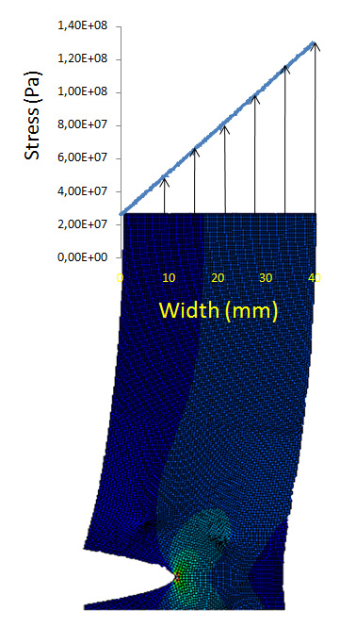
Figure 2. Characteristic profile of the stresses applied along the edge of the SENT specimens of this study.

Figure 3 shows the stress intensity factor solution for two of the SENT specimens configuration that have been used for tests. The curve was normalized by dividing the stress intensity factor by the applied stress and the crack length by the specimen width. The results obtained show that for the SENT specimens with wedge grips, the stress intensity factor depends on the size of the specimen.
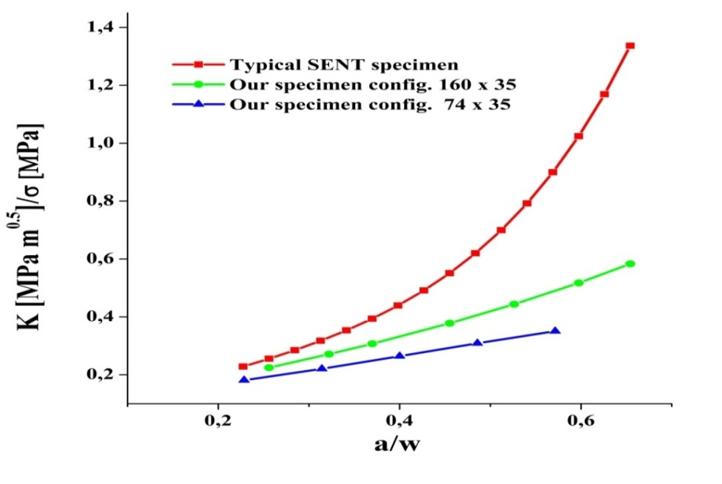
Figure 3. Stress intensity factor solution vs. crack length. For SENT specimen of two different lengths and for typical SENT specimen.
Figure 4 shows the relationship between fatigue crack growth rate vs. ΔK when the stress intensity factor (SIF) solution used is the one found in the handbooks, and when the stress intensity factor used is the one obtained by FEM. When using the stress intensity factor of the handbooks for specimens of the same size, there is an apparent increase of the FCGR with an increase in the applied stress for the same ΔK and the same load ratio. This dependency disappears when a specific stress intensity factor solution is used. This rationalization may be used to explain the contradictory results found in the literature [4,8] which show that in thin sheet SENT specimens of MASS, the FCGR increases with the increase of the applied stress.

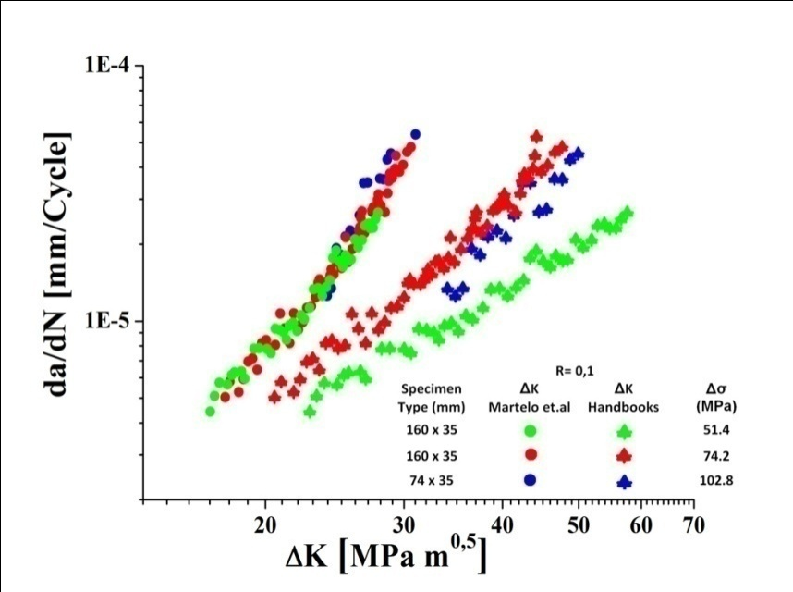
Figure 4. Fatigue crack growth rate vs. stress intensity factor range for a load ratio of 0.1 using the SIF solution proposed in this study and the SIF solution proposed in handbooks.

4. Results
4.1. Fatigue crack growth rate curves in terms of the range of stress intensity factor
Figure 5 shows the fatigue crack growth rate vs. ∆K of an austenitic stainless steel AISI 301LN in annealed condition (Figure 5a) and cold rolled condition (Figure 5b). In all cases, an increase in the FCGR with an increase of ∆K and with an increase in K_{max} for the same ∆K can be observed. For a given ΔK and load ratio, the FCGR is independent of the mean stress. The FCGR curve for a constant R is always lower for the annealed steel compared to the cold rolled steel. For the cold rolled, the influence of crack plane orientation is negligible.
Figure 5. Fatigue crack growth rate vs. stress intensity factor range at different load ratio (a) in the annealed steel (b) in the cold rolled steel.

4.2. FCGR curves in terms of K_{eff} and two driving force parameters
To explain the differences in FCGR curves as a consequence of load ratio, the crack closure has been chosen as the principal mechanism responsible [15]. This mechanism has also been used in the past to explain the difference in FCGR among different microstructural conditions [16]. According to the traditional concepts of crack closure proposed by Elber [17], the effective driving force for FCGR is defined as:

 | $$K_{eff}=K_{max}-K_{op}$$ | (2)
Figure 6 shows the plots of FCGR vs. ΔK_{eff} for the annealed steel using different methods to define the crack opening load (P_{op} or K_{op}) and different offsets. When the K_{op} is defined using a 2% offset (Figure 6a), the K_{eff} loses meaning as driving force. This is concluded because in the FCGR curve at R = 0.1 and ∆P = 2.6kN, an injective function between ∆K_{eff} and FCGR cannot be established. The FCGR can be better expressed in terms of ∆K_{eff} using an offset of 4% as shown in Figure 6b.
Figure 6. Fatigue crack growth rate as a function of the effective stress intensity factor defined using the method: (a) modified ASTM with offset of 2%, (b) modified ASTM with offset of 4%.

As it occurs in the Paris region for the annealed steel, the crack closure cannot explain the effects of the load ratio on the FCGR of the cold rolled steel (Figure 7). In this case, it is even more difficult to explain the difference in the FCGR based on crack closure concepts, since at R equal to 0.3 and R equal to 0.5 the crack closure phenomenon is not present.

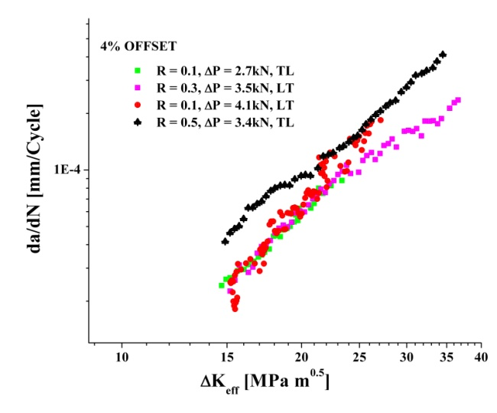
Figure 7. Fatigue crack growth rate as a function of the effective stress intensity factor for the cold rolled steel.

Another rationalization used to explain the load ratio effects are the concepts based on two driving forces as proposed by D. Kujawski [15]. The Kujawski’s parameter is based on the fact that both the K_{max} and the ∆K contribute to the crack growth, and for several alloys, this author has shown that the relationship of Figure 8 satisfied [15].
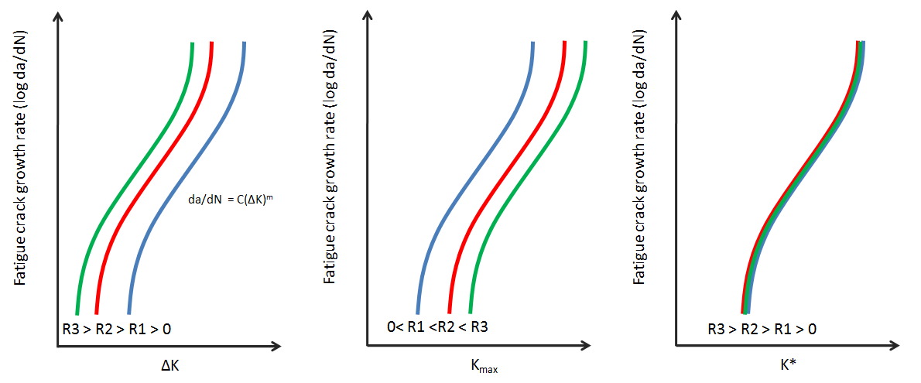
Figure 8. Schematic representation of the FCGR as a function of ΔK, K_{max} and K*.

The Kujawski's parameter is calculated as follows:

$$K^{*}={\left(K_{max}\right)}^{α}{\left({∆K}^{+}\right)}^{1-α}$$ | (3)
Where ΔK⁺ is the positive part of the range of the stress intensity factor and α is a factor that determines the importance of K_{max} and ΔK, here α is calculated by means of the following expression:

$$α=\frac{log\left(∆K_{1}/∆K_{2}\right)}{log\left((1-R_{1})/(1-R_{2})\right)}$$ | (4)

The average value of α for the AISI 301LN in annealed condition is 0.6, while for the AISI 301LN in cold rolled condition is 0.7. These results shows that Kujawski`s parameter can successfully correlate the load ratio effects for the steels in annealed and cold rolled condition, as seen in Figure 9a and b. Unfortunately, the driving forces for fatigue crack growth (ΔK, K_{max}, K*, ΔKeff), which are usually calculated using only the load, the crack length and the geometry of the specimen, can be substantially modified from the nominal values by factors like crack deflection [18], or residual stresses [19] among others variables. The correct estimation of the true driving force is a necessary step to explain the microstructural effects on the FCGR.
Figure 9. Fatigue crack growth rate as a function of the Kujawski`s parameter for (a) the annealed steel (b) the cold rolled steel.

5. Martensitic transformation zone
To determine and measure the martensitic transformation around the crack, different techniques were used. X-ray analysis were conducted on the fatigue fracture surface of the MASS in some of the different conditions tested, see Figure 10. The diffractograms do not show evidence of the austenite phase on the surface fracture, which indicates that very close to the crack, the martensitic transformation is complete.

Figure 10. X-ray diffraction spectra of the fracture surface in the annealed steel and in the cold rolled steel.

Optical micrographs (etched) of the fatigue crack tip can be seen in Figure 11a, b, c and d. In this micrograph the martensite is colored darker than the austenite. From the complete analysis of the micrographs, some features are worth mentioning:
- There is no martensitic transformation in front of the crack tip beyond the last grain that is traversed by the fatigue crack.
- There is no martensitic transformation, even in zones of partial martensitic transformation, caused by the crack advance beyond the 200 μm from the crack
- The martensitic transformation zone is bigger in the annealed specimen than in the cold rolled specimen.
- The zone of martensitic transformation is proportional to the range of stress intensity factor (ΔK), rather than the maximum stress intensity factor (K_{max}).
All these characteristics were confirmed by the micro-indentation technique, as it can be seen in Figure 11a, b, c and d. In this micrograph it is highly evident that the indentations next to the crack are smaller than the indentation in front of the crack tip. The height of the zone of complete martensitic transformation can be described by the material in annealed condition (ZT_{a}) and cold rolled (ZT_{c}) condition by the following equations (5) and (6), respectively.

Figure 11. Optical micrographs of the fatigue crack profile showing the martensite phase in black (a) and (b) annealed steel, (c) and (d) cold rolled steel.

 | $${ZT}_{a}=2.672∆K-28.36$$ | (5)

 | $${ZT}_{cr}=0.22∆K+3.87$$ | (6)
6. Discussion
6.1. Crack path profile analysis
Based on the experimental results of this paper, it is not possible to explain the differences in the FCGR between annealed and cold rolled specimens based on crack closure. It is neither possible to explain the difference in FCGR based on the existence of an extensive harder structure in front of the crack, like the martensite, or based on the increase in the work hardening, as explained above. However, there are other mechanisms that have been studied by others, which can contribute to explain the effects of martensitic transformation on the FCGR of MASS. Based on the success of Kujawski`s parameter to explain the load ratio effects, any other mechanism used to explain the FCG behavior of this kind of steels should not ignore the contribution of K_{max} as driving force.
It is well known that the microstructural characteristics are very important in the FCGR when the cyclic plastic zone is of the same dimension than the size of the microstructural characteristic size (near fatigue threshold). However, the interaction of a new coherent or semi coherent interface, like the austenite-martensite, could promote crack deflection. Roughness can decrease FCGR through three mechanisms (i) for the same over-all crack length, the effective crack length is larger for rougher cracks which implies more energy for the creation of a new surface fracture (ii) for the same crack, a rougher crack reduces the effective driving force (iii) roughness can induce crack closure [18]. Figure 12a, b, c and d show the crack profile of different specimens tested under different conditions. The existence of crack branching in the whole range of ΔK applied can be observed, being more pronounced in the region of higher values ​​of ΔK. For all cases, the crack path is irregular. The peaks of roughness R_{g} are a little bigger than the microstructural characteristic size, although, the typical roughness is of the same order of magnitude than the microstructural characteristic size.
Figure 12. Optical and Scanning electron micrographs of crack profile in a metastable austenitic stainless steel in (a) and (b) annealed condition and (c) and (d) cold rolled condition.
Due to the fact that the crack profiles of the different conditions tested did not show any particular characteristic and because no appreciable difference was found in crack roughness, it is not possible to use this mechanism to explain the difference in FCGR among the different microstructural conditions studied.

6.2. Stress field induced by the martensitic transformation

According to McMeeking et al. [20], an increase in the toughness of some brittle materials like Zirconia could be generated by the reduction in the crack opening displacement caused by an expansive transformation. In his original paper, Mcmeeking et al. [20] calculated the stress intensity factor caused by the martensitic transformation. Mei et al. [3], used the same idea to explain the decrease in the FCGR of an austenitic stainless steel AISI 304 at transformation temperature. However, in both cases they calculated the stress intensity factor caused by the martensitic transformation considering the existence of a zone of martensitic transformation in front of the crack tip.
In MASS like the AISI 304, the martensitic transformation causes a volume expansion of 2% [21]. To determine the stress intensity factor induced by the compressive stresses of the martensitic transformation, the weight function method proposed by P. Paris et al.[22] is used.

 | $$K_{tran}=\int_{S}{T∙h dS}$$ | Ecuación (7)

where T are the tensions applied along the contour S, if only the volume expansion is considered, then the tension T will be perpendicular to S. h is a weight function and K_{tran} is the stress intensity factor caused by the martensitic transformation. The results obtained using the weight function are limited to the region very close to the crack. The function h is given in reference [22] and it is defined as follows:

 | $$h_{x}=\frac{cos\frac{θ}{2}\left(4v^{*}-2+cosθ-cos2θ\right)}{4\sqrt{2π}(1-v)\sqrt{r}}$$  $$h_{y}=\frac{sin\frac{θ}{2}\left(4-4v^{*}-cosθ-cos2θ\right)}{4\sqrt{2π}(1-v)\sqrt{r}}$$ | Ecuación (8)

for plane stress υ∗ = υ/(1+ υ) and T can be expressed as [20]:

 | $$T=pn=p\left(n_{x}+n_{y}\right)$$ | Ecuación (9)

where p is the stress generated by the volume expansion. Taking into account that the experimental observations from this study do not show a zone of martensitic transformation in front of the crack tip, the calculation of stress intensity factor will be done following a contour S as shown in Figure 13.
Figure 13. Schematic contour of the martensitic transformation around a fatigue crack in a MASS AISI 301LN.

Therefore, the equation to be solved for each segment is as follows:

 | $$K_{tran}=p\int_{S}{n∙hdS}=p\int_{S}{\left(n_{x}h_{x}+n_{y}h_{y}\right)dS}$$ | Ecuación (10)

The stress intensity factor obtained from the contribution of all segments is plotted against the crack length normalized by the height of the zone of martensitic transformation, Figure 14.

Figure 14. Resistance curve caused by the martensitic transformation adjacent to the crack.

When the crack length is much bigger than the height of the zone transformed to martensite, the curve of Figure 14 approaches an asymptotic value. Equation (11) represents the decrease in the stress intensity factor due to zone of austenite completely transformed to martensite as observed in this material for the tests conducted.

 | $$K_{tran}=K_{1}+K_{2}+K_{3}+K_{4}\underset{⇒}{}K_{L}\underset{→}{a\underset{→}{}∞}-0.608\frac{p}{(1-v)}\sqrt{ZT}$$ | Ecuación (11)

Equation (11) implies that there is no need of a zone of martensitic transformation in front of the crack tip to explain a decrease in the fatigue crack growth rate associated to a martensitic transformation. However, K_{tran} cannot be used to explain the decrease in the FCGR if the ΔK_{eff} or ΔK is used as the only driving force for fatigue crack growth as it will be shown in expressions (12) and (13):

$${∆K}_{}=K_{max}-K_{min}$$  or  $${∆K}_{eff}=K_{max}-K_{cl}$$ | Ecuación (12)
Considering that ΔK_{eff} is not appropriate to characterize the FCGR in this kind of material, as previously shown, and after adding the contribution of the martensitic transformation as a driving force, we obtain:

$$K_{\min{}tran}=K_{min}-K_{tran}$$  $$K_{\max{}tran}=K_{max}-K_{tran}$$  $$∆K_{tran}=K_{\max{}tran}-K_{\min{}tran}={(K}_{max}-K_{tran})-{(K}_{min}-K_{tran)}=∆K$$ | Ecuacin (13)
Because K_{tran} does not contribute to ΔK parameter, and based on the fact that a two-driving-force parameter is very successful in explaining the load ratio effects, the following combined parameter is proposed to do so, as well as to explain the effect of martensitic transformation in the FCGR of MASS:

$$K_{m}^{*}={\left(K_{max}-f(x)\right)}^{α_{n}}{\left({∆K}_{}^{+}\right)}^{1-α_{n}}$$ | (14)
In this particular case:

$$K_{m}^{*}={\left(K_{max tran}\right)}^{α_{n}}{\left({∆K}_{tran}^{+}\right)}^{1-α_{n}}$$  or  $$K_{m}^{*}={\left(K_{max}-K_{tran}\right)}^{α_{n}}{\left({∆K}_{}^{+}\right)}^{1-α_{n}}$$ | (15)

where α_{n} is a parameter with the same physical meaning of the parameter α. The value of p used to calculate K_{tran} was taken from the experimental value obtained by K. Rajanna et al. [23], who measured the residual stresses in the martensite and austenite phases of the surface fracture of an MASS AISI 304 and AISI 316. The determination of α_{n} is performed by using the equation (4), however, in this case the values of R₁ = K_{min1}/K_{max1} and R₂ =K_{min2}/K_{max2} that must be used are R₁ = K_{mintran1}/K_{maxtran1} and R₂ = K_{mintran2}/K_{maxtran2.} The values of α_{n} are 0.5 and 0.6 for the steel in annealed condition and cold rolled condition, respectively. Figure 15 compares the results obtained using Kujawski`s parameter versus the parameter proposed in equation (15). It can be observed that the K_{m}* tends to join the curves together. However, the difference in the FCGR between the MASS in annealed condition and the one in cold rolled condition cannot be explained. The differences in the FCGR between the steel in annealed condition and cold rolled condition can be partially explained if the value of p is equal to C = LBε^{t} (L = 0.5, B is the bulk elastic modulus of the martensite, and ε^{t} is the volumetric strain of the martensitic transformation), as explained by S. Biswas et al. [5]. The results obtained using this value of p and values of α_{n} equal to 0.5 and 0.6 for the steel in annealed condition and cold rolled condition respectively are shown in Figure 16a for a load ratio of 0.1. The values of K_{tran} for both analysis are shown in Figure 17, the inferior limit is for the calculation according to results of K. Rajanna et al. [23] and the upper limit for the calculation according to estimation of S. Biswas et al. [5].
Figure 15. Fatigue crack growth rate as a function of (a) the Kujawski`s parameter (b) the Kujawski`s parameter modified by the compressive stresses generated by the martensitic transformation.
.
The inconvenience of the last solution proposed lies in the fact that when the value of α_{n} is calculated, it becomes bigger than 1 losing its physical meaning. Another observation obtained based on this solution is that the crack closure induced by the martensitic transformation in the annealed steel should be much higher than the obtained in the cold rolled steel, as can be seen in the values of (K_{min} - K_{tran}) in Figure 16b. Considering that the residual stress measured by K. Rajanna et al. [23] are taken from the surface fracture of an MASS with subcritical martensitic transformation, and taking into account the results obtained in Figure 16a, it is probable that the residual stresses induced by the martensitic transformation in the crack wake are partially responsible for the differences in the FCGR between the MASS in the annealed and cold rolled conditions used in this investigation.
Figure 16. (a) Fatigue crack growth rate as a function of the Kujawski`s parameter modified by the compressive stresses generated by the martensitic transformation (b) K_{max trans} and K_{min trans} vs. Fatigue crack growth rate.

Figure 17. Stress intensity factor caused by the martensitic transformation vs. range of stress intensity factor.

Another factor that should be considered when explaining the differences in the FCGR between the MASS in annealed and cold rolled condition is the damage distribution around the crack tip. To understand the micromechanism of crack growth in this steel, SEM images of the fracture surface of the different condition tested are shown in Figure 18.

6.3. Fracture surfaces analysis

In all cases, the observed fracture mode is transgranular without striations. The comparison between the SEM images obtained to a load ratio of 0.1 for the steel in annealed and cold rolled condition, Figure 18a and c, shows that the principal difference in the crack advance mechanism between the two alloys is the large number of micro cracks present in the surface fracture of the cold rolled steel. According to previous studies, the fatigue crack nucleation in the regime of low cycle fatigue, where the plastic deformation is large as in the plastic zone, occurs exclusively within the martensite phase both in the surface and in the bulk of the specimen [24]. The effect of micro cracks in the FCGR is varied; the linear elastic analyses of bifurcated cracks performed by S. Suresh [25] shows that for the same crack length, the effective stress intensity factor is lower for branched cracks than for straight cracks. However, micro cracks can increase the FCGR if they coalesce with main crack, creating a reduction in the crack path [26]. Figure 19 schematically shows the effect of the micro cracks in the crack path. These micro cracks are also present in the steel in annealed state tested to a R equal to 0.5, although the nucleation of these micro cracks is related to the increase in K_{max,} Figure 18b. With the increase in K_{max} in the steel in the cold rolled condition, both mechanisms of micro crack nucleation previously explained are present together with the formation of incipient micro voids, Figure 18d.
Figure 18. SEM image of the fatigue fracture surface corresponding to (a) and (b) annealed steel, (c) and (d) cold rolled steel.

Figure 19. Schematic illustration of the micro cracks and the incipient micro voids coalescing with the main crack.

As the explanation of the FCGR decrease based on the compressive stress field caused by the martensitic transformation, in which the effect of the residual stress is accounted in the applied driving force by modifying the contribution of K_{max} to the crack advance, the K_{max} parameter plays a fundamental role in the mechanism of fatigue crack advance of MASS and in the explanation of the lower FCGR of the annealed steel compared to the cold rolled steel. However, it is expected that if the lower FCGR in MASS compared to other alloys were caused only by the fracture mode, especially in the steel in annealed state, the surface fracture morphology should have a more ductile appearance. However, as general characteristic, fracture surfaces are quasi-brittle, which is attributed to the complete martensitic transformation in the zone adjacent to the crack.

7. Conclusions
A new stress intensity factor solution (K) is proposed for the SENT specimens of this investigation. This solution could be used as a possible explanation to the uncommon applied stress effect observed, in previous studies, in thin sheet specimens of MASS.
The FCGR curves have also been evaluated in terms of the ΔK_{eff}. The results show that, according to the offset used to measure the point where the crack faces make contact, the correlation of the load ratio effects can be improved or worsened. However, the correlation of the load effects using Kujawski`s parameter is superior. For the annealed specimens, the suitable value for α equals 0.6 and for the cold rolled specimens, 0.7
The exceptional FCGR of MASS has an explanation in the mechanism of the residual stress induced by the martensitic transformation, and the appearance of a quasi-static fracture mode such as micro-crack formation and incipient micro-voids. In this context, it is worth noting, that the increase of the crack propagation resistance of the annealed steel compared to cold rolled steel is not only caused by the austenite transformed to martensite prior the tests, but also, by the increase in the zone transformed to martensite attendant to the test in the annealed specimens.
Finally, a parameter that takes into account the effect of residual stress is proposed. This new parameter is based on the two-driving force concept for fatigue crack advance (K_{max} and ΔK).

Acknowledgements

Authors wish to express their gratitude to the funding provided by CONICET (Consejo Nacional de Investigaciones Científicas y Técnicas), and by Agencia Nacional de Promoción Científica y Tecnológica, Argentina (PICT2010 Nro.0379).

References

1 | TALONEN, J. (2007). Effect of strain-induced α’- martensite Transformation on Mechanical Properties of Metastable Austenitic Stainless Steel. 2007. (Doctoral dissertation)
2 | PINEAU, A. G.; PELLOUX, R. M. Influence of strain-induced martensitic transformations on fatigue crack growth rates in stainless steels. Metallurgical Transactions, 1974, vol. 5, no 5, p. 1103-1112. (Doi: 10.1007/BF02644322)
3 | MEI, Z.; MORRIS, J. W. Influence of deformation-induced martensite on fatigue crack propagation in 304-type steels. Metallurgical Transactions A, 1990, vol. 21, no 12, p. 3137-3152. (Doi: 10.1007/BF02647310)
4 | SCHUSTER, G.; ALTSTETTER, C. Fatigue of annealed and cold worked stable and unstable stainless steels. Metallurgical Transactions A, 1983, vol. 14, no 10, p. 2077-2084. (Doi: 10.1007/BF02662374)
5 | BISWAS, Somjeet, et al. Load history effect on FCGR behaviour of 304LN stainless steel. International journal of fatigue, 2007, vol. 29, no 4, p. 786-791. (Doi: 10.1016/j.ijfatigue.2006.06.003)
6 | CHANANI, G. R.; ANTOLOVICH, Stephen D.; GERBERICH, W. W. Fatigue crack propagation in trip steels. Metallurgical Transactions, 1972, vol. 3, no 10, p. 2661-2672. (Doi: 10.1007/BF02644242)
7 | HEAD, A. K. XCVIII. The growth of fatigue cracks. Philosophical Magazine, 1953, vol. 44, no 356, p. 925-938. (Doi: 10.1080/14786440908521062)
8 | RICKERBY, D. G.; FENICI, P. Fatigue crack growth in thin section type 316 stainless steel. Engineering Fracture Mechanics, 1984, vol. 19, no 4, p. 585-599. (Doi: 10.1016/0013-7944(84)90092-4)
9 | HARTMANN, H. R.,; CHURCHILL, R. W. KRAK-GAGE: A new Transducer for Crack Growth Measurement. presented at the Society for Experimental Stress Analysis Fall Meeting, sponsored by the Society for experimental Stress Analysis, 1981.
10 | ASTM E 647 - 08e1. Standard test method for measurement of fatigue crack growth rates. Annual book of ASTM standards, 2010.
11 | PARK, J.; SONG, J.; EARMME, Y.; Kim, C. Personal computer based fatigue testing automation and improvement in fatigue behavior monitoring. Transactions of the KSME, 1988, vol. 12, p. 123-130.
12 | KIM, Chung-Youb; SONG, Ji-Ho. An automated procedure for determining crack opening level from differential displacement signal data. International journal of fatigue, 1993, vol. 15, no 4, p. 301-309. (Doi: 10.1016/0142-1123(93)90379-5)
13 | CHUNG, Youn-Il; SONG, Ji-Ho. Improvement of ASTM compliance offset method for precise determination of crack opening load. International Journal of Fatigue, 2009, vol. 31, no 5, p. 809-819. (Doi: 10.1016/j.ijfatigue.2008.11.006)
14 | PARIS, P. C.; GOMEZ, M.; ANDERSON, W. E. A rational analytic theory of fatigue. Trend Eng Univ Washingtoon, 1961, vol. 13(1), p. 9-14.
15 | KUJAWSKI, Daniel. A fatigue crack driving force parameter with load ratio effects. International Journal of Fatigue, 2001, vol. 23, p. 239-246. (Doi: 10.1016/S0142-1123(01)00158-X)
16 | GRAY, G. T.; WILLIAMS, J. C.; THOMPSON, A. W. Roughness-induced crack closure: an explanation for microstructurally sensitive fatigue crack growth. Metallurgical Transactions A, 1983, vol. 14, no 2, p. 421-433. (Doi: 10.1007/BF02644220)
17 | ELBER, W. The significance of fatigue crack closure. ASTM STP 486. Damage tolerance in aircraft structures, 1971, p. 230-242.
18 | SURESH, S. Crack deflection: implications for the growth of long and short fatigue cracks. Metallurgical Transactions A, 1983, vol. 14, no 11, p. 2375-2385. (Doi: 10.1007/BF02663313)
19 | NOROOZI, A. H.; GLINKA, G.; LAMBERT, S. Prediction of fatigue crack growth under constant amplitude loading and a single overload based on elasto-plastic crack tip stresses and strains. Engineering Fracture Mechanics, 2008, vol. 75, no 2, p. 188-206. (Doi: 10.1016/j.engfracmech.2007.03.024)
20 | MCMEEKING, R. M.; EVANS, A. G. Mechanics of Transformation‐Toughening in Brittle Materials. Journal of the American Ceramic Society, 1982, vol. 65, no 5, p. 242-246. (Doi: 10.1111/j.1151-2916. 1982.tb10426.x)
21 | REED, R. P. The spontaneous martensitic transformations in 18% Cr, 8% Ni steels. Acta Metallurgica, 1962, vol. 10, no 9, p. 865-877. (Doi. 10.1016/0001-6160(62)90101-3)
22 | PARIS, P.; McMEEKING, M.; TADA, H. The Weight Function Method for Determining Stress Intensity Factors. ASTM STP 601. Cracks and Fracture, 1975, p. 471-489.
23 | RAJANNA, K.; PATHIRAJ, B.; KOLSTER, B. H. X-ray fractography studies on austenitic stainless steels. Engineering fracture mechanics, 1996, vol. 54, no 1, p. 155-166. (Doi: 10.1016/0013-7944(95)00246-4)
24 | STOLARZ, Jacques; BAFFIE, Natacha; MAGNIN, Thierry. Fatigue short crack behavior in metastable austenitic stainless steels with different grain sizes. Materials Science and Engineering: A, 2001, vol. 319, p. 521-526. (Doi: 10.1016/S0921-5093(01)01072-3)
25 | SURESH, S. Micromechanisms of fatigue crack growth retardation following overloads. Engineering Fracture Mechanics, 1983, vol. 18, no 3, p. 577-593. (Doi: 10.1016/0013-7944(83)90051-6)
26 | POKLUDA, Jaroslav; SANDERA, Pavel. Micromechanisms of Fracture and Fatigue. s.l. : Springer, 2010. (Doi: 10.1007/978-1-84996-266-7)

