Augmented and Geo-located information in architectural education framework

Ernest Redondo, Janina Puig

Universidad Politécnica de Cataluña-Barcelona Tech. Barcelona. Spain

[ernesto.redondo@upc.edu](mailto:ernesto.redondo@upc.edu) janinapuig@hotmail.com

David Fonseca, Sergi Villagrasa, Isidro Navarro

Architecture School - La Salle, Universitat Ramon Llull. Barcelona, Spain.

{[fonsi, sergiv, inavarro}@salle.url.edu](mailto:fonsi,%20sergiv,%20inavarro%7d@salle.url.edu)

**Abstract.** This work is focused to design an academic experience involving the implementation of augmented reality tool in architecture education practices to improve the motivation and final marks of the student. We worked under different platforms for mobile devices to create virtual information channels through a database associated to 3D virtual models and any other type of media content, which are geo-located in their real position. The basis of our proposal lies in the spatial skills improvement that students can achieve using their innate affinity to friendly digital media as Smartphones or tablets, to visualize educational exercises in real geo-located environments and allowing sharing and evaluating own-generated student’s proposals, on site.

The proposed method aims to improve the access to multimedia content on mobile devices, allowing access adapted to all types of users and contents. The students divided into various groups, both control and experimental in function of the devices and practices to perform, have as goal display 3D architectural geo-referenced content, using Sketchup and ArMedia for iOS and a custom platform for Android environment.

**Keywords:** Augmented reality, E-Learning, Geo-Elearning, Urban Planning, Educational research.

**1 Introduction**

New technology implementations in the teaching field have been largely extended to all types of levels and educational frameworks. However, these innovations require approval validation and evaluation by the final users, the students. A second step of the proposal (that will be generated along the first semester of 2014) will be discuss the advantages and disadvantages of applying mixed evaluation technology in a case study of the use of interactive and collaborative tools for the visualization of 3D architectonical models. We will use a mixed-method of evaluation  based on quantitative and qualitative approaches to measure the level of motivation and satisfaction with this type of technology and to obtain adequate feedback that allows for the optimization of this type of experiment in future iterations.

The current paper is based on three main pillars: The first pillar focuses on teaching innovations within the university framework that cultivate higher motivation and satisfaction in students. The second pillar concerns how to implement such an innovation; we propose the utilization of determinate tools (AR) of so-called Information Technologies (IT), so that students, as "digital natives", will be more comfortable in the learning experience. Finally, the study will employ a mixed analysis method to concretely obtain the most relevant aspects of the experience that should be improved both in future interactions and in any new technological implementations within a teaching framework.

**2 Background**

Augmented Reality (AR) technology is based on overlapping virtual information in real space. AR technology enables to mix virtual objects generated by computers with a real environment, generating a mixed environment that can be viewed through any technological device in real time. The main characteristics of an Augmented Reality system are [1]:

* Real-time interactivity
* Use of 3D virtual elements
* Mix of virtual elements with real elements

Augmented reality has emerged from research in virtual reality. Virtual reality environments make possible total immersion in an artificial three-dimensional world. The involvement of Virtual Reality (VR) techniques in the development of educational applications brings new perspectives to Engineering and Architectural degrees. For example, through interaction with 3D models of the environment, the whole constructive sequence in time and space of a deck can be simulated for a better understanding of our students [2]. We can also explore hidden structure through ghosted views within the real-world scenes [3] or find several examples of AR and VR applied to monitoring the maintenance of new buildings and to keep or save cultural heritage [4-6].

Evaluate the use of VR or AR applications in an industrial setting is a complex task, but some statistics suggest performance improvements up to 30% with involved employees reporting higher levels of engagement [7]. Applications of AR that support technicians in the field have the potential of reducing costs up to 25% throughout quicker maintenance or component substitution, identification and setup of new connections, solution of faults and misconfigurations, with less burden on backend personnel and system resources.



**Fig.1** Augmented Reality at the UPC University. A 3D model visualized through a mobile device screen thanks to the camera detection of a regular shape or code

2. 1. Mobile learning last improvements

Between 2008 and 2009, new platforms and paradigms emerged to propel AR development in smartphones, like Junaio, Layar and Wikitude. All of these companies embraced a new concept which consisted in creating an Augmented Reality browser with a number of features that allowed developers to produce AR content according to a specific set of rules, and, finally, enabled end-users to view computer generated elements superimposed to the live camera view of common smartphones. These AR browsers are compatible with most mobile operating systems like the Android, the iPhone OS, or the Symbian.

A framework where this technology could be potentially more interesting is the representation and management of the territory, because real scenes could be "completed" with virtual information. This method would facilitate a greater awareness and better understanding of the environment, especially if we use it in the educational framework. Last year research at universities worldwide has been focused on the development of AR applications (AGeRA[8], GIS2R[9], ManAR[10]), tools (GTracer for libGlass[11]), educational platforms (TLA[12]), or open resources and contents (ISEGINOVA AR Project[13]) such as 3D architectural models (3D ETSAB AR[14]).

2. 2. GIS Limitations

Real-time performance and qualitative modeling remain highly challenging, and in-situ 3D Modeling becomes increasingly prominent in current AR research, particularly for mobile scenarios [15]. The main problem of all these applications seems to be the location or geographical information, because a Geographic Information System (GIS) is needed to provide and manage and filter public queries with different levels of accurate and upgradeable information. In short, we need to link a 3D model to a database which contains all the necessary information associated with it. Furthermore, the introduction of new learning methods using collaborative technologies, offers new opportunities to provide educational multimedia content.

While GPS (Global Positioning System) has satisfactory accuracy and performance in open spaces, its quality deteriorates significantly in urban environments. Both the accuracy and the availability of GPS position estimates are reduced by shadowing from buildings and signal reflections. Mobile AR applications for outdoor applications largely rely on the smartphone GPS. Also, GPS provides the user position based on triangulation of signals captured from at least 3 or 4 visible satellites by a GPS receiver. Standard GPS systems have 5m to 30m accuracy due limitations such as [16]:

* Being unavailable (or slow in obtaining position) when satellite signals are absent such as underground, and when meteorological conditions block transmission, and
* Satellites can provide erroneous information about their own position.

Already well known applications are Wikitude, Nokia City Lens, Google Goggles and Metaio Junaio. Today's sensors capabilities in stability and precession have noticeably improved. For example, GPS accuracy is increased with differential GPS or DGPS which brings the accuracy of readings to within 1-3 meters of the object, as compared to the 5-30 meters of normal GPS. DGPS works using a network of stationary GPS receivers [17]. The difference between their predefined position and the position as calculated by the signals from satellites gives the error factor. This error component is then transmitted as a FM signal for the local GPS receivers, enabling them to apply the necessary correction to their readings.

**2.3 TIC at University**

Recently experiences related to the implementation of TIC at university degrees concluded that “digital natives” with a periodical activity on networks and chats are better students [18]. The use of VR technologies on practical courses for graduate and undergraduate students aims to develope personal skills [19] introduced in the European Educational Space (EEES) such as methodical approach to practical engineering problems, teamwork, working in interdisciplinary groups and time management.

In previous publications [20-21] we explained the relationship between Mobile Learning AR technologies introduced in engineering degrees and his impact at the academic results of our students, increasing their motivation and satisfaction in classroom.

**3 Case of study**

This item presents a teaching methodology for a practical course in architectural degree where the students improve AR and VR technologies through their own mobile devices. The course design follows previous examples [23] of moodle based evaluation systems for the actual requirements within EEES on new skills for professional technicians such as spatial vision, orientation or teamwork.

At the same time, to test the accuracy and satisfaction of GPS systems only avaible in smartphones and iOS devices, we developed an Android tool (RA3) based on markers as location encoders (i.e. markers with regular shapes, such as QR code-like markers) associated with specific points of the environment or objects.

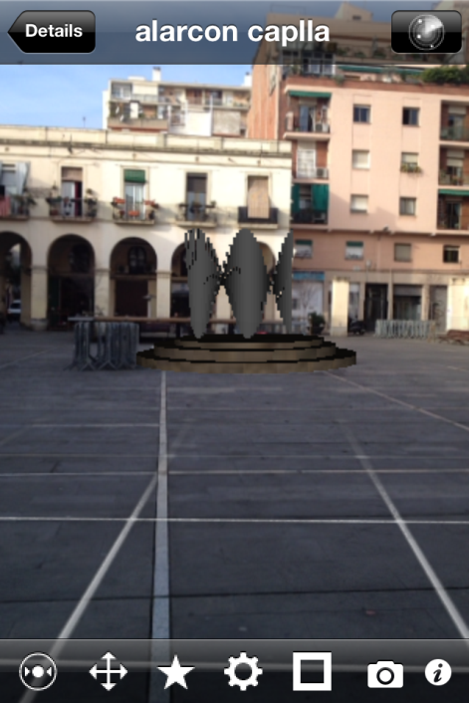 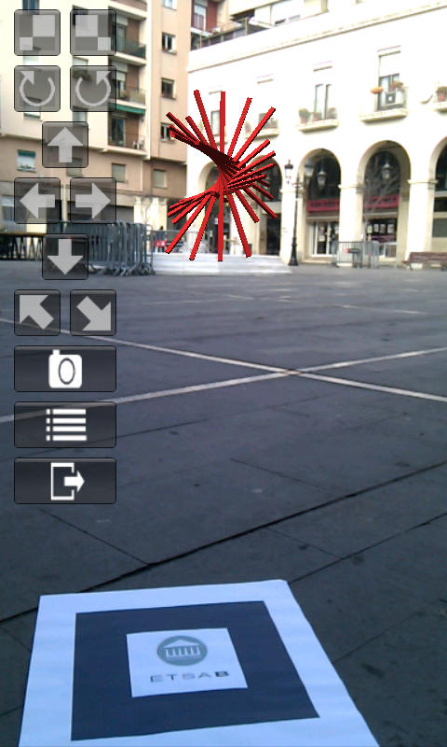

**Fig. 2.** At the left IOs screen displaying options with ArPlayer of Armedia. On the right sight the application RA3 developed for Android devices

**3.1 Methodology**

The proposed course focused two points. On one hand, the structure that defines the acquirement of knowledge is an inverted pyramid. Namely, students can't perform a practice without having completed and assimilated the activity before. So, only students who have built a 3D model will be able to insert it into a landscape or photograph according to its geometrical space or perspective. Likewise, only smartphones owners are able to play RA applications for IOs platforms. To separate mobile devices users from the rest of the class, all students get a Pre-test that will define two main groups; a control and experimental group. On the other hand, students improving this methodology challenge they self results thanks to VR and AR technologies, having the opportunity to compare their 3D model with its equal at the real world.

During the designed course at the Architecture University of Barcelona (ETSAB-UPC), four main exercises are developed in order to evaluate particular skills linked to architectural and engineering careers, such as spatial perception, orientation or occlusion. This kind of abilities can be introduced too with specific AR experiencies [24].

**3.2 Contents**

The first practice of the course is to generate a database of 3D sculptures of Andreu Alfaro. These virtual sculptures, in the second part of the course, have to be integrated in a nineteenth century square through a photographic refund. The third exercise is the virtual representation of the chosen architectural environment; one of the few arcaded squares of Barcelona, the Plaza Masadas. Finally, every student promote itself an urban intervention according to the regulation and urban plans.

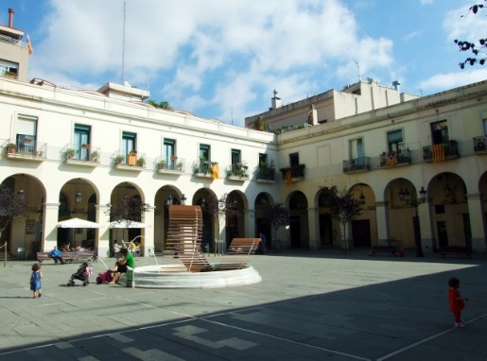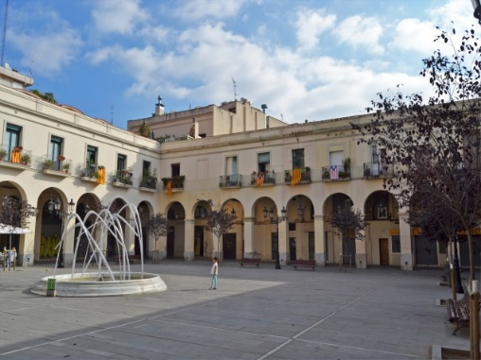

**Fig. 3.** Two examples of photographic refunds of 3D sculptures in the middle Plaza Masadas, Barcelona

In the photographic refund of the object or piece in the middle of a square, realism can be diminished if ambient occlusion or point of view of both images, the real square and the 3D sculpture, are in contradiction. Lighting, for example, is an element of realism that is dynamic and produces shadows that, when missing, break the realistic effect of AR. To avoid ambient occlusion contradictions the students should select several propreties such as colour, reflection or material, and use tools that introduce the latitude and light-time during the render process of 3D models in Artlantis, V-ray or 3DStudioMax to offer more interactive real environment [25]. Then Photomatch options of SketchUp are used to match the 3D model in the chosen square's photography according to its point of view.

The third part of the practical course introduce teamwork abilities to previous evaluated skills of geometric performing, spatial visualisation or orientation and ambient occlusion. Different segments of the existing arcaded buildings arround the square have to be developed in two partners groups separately according the urban plans that expect the reconstruction of one corner in this place. The more or less adjustments taked to join every segment with the hole compilation determinate the first mark of the group, beeing the second mark the result of a control exam inwhich every student have to represent a 3D building part of a similar arcaded square.

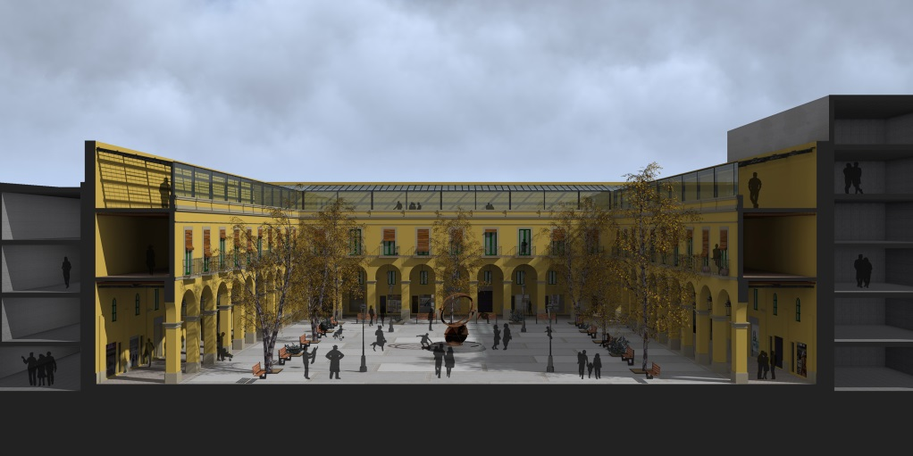

**Fig. 4.** 3D model of the section of an arcaded square in Barcelona

The fourth exercise implements physical and urban propreties to main 3D model. A personal approach must discuss material, colour, landscaping and urban furniture at the proposed space. The grade of this project is obtained from two perspectives rendered in a human point of view.

In between the last practice an experimental group composed by students having passed the "digital natives" Pre-test, improves spatial abilities using Augmented Reality with two location strategies for 3D models, marker-based and GPS. The two main platforms for mobile devices, Android and IOs (ArPlayer and RA3), determinate the location strategy for each user in order to integrate his own project on its real environment. Placed the 3D model in its real environment, the application displays different options of interaction such as rotation, scale and light-orientation. Playing with application choices the student should get a final scene with his device in order to compare it with his previous virtual representations and exercises.

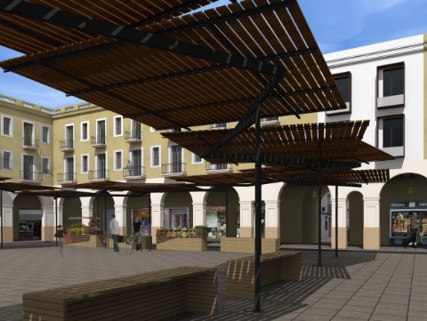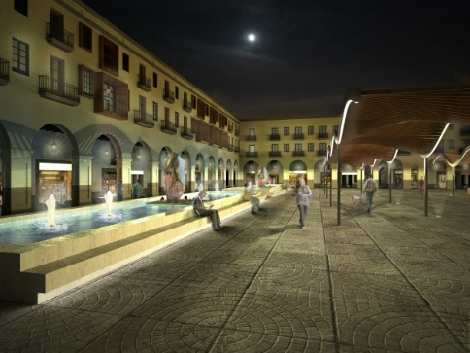

**Fig. 5.** Renders of two projects in a human point of view

**4 Conclusions**

The teaching methodology explained on this item is been thought to introduce our grade students in Virtual and Hand Held Augmented Reality (HHAR), to overlap virtual models on real scenes. Having previously developed test methods to confirm the motivation of our students working with VR and AR technologies our next point will be determinating what are the best resources and systems to introduce this technics at the educational community.

In forward papers the implementation of this methodology in a practical course at the Architecture University of Barcelona (ETSAB) will give us information about advances and users results on different issues:

* VR software and renderisation
* AR applications
* GIS (geographical information) systems on mobile devices

Computer graphics have become much more sophisticated, becoming more realistic. In the near future, researchers plan to display graphics on TV screens or computer displays and integrate them into real world settings. So, geometrical performing of 3D architecture for virtual representation is nowadays possible with 3D SketchUp, Rhinoceros or Autocad due their compatibilities in DBX or DWG files to generate a database.

In the field of architecture, virtual reality renderisation needs several options for ambient occlusion such as colour, reflection or material, using tools and files allowing the introduction of the latitude and light-time. Based on these premises we will work with Artlantis, V-ray or 3DStudioMax to offer more interactivity with real world environment.



**Fig. 6.** Geographic information channel linked on a 3D model

Augmented Reality can be explored in various areas of knowledge, contributing significantly in education. It provides a great potential in the creation of interactive books, allowing intuitive and easy to learn interaction. Attending our previous experiencies using AR applications we decided to use ArMedia (IOs) and to develope a new application for Android, RA3. The major difference between the two platforms that display AR services is the GIS(geographical information) system, where IOs works with GPS and Android needs a marker based on regular shapes (i.e. QR codes) as location encoders. GPS systems aren't currently accurate enough to aid in the teaching of architecture. So, in case of urban planning is recommended to replace the GPS for location based on shapes or QR codes.

**Acknowledgements:** Project funded by the VI National Plan for Scientific Research, Development and Technological Innovation, 2008-2011, Government of Spain. No EDU-2012-37247/EDUC.

References

1. Ana Grasielle D.Corrêa, André Tahira, João B. Ribeiro, Jr., Rodrigo K. Kitamura, Tiago Y. Inoue, Irene Karaguilla Ficheman: Development of an Interactive Book with Augmented Reality for Mobile Learning. CISTI 2013
2. Alcinia Zita Sampaio, Luís Viana: Virtual Reality Used As a Learning Technology: Visual Simulation of The Con-struction Of A Bridge Deck. CISTI 2013
3. Denis Kalkofen, Eduardo Veas, Stefanie Zollmann, Markus Steinberger, Dieter Schmalstieg: Adaptive Ghosted Views for Augmented Reality. ISMAR 2013
4. Alcinia Zita Sampaio, Daniel P. Rosário: Maintenance Planning of Building Walls Supported on Virtual Reality Tech-nology. CISTI 2013
5. E. Redondo, A. Sánchez Riera, and J. Puig, “Gironella tower in Gerunda, teaching roman architecture, using 3D model-ing and augmented reality. A case study,” in S.A.V.E. Heritage - International Forum S.A.V.E. Heritage Safeguard of Architectural, Visual, Environmental Heritage, Capri, 2011, pp.102–1–102–9.
6. Felipe Rodrigues Perrone, Felipe Etchegaray Heidrich, Hector Medina Gomes, Dr. Adriane Borda de Almeida da Silva: Desenvolvimento de Aplicativo para Visualização de Patrimônio Histórico-Arquitetônico em Realidade Aumentada (Development of an Application for Visualization of historical and Architectural heritage in Augmented Reality) SIGRADI 2012
7. Graziano Terenzi, Giuseppe Basile: Smart Maintenance. An Augmented Reality Platform for Training and Field Operations in the Manufacturing Industry. ARmedia. 2ond White Paper of Inglobe Technologies Srl (2013)
8. Ana Grasielle D.Corrêa, André Tahira, João B. Ribeiro, Jr., Rodrigo K. Kitamura, Tiago Y. Inoue, Irene Karaguilla Ficheman: Development of an Interactive Book with Augmented Reality for Mobile Learning. CISTI 2013
9. Leonel Dias, António Coelho, André Rodrigues, Carlos Rebelo, André Cardoso. GIS2R - Augmented Reality and 360° Panoramas Framework for Geomarketing. CISTI 2013
10. Hector Ramirez, Eduardo Gonzalez Mendivil, Pablo Ramirez Flores, Manuel Contero Gonzalez: Authoring Software for Augmented Reality applications for the use of maintenance and training process. VARE 2013
11. Marcelo de Paiva Guimarães, Valéria Farinazzo Martins, Diego Colombo Dias, Luiz Francisco Contri, Bruno Barberi Gnecco. Development and debugging of distributed virtual reality applications. CISTI 2013
12. Damon A. Regan: The Training and Learning Architecture: Infrastructure for the Future of Learning. SINTICE 2013
13. Pedro Vieira Cardoso, Miguel de Castro Neto: ISEGI-NOVA AR Project. Augmented Reality applied to the Univer-sidade Nova de Lisboa. CISTI 2013
14. App Isidro
15. Thanh Nguyen, Raphael Grasset, Dieter Schmalstieg, Gerhard Reitmayr: Interactive Syntactic Modeling With a Single-Point Laser Range Finder and Camera. ISMAR 2013
16. Christine Perey, Graziano Terenzi: AR-Assisted 3D Visualization for Urban Professional Users. ARmedia First White Paper of Inglobe Technologies Srl (October 2013)
17. Arnis Cirulis, Kristaps Brigis Brigmanis: 3D Outdoor Augmented Reality for Architecture and Urban Planning. VARE 2013
18. Diego Alonso Gómez-Aguilar, Francisco J. García-Peñalvo, Roberto Therón: Visual assessment of the relationships among students participation and their outcomes on eLearning environments. SINTICE 2013
19. Polina Häfner, Victor Häfner, Jivka Ovtcharova: Teaching Methodology for Virtual Reality Practical Course in Engi-neering Education. VARE 2013
20. David Fonseca, Sergi Villagrasa, Ernest Redondo, Isidro Navarro: Study of the motivation and the student profile using mobile devices in the visualization of three dimensional models. SINTICE 2013
21. Ernest Redondo, David Fonseca, Albert Sánchez, Isidro Navarro: New Strategies Using Handheld Augmented Reality and Mobile Learning-teaching Methodologies, in Architecture and Building Engineering degrees. VARE 2013
22. Juan Manuel Vaca, J. Enrique Agudo, Mercedes Rico. Evaluating competences in engineering: a Moodle-based eportfo-lio. SINTICE 2013
23. Cristina Roca González, Jorge Martín-Gutiérrez, Melchor García Domínguez, Alejandra Sanjuán HernanPérez, Carmen Mato Carrodeguas: Improving Spatial Skills: An Orienteering Experience in Real and Virtual Environments With First Year Engineering Students. VARE 2013
24. Nicolas Imbert, Frederic Vignat, Charlee Kaewrat, Poonpong Boonbrahm: Adding Physical Properties to 3D Models in Augmented Reality for Realistic Interactions Experiments. VARE 2013