Incorporation of deMon2k as a new parallel quantum mechanical code for the PUPIL system
Oscar Bertran,ª S. B. Trickey,^{b} and Juan Torras.^{c,*}
ª Departament de Física Aplicada, EUETII, Universitat Politècnica de Catalunya, Pça del Rei 15, Igualada 08700, Spain
^{b} Quantum Theory Project, Departments of Physics and of Chemistry, University of Florida,Gainesville, Florida 32611-8435
^{c} Departament d’Enginyeria Química, EUETII, Universitat Politècnica de Catalunya, Pça del Rei 15, Igualada 08700, Spain

*Corresponding author e-mail: torras@euetii.upc.edu

Abstract
The PUPIL system is a combination of software and protocols for the systematic linkage and interoperation of molecular dynamics and quantum mechanics codes to perform QM/MD (sometimes called QM/MM) calculations. The Gaussian-03 and Amber packages were added to the Pupil suite recently. However, efficient parallel QM codes are critical because calculation of the QM forces is the overwhelming majority of the computational load. Here we report details of incorporation of the deMon2k density functional suite as a new parallel QM code. An additional motivation is to add a highly optimized, purely DFT code. We illustrate with a demonstration study of the influence of perchlorate as a dopant ion of the poly(3,4-ethylenedioxythiophene) conducting polymer in explicit acetonitrile solvent using Amber and deMon2k. We discuss unanticipated requirements for use of a scheme for semi-empirical correction of Kohn-Sham eigenvalues to give physically meaningful one-electron gap energies. We provide comparison of both geometric parameters and electronic properties for non-doped and doped systems. We also present results comparing deMon2k and Gaussian03 calculation of forces for a short sequence of steps. And we discuss briefly some difficult problems of quantum zone scf convergence for the anionically doped system. The difficulties seem to be caused by well-know deficiencies in simple approximate exchange-correlation functionals.

Key words: multi-scale simulations; hybrid QM/MD or QM/MM simulations; AMBER-PUPIL-deMon2k interface; conducting polymer; DFT band gaps

Introduction
Polymer doping obviously is an important problem for molecular electronics, photovoltaics, flexible electronic technologies, etc. Study of polymer doping effects in the environment of organic solvents is faced with a challenge. System complexity demands a multi-scale approach in which most atomic motions are handled by molecular dynamics (MD) with forces generated from a classical potential. Only in chemically critical regions is quantum mechanics (QM) used to provide Born-Oppenheimer forces. (Such QM/MD schemes often are called QM//MM in the biomolecular community but we prefer more careful usage, namely QM/MM is simple energy minimization on a multi-scale potential surface without dynamics.) The PUPIL (Program for User Package Interfacing and Linking) system^{1,2} is a systematic, open-source suite for building such multi-scale simulations out of existing applications (codes or “user packages”) without tedious and potentially unreliable ad hoc code modification. PUPIL provides both software and a set of protocols for systematic inter-operation of existing codes for multi-threaded QM/MD simulations. One part of the PUPIL design is use of minimally intrusive wrappers for each user package.
This paper reports an extension of the inventory of user packages available for use in PUPIL. The motivation is balance between computational requirements and chemical and physical realism. Consider that the most realistic QM for the forces available today is density functional theory (DFT) with a pure (orbital-independent) exchange-correlation (XC) functional. There is strong motivation, therefore, to have one or more well-parallelized molecular DFT (electronic structure) codes incorporated in the PUPIL inventory. Here we treat deMon2k.³ As well as giving new functionality to PUPIL users, addition of deMon2k provides the option of cross-checking results with other molecular QM codes. In that context, this report is complementary to the previous introduction of Amber and Gaussian03 to the PUPIL suite of codes.²
Our illustrative physical and chemical problem class is doping effects on conducting polymers in explicit solvents. For all such problems, a basic interpretive tool for understanding conductivity changes from doping is the HOMO-LUMO or band gap. However, it has long been known that even though insulator and semi-conductor structures are well-predicted by comparatively simple pure DFT approximations, insulator⁴ and semi-conductor^{5,6} band gaps from the Kohn-Sham eigenvalues of such pure XC functionals are typically 30-50% too small. The source of the difficulty is the absence of derivative discontinuities (with respect to total electron number) and incomplete self-interaction cancellation in the usual pure XC approximate functionals, e.g. LSDA or GGA.^{7,8} The rigorous many-body methods for resolving this issue are quite costly computationally.^{9,10} So we are challenged to find a way to get useful gaps from the DFT that provides the forces for the MD. In the present study we have adopted the empirical procedure put forth by Zhang and Musgrave¹¹ (ZM hereafter) for scaling bare KS eigenvalue differences to physically useful approximate HOMO-LUMO gaps but with our own parameterization. We delineate some apparently un-discussed limitations of the ZM scheme as well.
The specific illustrative example involves a well-known conducting polymer. Among the polythiophenes family, poly(3,4-ethylenedioxythiophene), hereafter PEDOT (Scheme 1), has interesting properties because of a low oxidation potential and a low HOMO-LUMO gap combined with unusually high stability in the oxidized state.¹² From a relatively short QM/MD run in explicit acetonitrile (Figure 1), we present doped versus un-doped geometric parameters and electronic properties such as the HOMO-LUMO gap. We also discuss some difficulties with SCF convergence in the doped system.
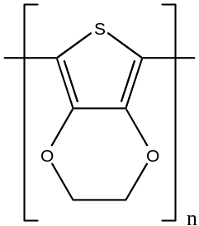
Scheme 1 poly(3,4-ethylenedioxythiophen) PEDOT.

The remainder of the paper is organized as follows. First we discuss issues of incorporation of deMon2k into PUPIL. Then we discuss the empirical ZM correction procedure for HOMO-LUMO gaps. The fourth section reports on the PEDOT-doping study as well as a comparison with other QM codes to show the stability of the newly implemented interface, while the fifth section has a brief summary of computing performance. We conclude with a concise summary and commentary.

Interface Implementation
Recently some of us and co-workers have reported the incorporation of both the AMBER 10 and Gaussian03 codes¹³ in the PUPIL inventory.² The motivation of the present work is to provide an alternative QM code designed and built purely for DFT calculations with orbital-independent XC functionals and good parallelism, namely deMon2k.³ Doing so gives access within PUPIL to the MD and analysis facilities in either AMBER 10 or DL_POLY.¹⁴ The parallel implementation of deMon2k provided in PUPIL by this work is via “Start-Stop” mode for the QM calculations. In PUPIL Start-Stop mode, the QM calculation is started fresh at each MD step. It then runs to completion, whereupon its output files are parsed by PUPIL to obtain the energy and forces information which is then transmitted to the MD code.
Implementation of the deMon2k interface for PUPIL involves three software updates. One is to the PUPIL core itself. The other two are to the software and physics interfaces for the QM parallel worker. Recall that in the computer science vocabulary adopted in PUPIL, a “worker” is the implementation of PUPIL functionality specific to a particular user package. The user package then has the role of a PUPIL “calculation unit” or “CU”. At present, workers are implemented in JAVA. See Ref.¹) The distinction between the software and physics interfaces was introduced in the general treatment of the QM/MD AMBER-PUPIL-QM_worker interface,² as follows. The software interface addresses the interaction between the PUPIL libraries and the worker code, with responsibility for the exchange of current simulation information among the software partners. Conversely, the physics interface implements a particular QM/MD scheme, most often, a particular choice of link or pseudo-atoms by which the QM and classical regions are coupled. Ordinarily, addition of a new worker to the PUPIL inventory would require only those two. However, in the present case a third actor is involved because the QM worker is no longer solitary but is in fact a set parallel QM workers (corresponding to the parallel CUs) interacting with the PUPIL system. The PUPIL core thus has been enhanced to allow the management and distribution of available resources among the workers involved in each simulation. We consider these changes in order.
PUPIL core
One of the fundamental goals in the PUPIL design is that the software system would be able to manage several workers on the fly. That implies the provision of general resource management from the PUPIL core, including maintaining up-to-date knowledge of the state of the simulation. Requisite information might include, for instance, the number of operating CUs and the number of processors being used by each one of those CUs, as well as the free processor units still available to be assigned to a specific CU. To keep the information related to resources utilized in memory, several specialized Java classes have been added to the PUPIL server manager class diagram (Conceptual Model). This class diagram is a static view of the system which follows Unified Modeling Language (UML)¹⁵ standards in the Object Oriented approach. The aim is to deal with CUs as well as both assigned and free processors for the current simulation. Figure 2 shows a class diagram detail for storing computational resources with the new Java classes (squares), relationships (lines between boxes), and their multiplicity (numbers or stars) following UML standards.¹⁵ The main ResourceManager Java class has two composition relationships; corbaServers and freeProcessors. The first stores all the active CORBA server Calculation Units references in the system (PUPIL worker servers waiting for client petitions). The second composition relationship stores the identities of all the free processors not yet assigned. Identities of all the processors (ProcessorResource) already assigned to a specific CORBA server (CU and worker, CorbaServerResource), are stored through another composition relationship (usedProcessors). Thus, two sets of specialized classes are used to specify the kind of available and/or already used resource identities to be stored; ProcessorResource and CorbaServerResource. Those resources are contained in a list of resources using a composition modeling (ResourceList).
Prior to starting any parallel worker, the parallel environment must be initiated in accordance with local hardware and software cluster characteristics and policies. A startup shell script is generated from the PUPIL core following a user-provided shell script template which incorporates those local cluster characteristics and policies. An example would be the MPI environment commands to get the worker running in the local hardware environment and the execution syntax for the corresponding CU.
Software interface
The software interface in this implementation is restricted to building the input and output parsers adequate to handling the deMon2k input and output files. These parsers exchange information with the PUPIL core in order to support the QM-MD particle identification mapping specific for the deMon2k package. They also exchange information with the new specialized (to this CU) JAVA classes to store simulation data specific to this CU (here, deMon2k).
Physics interface
The physics interface implementation follows closely the scheme of the previous QM/MD implementation² for Amber-PUPIL-Gaussian. The major difference from that implementation is found in the so-called forces-over-point-charge (“QZ-PC correction for PC”) calculation.² Recall that the physical issue arises from embedding. So far as forces on the QM zone atoms are concerned, the classical zone atoms appear as a set of embedding point charges. The issue is to recover the forces on those classical zone atoms due to the QM zone atoms, something not ordinarily done in molecular QM codes that support classical-array embedding. In the case of Gaussian, the QZ-PC correction calculation was done via representation of the electron density on a dense point grid using the so-called “Cube” file. The calculations used Java threads on shared-memory (SMP) machines. In this work we have implemented a new MPI program called pcforce. Though external to PUPIL, it will be distributed as a tool together with the PUPIL release. It takes advantage of big Non-Uniform Memory Architecture (NUMA) cluster machines to calculate the forces-over-point-charges contribution. This new application is aimed at being a general, faster implementation to obtain the QZ-PC correction which is independent of the specific QM CU used. As might be expected, deMon2k stores the electron density on a grid in a format different from that used in the Gaussian Cube file. However, they are similar. Thus the external MPI application can be modified easily to treat input electron density files in either format.

Theory (Band gap correction)
Various computationally cheap ways to avoid the DFT band gap problem (a misnomer; it is a problem of approximate functionals) have been proposed, ranging from rigid shifts (“scissors operator”) to self-interaction corrections, to various modified Hamiltonians and density functionals. Review of that extensive and somewhat complicated literature is beyond the scope of the present work. Initially we chose to follow the frankly empirical ZM scheme.¹¹ It is based on the DFT IP theorem: for the exact XC functional the K-S HOMO is the negative of the IP of the neutral ground state or the EA for the negative ion ground state.¹⁶ Therefore, the exact gap is related to the exact KS eigenvalues by
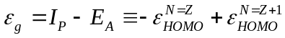 | (1)
The frozen-orbitals assumption, namely that the LUMO of the neutral system is approximately the HOMO of the anionic system, then leads to the exploration of possible simple relationships between the HOMO and LUMO eigenvalues from an approximate XC functional and the exact IP and EA. For a small set of relatively simple molecules (C₂H₂, CH₄, CO, H₂, HF, C₆H₆, C₁₀H₈, C₁₄H₁₀, H₂O, NH₃) ZM indeed found a linear relationship, namely
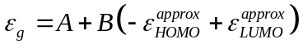 | (2)
with A and B empirical constants.
For the PW91 XC functional^{17,18} and a fairly large basis, ZM reported A=-0.079 eV, B=1.04. With the deMon2k code, a 6-311++G** KS basis set¹⁹⁻²¹ and the deMon 2k GEN-A2* auxiliary basis, we redid the calculations. We were unable to reproduce the ZM results, even after very careful checking. Investigation showed that the problem is mostly a result of the strong sensitivity of the LUMO eigenvalue to the KS basis. This finding contradicts a claim of ZM. A stark illustration is provided by H₂. For H, the 6-311++G** basis set differs from the 6-311+G(d,p) set used by ZM by having only one more diffuse s-type function (orbital exponent 0.036). That addition alone is enough to reduce the HOMO-LUMO gap (PW91 XC functional) by more than 0.7 eV. The deMon2k values are 11.66 eV [6-311+G(d,p)] vs. 10.80 eV [6-311++G**] while the corresponding Gaussian-03 values are 11.40 eV and 10.67 eV. The difference between results from the two codes illustrates a second problem with the LUMO energies. Since DFT variational optimization affects only the occupied KS orbitals, there is no guarantee that different algorithms will yield the same LUMOs. The problem is particularly acute for those cases, such as H₂ in PW91, for which the LUMO energy is positive. For such levels, the KS basis forces the representation of what is properly a scattering state onto an L² state. It is not particularly surprising that the outcome is highly dependent on the details of the KS basis and algorithmic details of matrix element formation. (As an aside, we also are unable to reproduce the ZM value for the HOMO-LUMO gap in anthracene with either basis and either code.)
To use the ZM procedure therefore, one must calibrate the parameters A, B in Equation (2) not only to a chemically relevant set of molecules and the selected XC functional, but also to the basis sets to be used. Even with that there is a problem related to fundamentals of DFT. A straight-forward fit to our data (See Table 1) for the ZM molecule set yields A = -0.8312 eV, B = 1.1869. With these parameters, any bare KS HOMO-LUMO gap below 0.700 eV would be “corrected” to a nonsensical negative value. But as a matter of principle, bare HOMO-LUMO gaps from a so-called continuous exchange-correlation functional (such as PW91) must be too small compared to the experimental ε_{gap}. This is because of two facts. The omitted derivative discontinuity is positive and the spurious self-interaction in such functionals pushes the HOMO energy up from where it should be.^{5,7,8,22} All proper ZM-style corrections therefore must have a positive intercept, A > 0. Any fit, including ZM's to their PW91 data (see their Figure 3) or ours (just given) will improperly reduce small bare band gaps.
Thus we must force the fit to have a positive intercept. That intercept should be small compared to any relevant gap so that a near-zero bare HOMO-LUMO gap becomes something like an 0.1 eV or smaller ε_{g} Examination of our bare HOMO-LUMO gaps shows that three of them (CO, C₂H₂, C₆H₆) are substantially bigger than ε_{g}, a violation of the basic theory. This is an indication that that the use of a consistent basis set has forced the LUMO up artificially in these cases. Therefore, one might consider ignoring these three molecules in the ZM style fit but the result is not satisfactory: A= -0.2847 eV, B = 1.1805. Since the value of an enforced positive intercept is arbitrary, we simply pick an obvious small value, about +0.05eV. The motivation is that in the MD runs it is possible to force the polymer plus solvent into a temporary configuration which is virtually metallic but we want to ensure that in such a case the corrected electronic levels go metallic because the bare levels did in fact go metallic. We get A = 0.0501 eV, B = 1.0670. We show all three fits (original bare fit, three-molecules-omitted fit, and forced-positive-intercept) in Figure 3.

Illustrative Study
To demonstrate the deMon2k capability in PUPIL we chose simulation of a short conducting polymer made of six 3,4-ethylenedioxythiophen (EDOT) monomers in explicit acetonitrile solvent. Two cases were considered: un-doped and doped by introducing a ClO₄K molecule in the system. The ClO₄⁻ has been shown to be a doping ion in the EDOT polymerization²³ stabilizing a charge of 0.54 electrons per monomeric unit from electrogenerated and oxidized polymer, confirming its salt structure. We present some geometry parameters and electronic properties such as the energy gap and the charge transfer between oligomer and doping moiety. Because of the expensive nature of the calculations presented here, much longer runs on the test cases with more highly refined models would be needed before quantitative assertions could be made, though the qualitative outcomes are quite reasonable. The results given here primarily illustrate the capabilities of the new parallel interface as well as bringing to light an interesting and potentially important issue regarding the anioncally doped system.
Technical Details
The PEDOT system (Figure 1) was built using the LEaP program from the Amber suite. The polymer was solvated in a box with 747 acetonitrile molecules. This is enough solvent molecules to provide a 15 Å buffer region around the oligomer. The doped PEDOT system was obtained by adding a potassium perchlorate molecule (ClO₄K). The acetonitrile model of six explicit atoms developed by Grabuleda et al.²⁴ and the perchlorate model developed by Baaden et al.²⁵ were employed in the classical simulations. Both of them are fully compatible with the General Amber Force Field (GAFF)²⁶ model which was used for the rest of the classical system forces. For the doped system, maintenance of the 15 Å buffer region around the doped oligomer required use of 897 acetonitrile molecules. The system first was energy-minimized for 1500 steps and heated from 0 to 298 K during 5ps of simulation using a Langevin thermostat with a collision frequency of 8.0 ps⁻¹ and a cutoff radius of 12 Å for non-bonded pairs. Finally, the system was brought to 1 atm pressure for another 150 ps, using a pressure relaxation time of 1.0 ps (in the NPT ensemble) in order to adjust the solvent density to the experimental value 0.777 g cm⁻³ appropriate to 298 K. In comparision, the actual final theoretical equilibrated density was 0.744 g cm⁻³. The perchlorate moiety (ClO₄⁻) in the doped system was constrained to lie within about 3.5Å of one of the central PEDOT thiophene rings during the whole initial system equilibration. The SHAKE algorithm²⁷ was used in all the classical calculations (except in the energy minimization process) to restrict bond distances for those bonds involving hydrogen atoms. Finally, two central PEDOT monomers were treated as quantum entities for the QM/MD calculation. We used two levels of QM treatment for the quantum zone, as follows. Initial trajectories of 1400 and 5000 steps were run for the doped and un-doped systems, respectively, with a time step of 1 fs using the Local Spin Density (VWN) DFT approximation and effective core potentials (RECP-SD). Every 20 fs, a snapshot was extracted to provide the geometry with which to calculate the electronic properties with a more refined (“higher level”) calculation. Those single-point calculations were done using the PW91 correlation-exchange functional, a 6-311++G** basis, and the deMon2k auxiliary density basis set designated GEN-A2*; consistent with the ZM calibration discussion above.
Results
Figure 4 shows the temperature (top), the variation of potential energy with respect to the first step (middle), and Mulliken charge for each one of the moieties (PEDOT and perchlorate ion) from the doped system (bottom). The stress due to mixing of different kinds of forces induces an increase in the potential until it reaches a new equilibrium point. Observe that the effect is more rapid in the non-doped structure than in the doped one. This could be due to the doping of PEDOT induced by the ClO₄⁻ ion, which seems to give rigidity. Figure 5 shows the evolution of the dihedral angle θd (see Figure 1) over the long and short QM/MD trajectory. After a short equilibration time, the dihedral angle is stabilized around 153º with an average value of θd=152.9±7.0º for the last 2.5 ps. of simulation. Also, no big differences were observed between doped and un-doped dihedral angle evolution. The doping effect of perchlorate ion upon thiophene-based conducting polymers has been studied previously²⁸ with all-QM methodology. That study showed that the perchlorate ion induces charge transfer from the polythiophene conducting polymer to the doping ion in order to stabilize a planar form closer to that of the radical cation state (intermediate structure between quinoid and benzoid) than to that of the neutral state (benzoid canonical form). In the same way, we have observed a planar form, similar to that previously reported by Alemán et al.²⁸ for the PEDOT-ClO₄⁻ complex performing a quantum mechanical geometry optimization with the same DFT approximations as those used in the current QM/MD simulation (data not shown).
The Mulliken charges of PEDOT and ClO₄⁻ moieties are shown in Figure 4 (bottom). A charge transfer from PEDOT to the ClO₄⁻ moiety is observed. This is in agreement with the tendency previously reported in the literature,²³ namely that PEDOT monomeric units support average positive charges close to 0.54, balanced with ClO₄⁻ counterions. The band gap evolution obtained using the higher level of calculation (recall prior discussion) for both the long and short QM/MD simulation is shown in Figure 6. Although the charge is equilibrated after 1ps of simulation, the band gap is still oscillating at the end of the current test calculations. We find that the ZM-style HOMO-LUMO correction does not change the general features of the gap evolution but does broaden the range of gap variation, as might be expected. The extended PEDOT in explicit acetonitrile trajectory (see Figure 6a) shows an initial equilibration time of around 1 ps. This is followed by a band gap oscillation close to 1.1±0.4 eV for the last 2.5 ps. A peculiarity of the band gap evolution with time for both doped and un-doped systems is the enlargement of the gap in the neighborhood of 1 ps. Whether this is a physical phenomenon is a question beyond the scope of the present deMon2k-PUPIL demonstration simulation.
For the sake of understanding the stability of outcomes with respect code choice as well as get a sense of performance, we also did a short QM/MD simulation using the AMBER-PUPIL-Gaussian03 interface, previously developed by some of us.² The starting point was the nuclear configuration at the middle of the previous simulation of PEDOT in explicit acetonitrile (non-doped system) which used the AMBER-PUPIL-deMon2k interface. The comparison run was carried out for 0.15 ps. Averaged geometrical parameters from both simulations were extracted, as listed and compared in Table 2. There one can see the quite satisfactory result that the averaged geometries from the two calculations exhibit only small differences. Most of them are smaller than the standard deviation of their averaged value. This confirms that the QM model adopted (in this case, a simple DFT approximation) is represented properly by either code and that both are integrated properly by the PUPIL interfaces.
We encountered an interesting and challenging simulation problem whose resolution is outside the scope of this study. With either QM code, SCF convergence exhibited similar behavior. The non-doped system does not exhibit any problems converging the quantum zone. In contrast, the doped system generates SCF convergence difficulties for both codes. With either deMon2k or Gaussian03, it is increasingly difficult as time evolves to get enough SCF stability in the doped system to extend the simulation beyond 1.4 ps. We suspect that the problem is destabilization of anions by spurious self-repulsion in the simple DFT exchange-correlation approximations.²⁹ Since the main goal of our test calculations is to illustrate the capabilities of the new parallel interface, a separate study should be addressed to study the model chemistry best suited to tackle longer simulations of this doped system in order to extract better scientific conclusion that are beyond the scope of this work.

Performance Considerations
An unusual aspect of performance overhead is introduced by the external calculation of quantum forces on the point charges (recall discussion above). We used a SMP dedicated machine to study this usage. The calculations were carried out using up to eight processors for the QM and forces-over-point-charges calculations, with a total computational time of about 258 s per MD step. The results obtained are shown in Table 3. In that tabulation, the whole MD step has been split into the three main time consuming processes; quantum mechanical calculation (deMon2k), creation and writing of the density file (Density wr.), and forces-over-point-charges correction (pcforce). The results shown are better than those obtained in the previous work² which reported the new interface between PUPIL and Gaussian 03. In that case, about 50% (8 processors) of the whole MD step was used by an internal PUPIL implementation through Java threads. This improvement is achieved spite of the increased time consumed by creating and writing the density file from deMon2k. That overhead becomes relatively less significant as the system size is increased because there is a fixed amount of time involved.

Conclusions
In this work we have successfully added (“plugged in”) deMon2k as a new parallel PUPIL-supported package for quantum calculations in Start-Stop mode. An internal PUPIL core update has been done in order to support a general, parallel, distributed Calculation Unit. An External MPI code has been added to obtain the forces-over-point-charge (QZ-PC correction for PC) due to electron density from the quantum zone in the QM/MD scheme. A small-scale demonstration test using a short conductor oligomer (PEDOT) in explicit acetonitrile confirms the potential utility of the new PUPIL functionality. The band gap and geometry and charge transfer were extracted and compared from a short QM/MD trajectory applying two different levels of DFT approximations.

This work demonstrates the utility of the PUPIL interface in combining new efficient parallel packages such as deMon2k (and earlier, Amber 10) into a unified QM/MD scheme, taking advantage of extended Non-Uniform Memory Architecture clusters in order to reach complex and bigger systems. User documentation and source code for this new interface will be made available soon at the PUPIL webpage (http://pupil.sourceforge.net) as part of the continuing PUPIL open-source project.

Acknowledgment
OB and JT were supported in part by MCYT and FEDER (Grants MAT2006-04029 and MAT2009-09138), and by the Generalitat de Catalunya (Grants 2009-SGR-925 and XRQTC) and SBT by US NSF grant DMR0325553 and US DOE grant DE-SC-0002139.. Thanks especially to Andreas Köster (Cinvestav, Mexico City) of the deMon collaboration for technical assistance. We are indebted to the Centre de Supercomputació de Catalunya (CESCA) and to the University of Florida High-Performance Computing Center for computational facilities.
References
1. Torras, J.; He, Y.; Cao, C.; Muralidharan, K.; Deumens, E.; Cheng, H.-P.; Trickey, S. B. Comput Phys Commun 2007, 177(3), 265-279.
2. Torras, J.; Seabra, G. d. M.; Deumens, E.; Trickey, S. B.; Roitberg, A. E. J Comput Chem 2008, 29(10), 1564-1573.
3. Köster, A. M.; Calaminici, P.; Casida, M. E.; Flores-Moreno, R.; Geudtner, G.; Goursot, A.; Heine, T.; Ipatov, A.; Janetzko, F.; Campo, J. M. d.; Patchkovskii, S.; Reveles, J. U.; Salahub, D. R.; Vela, A.; deMon developers, 2006.
4. Trickey, S. B.; Green, F. R.; Averill, F. W. Phys Rev B 1973, 8(10), 4822.
5. Perdew, J. P.; Zunger, A. Phys Rev B 1981, 23(10), 5048.
6. Pickett, W. E.; Wang, C. S. Phys Rev B 1984, 30(8), 4719.
7. Perdew, J. P.; Levy, M. Phys Rev Lett 1983, 51(20), 1884.
8. Sham, L. J.; Schlüter, M. Phys Rev Lett 1983, 51(20), 1888.
9. Aulbur, W. G.; Jönsson, L.; Wilkins, J. W.; Henry, E.; Frans, S. Solid State Physics 1999, 54, 1-218.
10. Onida, G.; Reining, L.; Rubio, A. Rev Mod Phys 2002, 74(2), 601.
11. Zhang, G.; Musgrave, C. B. J Phys Chem A 2007, 111(8), 1554-1561.
12. Groenendaal, L.; Jonas, F.; Freitag, D.; Pielartzik, H.; Reynolds, J. R. Adv Mater 2000, 12(7), 481-494.
13. Case, D. A.; Darden, T. A.; T.E. Cheatham, I.; Simmerling, C. L.; Wang, J.; Duke, R. E.; Luo, R.; Crowley, M.; Walker, R. C.; Zhang, W.; Merz, K. M.; B.Wang; Hayik, S.; Roitberg, A.; Seabra, G.; Kolossváry, I.; K.F.Wong; Paesani, F.; Vanicek, J.; X.Wu; Brozell, S. R.; Steinbrecher, T.; Gohlke, H.; Yang, L.; Tan, C.; Mongan, J.; Hornak, V.; Cui, G.; Mathews, D. H.; Seetin, M. G.; Sagui, C.; Babin, V.; Kollman, P. A. In AMBER 10; University of California: San Francisco, 2008.
14. Smith, W.; Forester, T. R. J Molec Graphics 1996, 14(3), 136-141.
15. Object_Management_Group. Unified Modeling Language: Infrastructure
(version 2.1.1),OMG, 2007.
16. Levy, M.; Perdew, J. P.; Sahni, V. Phys Rev A 1984, 30(5), 2745.
17. Perdew, J. P. In Electronic structure of solids '91; Ziesche, P.; Eschrig, H., Eds.; Akademie Verlag: Berlin, 1991, p 11-20.
18. Burke, K.; Perdew, J. P.; Wang, Y. In Electronic Density Functional Theory: Recent Progress and New Directions; Dobson, J. F.; Vignale, G.; Das, M. P., Eds.; Plenum Press: New York, 1998, p 81-111.
19. Krishnan, R.; Binkley, J. S.; Seeger, R.; Pople, J. A. J Chem Phys 1980, 72(1), 650-654.
20. Clark, T.; Chandrasekhar, J.; Spitznagel, G. W.; Schleyer, P. V. R. J Comput Chem 1983, 4(3), 294-301.
21. Frisch, M. J.; Pople, J. A.; Binkley, J. S. J Chem Phys 1984, 80(7), 3265-3269.
22. Perdew, J. P. In Adv Quantum Chem; Trickey, S. B., Ed.; Academic Press, 1990, p 113-134.
23. Ocampo, C.; Oliver, R.; Armelin, E.; Alemán, C.; Estrany, F. J Polym Res 2006, 13(3), 193-200.
24. Grabuleda, X.; Jaime, C.; Kollman, P. A. J Comput Chem 2000, 21(10), 901-908.
25. Baaden, M.; Berny, F.; Madic, C.; Wipff, G. J Phys Chem A 2000, 104(32), 7659-7671.
26. Wang, J.; Wolf, R. M.; Caldwell, J. W.; Kollman, P. A.; Case, D. A. J Comput Chem 2004, 25(9), 1157-1174.
27. Miyamoto, S.; Kollman, P. A. J Comput Chem 1992, 13(8), 952-962.
28. Alemán, C.; Oliver, R.; Brillas, E.; Casanovas, J.; Estrany, F. Chem Phys 2005, 314(1-3), 1-7.
29. Rösch, N.; Trickey, S. B. J Chem Phys 1997, 106(21), 8940-8941.

Table 1. HOMO-LUMO gaps calculated directly from the energy difference between HOMO and LUMO eigenvalues (PW91 GGA). Experimental band gap is also reported.
 | E_{tot} (a.u.) | E_{HOMO} (a.u.) | E_{LUMO} (a.u.) | E_{g}^{HL} (eV) | E_{g}^{exp} (eV)
H₂ | -1.1749938 | -0.3809 | 0.0158 | 10.8 | 11.8
HF | -100.4530821 | -0.3560 | -0.0394 | 8.61 | 10.3
CO | -113.3083775 | -0.3365 | -0.0806 | 6.96 | 6.40
H₂0 | -76.4332409 | -0.2662 | -0.0393 | 6.17 | 7.10
NH₃ | -56.5588082 | -0.2236 | -0.0308 | 5.25 | 5.72
C₂H₂ | -77.3156865 | -0.2678 | -0.0161 | 6.77 | 5.23
CH₄ | -40.5077102 | -0.3475 | -0.0146 | 9.06 | 10.9
C₆H₆ | -232.221949 | -0.2325 | -0.0443 | 5.12 | 4.72
C₁₀H₈ | -385.849995 | -0.2023 | -0.0767 | 3.42 | 3.99
C₁₄H₁₀ | -539.480177 | -0.2012 | -0.0770 | 3.38 | 3.31

Table 2. Comparison of time-averaged geometries from the QM/MM simulations of PEDOT in explicit acetonitrile between deMon2k and Gaussian03 packages, using Local Spin Density (VWN) DFT approximation and effective core potentials (RECP-SD) in the quantum zone.
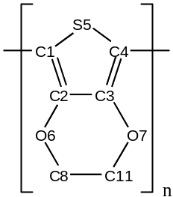
 | deMon2k | Gaussian03 | |diff| | |%diff|
Bondsª
C4C1 | 1.422±0.026 | 1.442±0.023 | 0.020 | 1.4
S5C4 | 1.828±0.039 | 1.833±0.032 | 0.005 | 0.3
C3C4 | 1.375±0.028 | 1.392±0.024 | 0.017 | 1.3
O7C3 | 1.397±0.043 | 1.403±0.041 | 0.006 | 0.4
C8C11 | 1.508±0.025 | 1.534±0.025 | 0.026 | 1.7
Angles^{b}
S5C4C1* | 118.5±2.7 | 118.9±2.7 | 0.4 | 0.4
O7C3C4 | 119.9±1.6 | 119.9±1.8 | 0.0 | 0.0
O7C11C8 | 110.0±2.9 | 110.6±2.6 | 0.6 | 0.6
Dihedrals^{c}
S5C4C1*S5* | 147.9±4.1 | 146.5±2.4 | 1.4 | 1.0
ª Bond distances in Å, ^{b} Angles in degrees, ^{c} Dihedrals in degrees, * Atom label belonging to the next monomer

Table 3. Time process percentage for the main processes involved into a Molecular Dynamics PUPIL step in a dedicated machine.
n. processors | deMon2k | Density wr. | pcforce
1 | 40 | 19 | 41
2 | 45 | 18 | 37
4 | 55 | 25 | 20
8 | 60 | 28 | 12

Figure captions
Figure 1. Demonstration system: Doped PEDOT in explicit acetonitrile solvent (left) and the detail of the quantum zone considered in the QM/MD (right).
Figure 2. Class diagram detail to store and manage computational resources in a PUPIL parallel execution such as current PUPIL workers and free processors.
Figure 3. Calculated HOMO-LUMO gaps (ε_{g}^{HL}, eV) versus experimental (ε_{g}^{exp}, eV) lowest excitation energies (blue diamond). Also original bare fit (black line), three-molecules-omitted fit (green line) and forced-positive-intercept (red line) linear regressions are shown (see text).
Figure 4. Temperature (top) and variation of the potential energy from the first step (middle), in both figures, doped (solid line) and non-doped (dashed line) systems are shown. Mulliken charge time evolution (bottom) of PEDOT (solid line) and ClO4- moieties (dashed line) are shown.
Figure 5. S-C-C-S dihedral angle (θd) of PEDOT versus time, where (top) full time simulation of non-doped (dashed line) system and their comparison (bottom) between doped (solid line) and non-doped (dashed line) systems are shown
Figure 6. Evolution of the energy gap of the quantum zone applying our empirical correlation (see text), where (top) full time simulation of non-doped (dashed line) system and their comparison (bottom) between doped (solid line) and non-doped (dashed line) systems are shown.

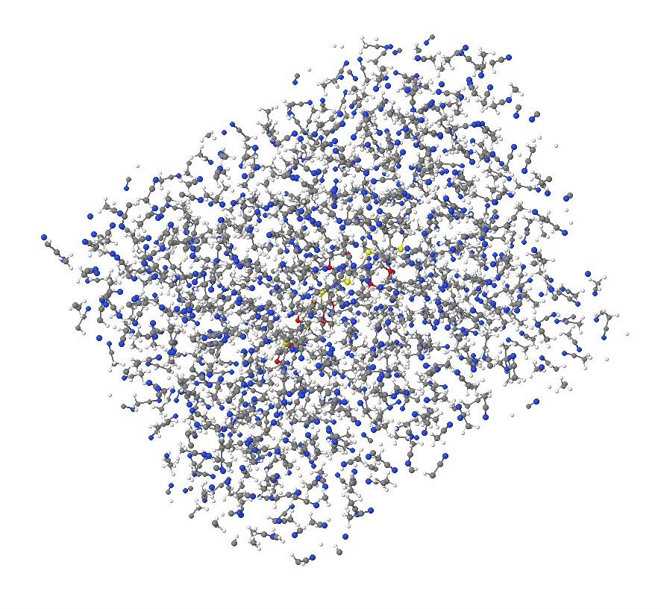
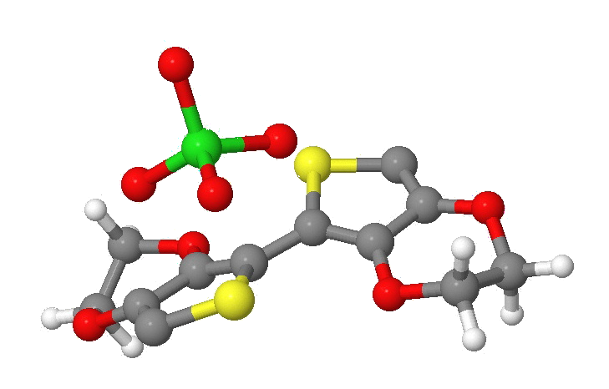
MD particles
Quantum zone
θ_{d}

Figure 1

ResourceManager
ResourceList
Resource
ProcessorResource
CorbaServerResource
0..*
1
1
1
1
1
corbaServers
freeProcessors
1
1
usedProcessors

Figure 2

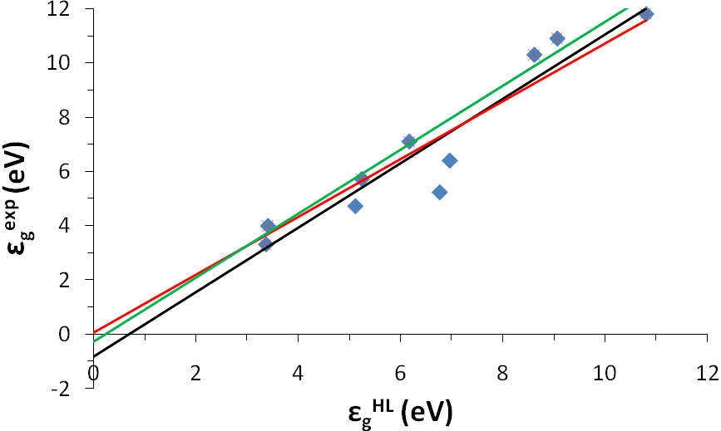

Figure 3

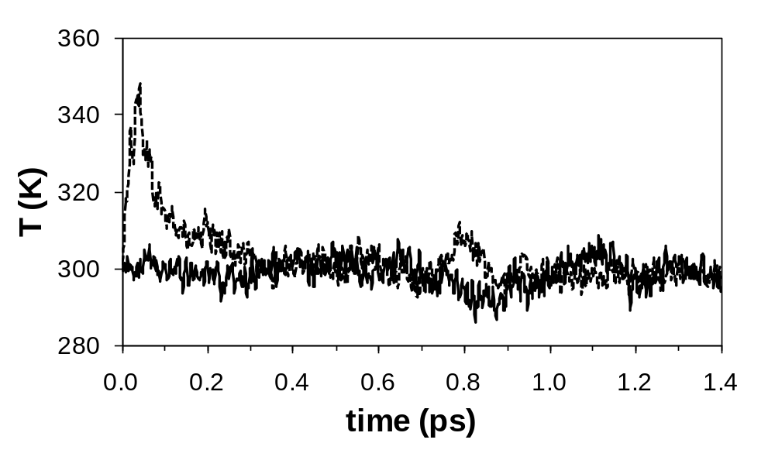
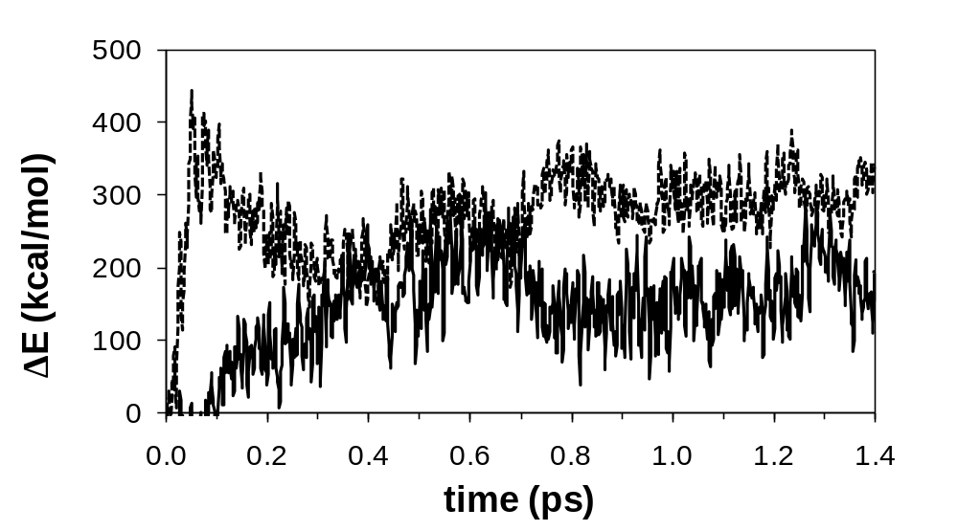
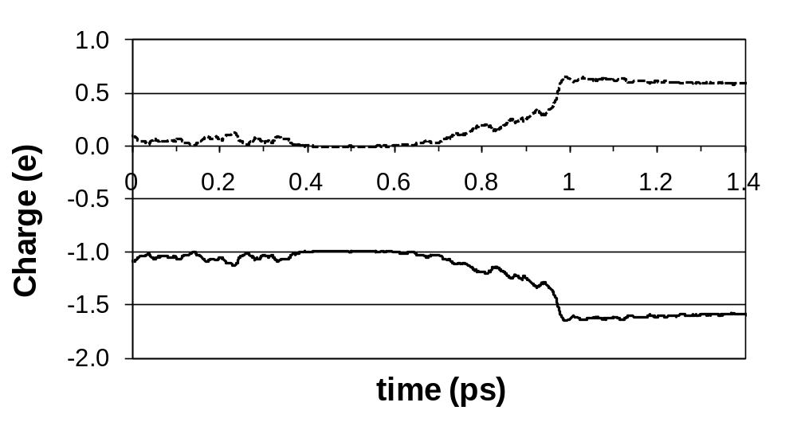

Figure 4

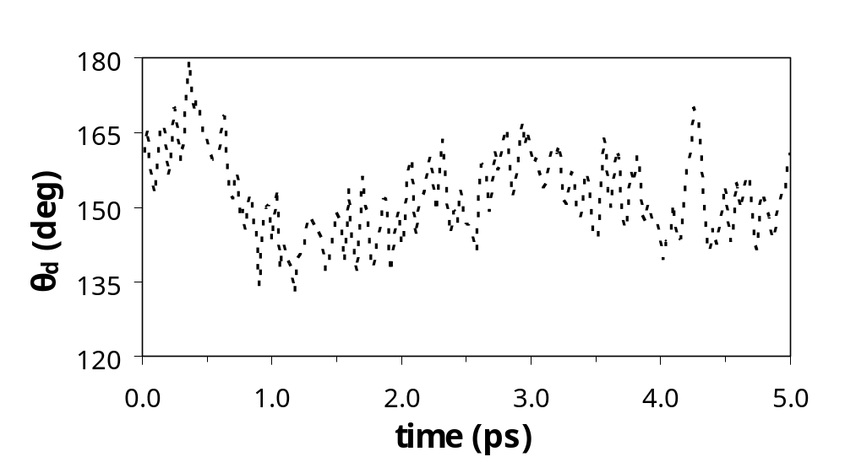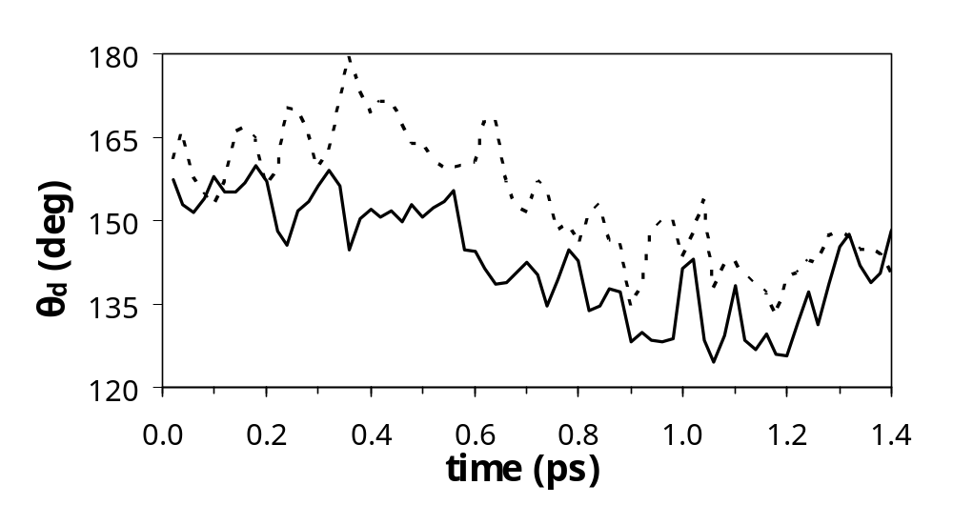

Figure 5

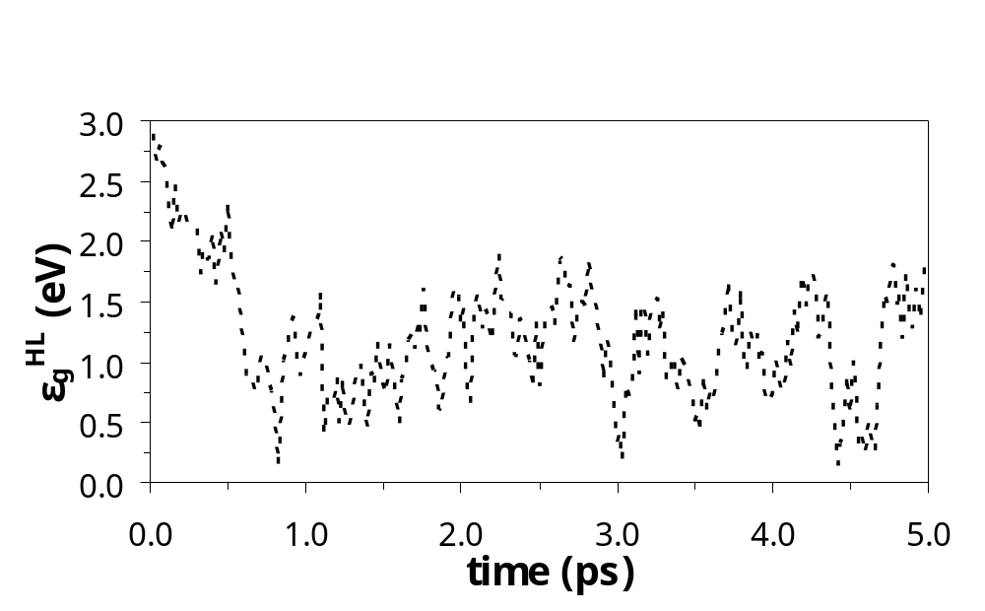
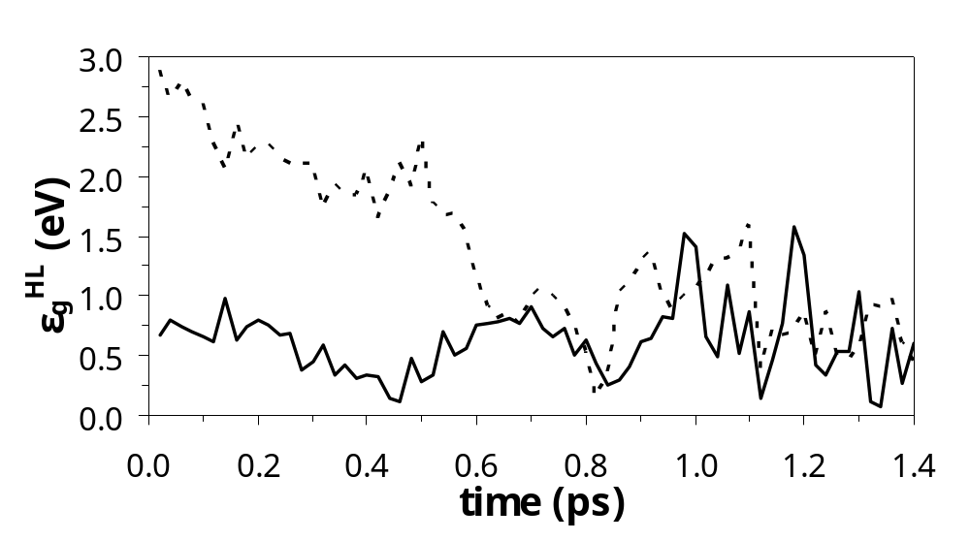
Figure 6

