CO preferential oxidation under H2-rich streams on copper oxide supported on Fe promoted CeO2

P.S. Barbato a , S. Colussi b , A. Di Benedetto c , G. Landi a,∗ , L. Lisi a , J. Llorca d , A. Trovarelli b

a Research Institute on Combustion-CNR, Naples, Italy
b Dipartimento di Chimica, Fisica e Ambiente, Università di Udine, Udine, Italy
c Department of Chemical, Materials and Industrial Production Engineering, Università di Napoli Federico II, Naples, Italy
d Institut de Tècniques Energètiques and Centre for Research in Nanoengineering, Universitat Politècnica de Catalunya, Barcelona, Spain

In this work the effect of Fe addition to copper/ceria catalysts on the catalytic activity toward CO-PROX reaction has been studied and related to the modiﬁcation of textural and redox properties induced by iron. Catalysts have been characterized by the use of BET surface area measure, X-ray diffraction (XRD), high-resolution transmission electron microscopy (HRTEM), X-ray photoelectron spectroscopy (XPS) and TPR with different reducing mixtures (CO/N2 and/or H2 /N2 ). Results show that iron promotes a superﬁcial enrichment of highly dispersed copper sites improving catalyst reducibility, especially under CO-containing mixture, thus resulting in an enhanced selectivity of CO-PROX reaction.

Introduction

Copper oxide supported on CeO2 is considered among the most active and selective catalyst for CO-PROX reaction at low temper- atures. The high activity of the CuO/CeO2 catalysts is related to the strong interfacial interaction between copper and cerium oxides [1–5]. It is widely accepted that CO oxidation over CuO/CeO2 occurs via copper (Cu2+/Cu1+) and cerium (Ce4+/Ce3+) redox cycles which are activated at the interface between copper oxide and the support through the oxygen exchange ability [3,5,6]. Moreover, TPR anal- ysis showed that copper–ceria sites are able to oxidize CO even at room temperature in the presence of H2 leading to an outstanding selective CO oxidation [3,7].
In the last years a lot of work has been carried out in order to enhance the performances of copper/ceria catalysts by modi- fying metal dispersion, enhancing metal-support interaction and increasing oxygen storage capacity [8–12]. The modiﬁcation of preparation method and the introduction of dopants are possi- ble approaches that can be used to improve the above mentioned properties in the ﬁnal catalyst material.
Among the potential dopants, the promoting effect of iron addi- tion to CeO2 or CuO/CeO2 mixed oxide has been studied [13–17].

It was found that the addition of Fe and Ni oxides increases the activity in CO-PROX reaction of the CuO/CeO2 catalysts with a low concentration of CuO due to the role of iron and nickel in the redox cycles [13]. Also, Bao et al. [14] reported that the higher catalytic activity in CO oxidation of Fe2O3–CeO2 composites compared to pure CeO2 and Fe2O3 was related to the density of surface oxy- gen vacancies promoted by iron addition. Sirichaiprasert et al. [15] compared the performance in the PROX reaction of Cu–Fe–Ce–O catalysts prepared by urea-nitrate combustion (UNC) and single step citrate method (SSC). They found that the catalysts prepared with the UNC preparation method show an increase of the surface area and the pore volume with a consequent increase of activity but a slightly lower selectivity; from these results they concluded that the presence of Fe improves the copper–ceria interaction. Fe-doped CuO/CeO2 catalyst prepared via citrate sol–gel method was also tested in the low temperature CO oxidation [16]. They concluded, in agreement with previous studies [14,15], that the addition of Fe decreases the crystalline size of ceria and increases the surface area, thus resulting in a large number of more active superﬁcial oxygen species. Similarly, Lendzion-Bielun et al. [17] reported that ceria supported bimetallic Fe–Cu catalyst showed the best morphologi- cal features and catalytic performance although copper reducibility was lower than that of the Cu monometallic catalyst [17]. As a con- sequence the authors concluded that a high copper reducibility prevails on metal dispersion in providing good catalytic perfor- mance only for monometallic sample.

From the analysis of the literature, it thus appears that a clear
HIN
OUT

demonstration of the effect of iron on copper morphological and chemical properties has not been addressed. Only in [17] by XRD and TEM measurements the Authors claimed a reduction of CuO
xH2 =
2 − H2
IN 2
H
L1OCO
2

COIN − COOUT
(3)

particle size upon Fe addition, but no correlation with the reducibil-
SCO = CO
H2 = 0.5 × IN
OUT
(4)

ity was found on Fe–Cu catalysts.
L1O2 + L1O2
O2 − O2

In this work we also observed a signiﬁcant increase of the selectivity in CO-PROX reaction when copper is dispersed on Fe- promoted CeO2 support. For that reason, for the ﬁrst time, a detailed morphological characterization of catalysts and reducibil- ity analysis using both H2 and CO were carried out to address the modiﬁcations induced by Fe addition on the physical and mor- phological nature of supported copper and on the interaction of copper with the two species involved in the desired and undesired oxidation reactions of CO-PROX process.

Materials and methods

  - Catalysts preparation

The catalysts prepared throughout this study are character- ized by deposition of copper on ceria and on iron-promoted ceria support. This is in contrast to previous works, where catalysts for- mulations containing Cu and Fe on ceria were prepared mainly by one-pot synthesis [15,16] or by impregnation of iron and cop- per precursors [13,17]. Ceria and iron (5 wt%) promoted ceria were prepared by precipitation/coprecipitation starting from the corre-
sponding nitrate precursors. The precipitates were dried at 120 ◦C
and then calcined at 500 ◦C for 2 h to obtain the fresh support mate-
rials (indicated as CeO2 and CeO2–Fe, respectively). CuO (4 wt% nominal content, approximatively corresponding to the theoretical monolayer value) was then deposited onto the supports surface by wet impregnation using copper nitrate (Aldrich) as precursor. The copper content was chosen according to [3]. After impregnation the
samples were dryed overnight at 120 ◦C followed by calcination at
where xCO, xO2 , xH2 and SCO are, respectively, the CO, O2 and H2 conversions and the O2 selectivity to CO2 and SO2CO and SO2H2
the oxygen moles consumed for CO and H2 oxidation, respectively.

2.3. Catalyst characterization

The actual Cu metal content was determined by means of ICP- MS analysis using an Agilent 7500CE instrument. The surface and bulk morphologycal characterizations were carried out by surface area analysis, XRD, XPS and high-resolution transmission electron microscopy (HRTEM). BET surface areas of supports and catalysts were measured by N2 adsorption at 77 K with a Quantachrome
Autosorb-1C instrument after degassing the samples at 150 ◦C for
1.5 h. X-ray diffraction spectra were collected with a Philips X’Pert diffractometer equipped with an X’Celerator detector with Cu-Kcx radiation. The measurements were carried out with a step size of
0.02◦ and a counting time of 80 s per step. X-ray photoelectron spec-
troscopy (XPS) was performed with a SPECS system equipped with an Al anode XR50 source operating at 150 W and a Phoibos 150 MCD-9 detector. Spectra were recorded with pass energy of 25 eV
at 0.1 eV steps at a pressure below 5 10−12 bar. Binding energies
were referred to the adventitious C 1 s signal at 284.8 eV.
Fresh and used samples for HRTEM studies were mounted on standard grids with a holey-carbon ﬁlm. A JEOL JEM 2010F micro- scope with a ﬁeld emission gun (200 kV, 0.19 nm point-to-point resolution) was used for microstructural characterization. Electron energy loss spectra (EELS) were obtained with a Gatan Image Filter (GIF 2000) coupled to the microscope.
Reducibility of supports and catalysts was studied by Tempera-
ture Programmed Reduction (TPR) analysis carried out in a quartz

450 ◦C for 2 h to obtain the fresh catalysts (indicated as CuO/CeO2
and CuO/CeO2–Fe, respectively).
ﬁxed bed reactor using mixtures containing 2 vol.% H2
or 1 vol.%

2.2. Activity tests

The lab-scale set-up used for CO-PROX experiments was described elsewhere [18]. The powder catalyst (300 mg) with 180–300 μm particle size was placed in a tubular quartz reac- tor. A thermocouple placed inside a tube co-axial with the reactor provided the temperature measurement of the catalyst. The tem- perature was controlled by inserting the reactor into an electric tubular furnace (Lenton) provided with a PID-type controller. An ice bath based condenser and a CaCl2 trap were used to dry the gaseous ﬂow downstream to the reactor; the dried ﬂow was analyzed in a Fisher–Rosemount NGA2000 continuous analyzer to measure CO, CO2, H2 and O2 concentrations.
Catalytic tests were conducted at ﬁxed ﬂow rate (20 slph) with a
contact time equal to 0.054 g/(s cm3). Hydrogen, carbon monoxide and oxygen concentrations were set at 50, 0.5 and 0.9 vol.%, respec-
tively. Reaction temperature ranged from 80 to 220 ◦C to explore
the whole temperature range of interest for CO-PROX. Mass balance was always closed within ±4%. Reactants conversions and selec-
tivity of oxygen reacting with carbon monoxide were calculated according to the following equations:
COIN − COOUT
CO in N2 with a total ﬂow rate of 14 slph, loading 0.3 g of sample
with a particle dimension of 180–300 μm. For each catalyst three
TPR cycles were performed. Before each run the sample was oxi- dized with 10 vol.% O2 at 450 ◦C and then purged with N2 at room temperature. In all TPR tests the sample was heated at 10 ◦C/min up to 450 ◦C, maintaining the ﬁnal temperature for 1 h. Because CO-PROX occurs at temperatures between 80 and 200 ◦C, we did not investigate reducibility at temperatures higher than 450 ◦C. TPR
tests co-feeding 2 vol.% H2 and 1 vol.% CO were also carried out on pre-oxidized samples after the third hydrogen TPR run. Hydrogen and carbon monoxide uptakes and CO2 production were monitored using a Fisher–Rosemount NGA2000 continuous analyzer to mea- sure CO, CO2, H2 and O2 concentrations. Due to the sensitivity of the analyzing system toward water vapor, H2O was separated from the gas mixture upstream of the analyzer by a CaCl2 trap.

Results

  - Catalytic activity

In Fig. 1 CO conversion and selectivity are plotted as a function of the temperature for the CuO/CeO2 and CuO/CeO2–Fe catalysts and for the CeO2–Fe support. A negligible activity was found for
the CeO2 support up to approximately 250 ◦C, in agreement with

xCO =

OIN

COIN

OUT
(1)
literature data [3,13,17,18].
Both catalysts exhibit almost total conversion at temperature higher than about 120 ◦C, with the promoted catalyst showing a

xO2 =
2 − O2
IN 2
O
(2)
slightly higher conversion. The main difference is found in the selectivity values: the CuO/CeO2–Fe catalyst has 100% selectivity

100

80

60
Xco, %

40

20

(a)

0

100

(a)

80

60
Sco, %

40

20

(b)

0
60 80 100 120 140 160 180 200 220

Temperature, °C

Fig. 1. CO conversion (a) and selectivity (b) as a function of temperature. Symbols: (•) CuO/CeO2 ; (e) CuO/CeO2 –Fe; (•) CeO2 –Fe.

up to 120 ◦C, while the selectivity of CuO/CeO2 catalyst does not
exceed 80% in the temperature range investigated. The CeO2–Fe support shows a signiﬁcant activity (30% conversion at 200 ◦C)
with a remarkable selectivity also due to the low conversion value (see Fig. 2). CuO/CeO2–Fe catalyst maintains a very high selectiv- ity (100%) up to 80% CO conversion while the CuO/CeO2 catalyst is less selective. The improvement of both activity and selectivity of CuO/CeO2–Fe agrees well with results of Lendzion-Bielun et al. [17] for copper impregnated on commercial Fe doped ceria and those of Firsova et al. [13] for a catalyst prepared by subsequent impregnation of ceria with Fe and then with copper. However, our catalysts, both promoted and unpromoted, show better perfor- mances in terms of conversion and selectivity compared to previous investigations [13,17].
On the contrary, Sirichaiprasert et al. [15] found that the selec- tivity attained over ternary Cu–Fe–Ce–O oxides was lower than the corresponding one over Cu–Ce–O catalysts; however these
composite oxides were prepared or by urea-nitrate combustion or by single step citrate method that are known to give rise to com- plex interactions between the metal and the support-promoter, different from the situation of the samples object of this work.

  - Characterization

    - Textural and structural data
In Table 1 the BET surface areas of supports and catalysts are given. The speciﬁc surface areas (SSA) of both supports are slightly reduced by copper deposition of about 20%, despite the copper oxide loading does not exceed the theoretical monolayer value. It is worth noting that the SSA of our samples is higher than those reported in the literature [13,17]. This allows to deposit larger amout of well dispersed copper oxide, thus explaining in part the superior activity of our catalysts. Elemental analyses revealed that

100

80

60
sco, %

40

20

0
0 20 40 60 80 100

xco, %

Fig. 2. Selectivity to CO2 as a function of CO conversion. Symbols: (•) CuO/CeO2 ; (e) CuO/CeO2 –Fe; (•) CeO2 –Fe.

Table 1
Actual metal content, SSA and crystallite dimension.
containing sample undergoes a copper surface enrichment after reaction which does not occur over the CuO/CeO2 sample.

Sample Actual Cu content, wt%
SSA, m2 /g Crystallite
dimension, nma
The Fe/Ce ratio is negligible in the fresh sample while signiﬁ-
cant in the used sample, suggesting that exposure of the promoted

CeO2 – 55
CeO2 –Fe – 60
CuO/CeO2 4.2 45 13
CuO/CeO2 –Fe 3.9 49 9
a As calculated by Scherrer’s equation.

Table 2
Cu/Ce, Fe/Ce and Cu/(Cu + Ce + Fe) ratios from XPS analysis.

Sample | Cu/Ce | Fe/Ce | Cu/(Cu + Ce + Fe)
Fresh CuO/CeO2 | 0.21 | – | 0.17
Used CuO/CeO2 | 0.24 | – | 0.19
Fresh CuO/CeO2 –Fe | 0.14 | n.d. | 0.12
Used CuO/CeO2 –Fe | 0.33 | 0.15 | 0.22

both fresh and used samples have metal contents close to the nom- inal values (Table 1).
In Fig. 3 XRD proﬁles of the Fe-doped and undoped catalysts are shown. XRD features allow to detect only the CeO2 Fm3m cubic phase while Fe2O3 or other iron oxide phases and features related to CuO, Cu2O or Cu were not detected. XRD peaks are broad and the values of crystallite size obtained according to Scherrer equa- tion are about 9 nm for sample CuO/CeO2–Fe and 13 nm for sample CuO/CeO2. The lack of signals due to iron oxide could indicate the formation of solid solution between Ce and Fe. However, the larger fraction is located as free Fe2O3 or Fe2O3 encapsulated by ceria not detectable by XRD (see XPS/HRTEM). In agreement, it is known that lower valence ions such as Fe3+ are extremely difﬁcult to dissolve into the ceria lattice, especially when treating at high temperature [19]. Mutual dissolution of Ce and Fe into Fe2O3 and CeO2 has been reported to exist only in Fe-rich Ce/Fe mixed oxides prepared by co-precipitation [20].

    - X-ray photoelectron spectroscopy (XPS)
In Table 2 the results of XPS analysis are reported for both fresh and used samples. The Cu/Ce ratio increases in the used Fe-doped sample with respect to the fresh sample, suggesting that the iron
sample to reaction mixture causes also an iron surface enrichment as a consequence of the migration of iron encapsulated into the ceria lattice toward catalyst surface. A direct comparison between Cu/Ce ratios of samples containing or not Fe is not possible due to the different fraction of surface Ce which can be reduced by the presence of iron in CuO/CeO2–Fe, thus leading to a misinterpreta- tion of the Cu/Ce ratio. Trying to overcome this issue, in Table 2 the Cu/(Cu + Ce + Fe) ratios are given. It appears that the surface of the used CuO/CeO2–Fe is richer in copper than the unpromoted sam- ple, suggesting a larger copper dispersion due to iron addition in agreement with previous studies [14,15,17].
The higher copper dispersion of iron promoted sample revealed by XPS analysis can be directly related to the improved perfor- mance of this catalyst. As a matter of fact, highly dispersed copper species in close contact with ceria are responsible for CO oxidation. Fig. 4 shows the Cu 2p spectra recorded over the samples before and after reaction. The spectrum corresponding to the CuO/CeO2 sam- ple after reaction is quite similar to that recorded over the fresh
sample, with Cu 2p3/2 and Cu 2p1/2 binding energies at about 933.0 and 953.0 eV, respectively, which are ascribed to Cu2+ species. The
spectrum recorded over the fresh CuO/CeO2–Fe sample does not allow for a proper analysis, according to the low amount of Cu at the surface (Table 2). After reaction, the spectrum of the CuO/CeO2–Fe sample reveals again the presence of Cu2+ at 933.0 eV. However, the photoelectron peaks are broader in the CuO/CeO2–Fe sample with respect to CuO/CeO2, which is an additional indication of a strong Cu–Fe interaction in the former.

    - High-resolution transmission electron microscopy (HRTEM)
HRTEM was performed on both fresh and used catalysts. A general view of the fresh sample prepared by impregnation on Fe- doped support is shown in Fig. 5A, along with electron diffraction pattern showing the spacing of CeO2 (111) at 3.12 Å and (200) at
2.71 Å. The sample is comprised by homogeneous crystallites of
about 2–12 nm in size, in agreement with crystallite size calculated from XRD spectra. High magniﬁcation images of the fresh sample are shown in Fig. 5B. Several types of particles are identiﬁed on

Cu/CeO2-Fe fresh
Intensity (a.u.)

Cu/CeO2 fresh

20 30 40 50 60

2 teta (degrees)

Fig. 3. XRD spectra of CuO/CeO2 and CuO/CeO2 –Fe samples.

the basis of their lattice fringes. In addition to CeO2 crystallites, particles of Fe2O3 and CuO are present as well, in contrast with XPS analysis giving a very low Fe detectability. These are charac- terized by lattice fringes at 3.68 Å (planes (0 1 2) of Fe2O3) and at
2.31 Å (planes (2 0 0) of CuO), which do not overlap with the spac-
ing of the CeO2 support. It is interesting to note that in this sample CuO particles are well identiﬁed and measure about 5–8 nm. The CuO/CeO2–Fe sample after reaction is virtually identical to the fresh sample. Fig. 5C and D show HRTEM images of the sample after reac- tion. Similar CeO2, Fe2O3 and CuO particles are encountered with similar sizes. No Cu2O phase is identiﬁed, which may be explained if reduced Cu is mainly located at the surface of CuO particles.
A general HRTEM view performed on CuO/CeO2 for compari- son is reported in Fig. 6A. It shows a low magniﬁcation image of the fresh sample which is comprised by ceria crystallites of about

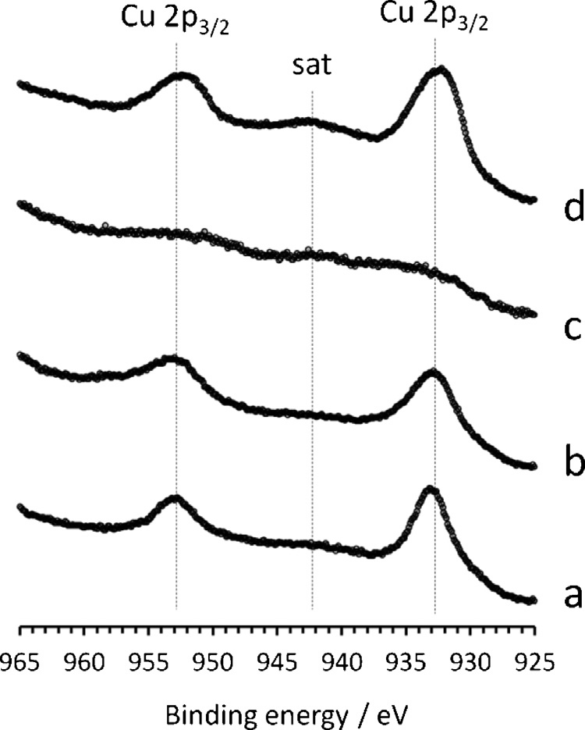

Fig. 4. Cu 2p XPS spectra of CuO/CeO2 (a: fresh, b: used) and CuO/CeO2 –Fe (c: fresh, d: used) samples.
6–10 nm in size. In this sample, CuO particles are clearly recog- nized in the HRTEM images. As an example, Fig. 6B shows lattice fringes of several particles. At 3.12 Å the (1 1 1) planes of CeO2 are evident for most particles. In addition, lattice fringes at 2.31 Å cor- respond to (2 0 0) planes of CuO. Most Cu oxide particles measure around 5–8 nm. Essentially the same phases and morphology as well as particle size are encountered in the sample after reaction. Fig. 6C shows HRTEM images of the used sample. Again, only CuO is detected.
It is worth noting that CuO and Fe2O3 were not observed by XRD, nor Fe2O3 was detected in the fresh sample by XPS, although some CuO and Fe2O3 nanoparticles were identiﬁed in all the samples by HRTEM. This is likely due not only to their small dimensions but also to their low amount and/or poor crystallinity, suggesting the for- mation of a relatively low number of nanoparticles well dispersed onto the ceria surface.

    - Temperature programmed reduction (TPR)
      - H2–TPR.
Fig. 7 shows the H2–TPR proﬁles of iron promoted support and catalyst compared to that obtained on unpromoted copper/ceria. In good agreement with [17,21] a main peak centered at about
385 ◦C with a shoulder at about 260 ◦C is detected for CeO2–Fe, with
the reduction starting at about 180 ◦C, a temperature signiﬁcantly
lower than that of unpromoted ceria [3]. Two peaks centered at 165 ◦C and 210 ◦C were found for the iron promoted catalyst. By
comparing the proﬁle of CuO/CeO2–Fe with that of the support it can be assumed that most of the H2 consumption can be addressed
to copper, since iron reduction starts at about 200 ◦C. The com-
parison with the TPR of the CuO/CeO2 catalyst suggests that the presence of iron delays the reduction of copper when hydrogen is used as the reducing agent. This is in contrast with the results of Lendzion-Bielun et al. [17] who observed a shift to lower tempera- ture for the reduction of ceria supported bi-metallic Cu–Fe catalyst, but it is in agreement with the enhanced selectivity of the Fe- promoted sample which starts to interact with H2 at a temperature
about 35 ◦C higher compared to the copper catalyst.
By repeating the TPR after a re-oxidation of the samples, we observed the presence of a new peak at about 450 ◦C for the iron
promoted support and catalyst (not reported). This peak can be

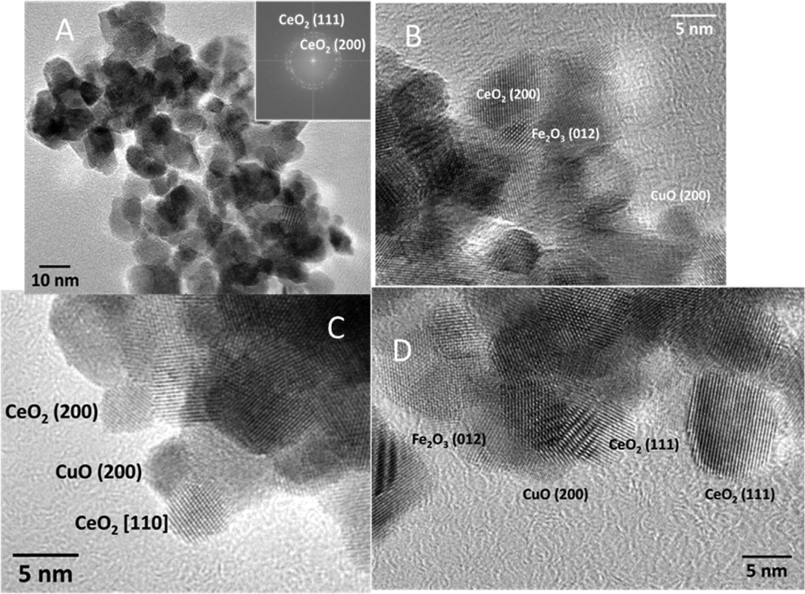

Fig. 5. HRTEM of fresh (A: general view; B: high magniﬁcation) and used (C: general view; D: high magniﬁcation) CuO/CeO2 –Fe sample.

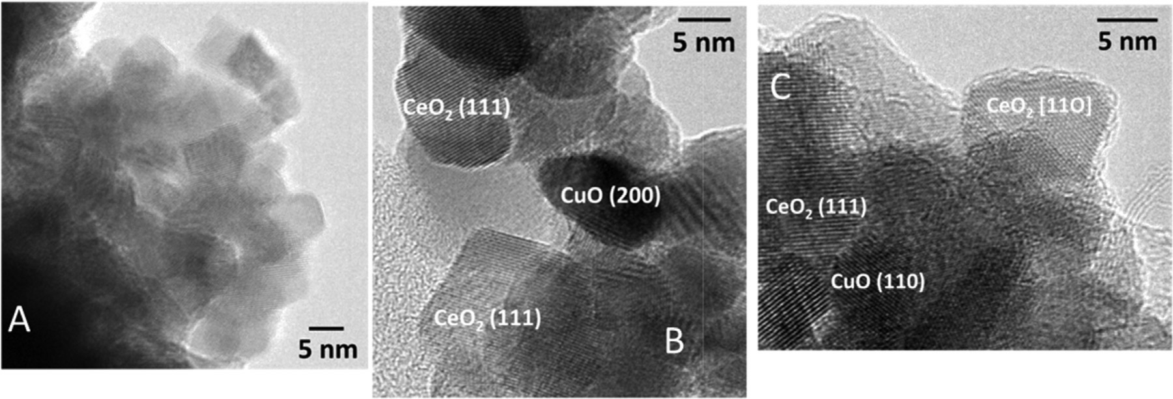

Fig. 6. HRTEM of fresh (A: general view; B: high magniﬁcation) and used (C: high magniﬁcation) CuO/CeO2 sample.

Table 3
Total H2 and CO uptakes, CO2 production and corresponding M (H2 ; CO; CO2 )/(Cu + Fe) ratios for different TPRs on CeO2 –Fe, CuO/CeO2 –Fe and CuO/CeO2 .

Reducing agent |  | CeO2 –Fe |  |  | CuO/CeO2 –Fe |  |  | CuO/CeO2
 |  | Uptake | Ma /(Cu + Fe) |  | Uptake | Ma /(Cu + Fe) |  | Uptake | Ma /(Cu + Fe)
H2 |  | 872 | 1.35 |  | 1293 | 1.05 |  | 784 | 1.49
CO |  | 1568 | 2.36 |  | 1604 | 1.43 |  | 894 | 1.70
H2 + CO | H2 | 129 | 0.20 |  | 188 | 0.15 |  | n.v.b | –
 | CO | 1152 | 1.78 |  | 2046 | 1.66 |  | 814 | 1.55
 | CO2 | 977 | 1.51 |  | 1370 | 1.11 |  | 839 | 1.59
- Molecule = H2 ; CO; CO2 .
- Negative value.

assigned to iron oxide reduction; as suggested by XPS and HRTEM analyses, iron is extracted from the ceria structure under reducing environment and, as a consequence, iron oxide is produced during the re-oxidation of the sample. These results are in agreement with previous literature ﬁndings [19,20].
H2 consumed has been calculated in the whole temperature range investigated in TPR tests (Table 3) or up to T = 300 ◦C (Table 4)
for the copper containing catalysts. The total amount of hydrogen consumed during TPR, assigned to copper reduction, is higher for CuO/CeO2–Fe. For this sample the H2/(Cu + Fe) ratio is close to 1 if the integration of the TPR curve is extended up to the end of the experiment, indicating a further reduction of the catalyst. If
the integration is carried out only up to 300 ◦C the H2/(Cu + Fe)
ratio is equal to about 0.85. If we exclude cerium contribution to

8000

6000

CuO/CeO2-Fe
CeO2-Fe
CuO/CeO2

4000
H2 uptake, ppm

2000

0
0 100 200 300 400

Temperature, °C

Fig. 7. H2 TPR proﬁle of CuO/CeO2 –Fe compared with those of CeO2 –Fe and CuO/CeO2 (proﬁle of CuO/CeO2 from [3]).

Table 4
Partial H2 and CO uptakes, CO2 production and corresponding M (H2 ; CO; CO2 )/(Cu + Fe) ratios for different TPRs on CeO2 –Fe, CuO/CeO2 –Fe and CuO/CeO2 .

Reducing agent |  | Final T, ◦ C | CeO2 –Fe |  |  | CuO/CeO2 –Fe |  |  | CuO/CeO2
 |  |  | Uptake | Ma /(Cu + Fe) |  | Uptake | Ma /(Cu + Fe) |  | Uptake | Ma /(Cu + Fe)
H2 |  | 300 | – | – |  | 989 | 0.85 |  | 784 | 1.49
CO |  | 25 | 26 | «0.1 |  | 242 | 0.48 |  | 163 | 0.31
H2 + CO | H2 | 200 | – | – |  | 192.5 | 0.16 |  | 216.6 | 0.41
 | CO |  | 148.2 | 0.23 |  | 418 | 0.34 |  | 609.3 | 1.16
 | CO2 |  | 89.8 | 0.14 |  | 421 | 0.34 |  | 464.2 | 0.88
a Molecule = H2 ; CO; CO2 .

the reduction occurring up to 300 ◦C H2/(Cu + Fe) ratio = 0.85 well agrees with the complete reduction of copper from Cu2+ to Cu0 and
with that of iron from Fe3+ to Fe2+ in the hypothesis that all cop- per is in the +2 oxidation state. Nevertheless, a partial reduction of the surface ceria is very likely to occur, thus suggesting that a part of copper could be in a lower oxidation state (Cu+) as expected for copper/ceria systems [22–24]. Even if hydrogen consumption on Fe-promoted catalyst is higher than that obtained on CuO/CeO2, H2 to metal ratio is lower due to the signiﬁcant iron contribution to the sample reducibility.
3000

2500

2000

1500

1000

      - CO–TPR.
In Fig. 8 CO uptake and CO2 and H2 production are shown as function of temperature, as determined during CO–TPR run over
CeO2–Fe. For CO uptake a main peak was found at T = 260 ◦C while
a smaller peak was recorded at the end of the heating phase.
CO consumption and CO2 formation are roughly in phase up to the end of the heating ramp. In addition, at about 400 ◦C a peak
of H2 is detected which can be addressed to the activation of the water gas shift reaction (WGS) between surface hydroxyls and CO, as also found for pure ceria [3].

500
CO uptake, ppm
CO2 production, ppm
H2 production, ppm

0

100 200 300 400

Temperature, °C

Fig. 8. CO-TPR proﬁle of CeO2 –Fe.

It can be concluded that the presence of iron signiﬁcantly increases CO uptake and decreases the temperature of CO con- sumption compared to the unpromoted ceria [3].
In Table 3 the CO consumed subtracting the WGS contribution is reported. It can be observed that on CeO2–Fe support the total CO consumption is about 2 times higher than that of H2. The com- parison between H2 and CO TPR results, both in terms of reduction temperature and of CO and H2 uptake, suggests that on the Fe- promoted support the oxidation of CO is more favorable than that
of H2. Furthermore, differently from what observed during H2–TPR, in this case ceria contribution to the reduction must be invoked since the amount of CO consumed exceeds by 1.5 the theoretical amount [3,7].
In Fig. 9a the CO–TPR of CuO/CeO2–Fe is shown and compared to those of the CeO2–Fe and CuO/CeO2 in terms of CO2 evolution in the gas phase. The peaks recorded over the Fe-promoted sup- port shift at lower temperatures over the CuO/CeO2–Fe sample. It should also be observed that differently from the support (CeO2–Fe)

4000

a)

3000

CuO/CeO2
CuO/CeO2-Fe
CeO2-Fe
10000

b)
9000

8000

7000
CO uptake, ppm
CO2 production, ppm

6000
CO2, ppm

2000
5000

4000

1000
3000

2000

1000

0
100 200 300 400

Temperature, °C
0
0 2 4 6 8 10

time, min

Fig. 9. (a) CO TPR proﬁle of CuO/CeO2 –Fe compared with those of CeO2 –Fe and CuO/CeO2 (proﬁle of CuO/CeO2 from [3]); (b) CO consumption at room temperature on CuO/CeO2 –Fe (the dashed line represents the reactor hold-up).

a signiﬁcant CO uptake at room temperature without CO2 emission is found (Fig. 9b). This peak is not fully addressable to the reactor hold-up (dashed line) and it is typical of copper/ceria catalysts and related to highly dispersed Cu species [3]. Moreover, as observed for H2 oxidation, CO oxidation starts at higher temperature for the Fe- promoted CuO/CeO2 sample compared to the unpromoted catalyst. Nevertheless, the extent of temperature shift is lower for CO oxida- tion with a consequent enhanced difference between the activation temperature of CO and H2 oxidation for CuO/CeO2–Fe.
The total CO consumption and the CO adsorbed at room tem-
perature on CuO/CeO2–Fe are compared with that of CeO2–Fe and CuO/CeO2 in Tables 3 and 4, respectively. The total CO uptake for CuO/CeO2–Fe is higher than that calculated for the CeO2–Fe sup- port (1604 vs. 1568 ppm) but the additional CO consumed is not enough to reduce copper if the CO uptake of the support is assumed unaltered. Consequently, as discussed before, it is not possible to assign the different peaks to copper or iron oxides or even to pro-
moted ceria. On the contrary, CO consumption at 25 ◦C, ascribed
to the presence of copper as in the case of the CuO/CeO2 sample [3], increases in the presence of iron suggesting a higher exposition of copper able to adsorb CO at room temperature in CuO/CeO2–Fe sample which could be Cu(I) already present in the fresh sample or formed by the interaction with CO.
The Fe-promoted sample shows a CO2 production lower than that of the CuO/CeO2 catalyst in the temperature range 100–160 ◦C
(Fig. 9). However by further increasing the temperature, the CO2 production becomes higher in the Fe containing sample. This obser- vation is in agreement with the catalytic results reported in Section
3.1 and showing better CO-PROX performances of the CuO/CeO2 sample at low temperature whereas CuO/CeO2–Fe provides the best performances at higher temperature.
reducibility up to 250 ◦C. Independently from the sample, the
simultaneous presence of CO and H2 signiﬁcantly reduces the amount of H2 consumed, whereas CO uptake increases, exceeding the values obtained during CO-TPR and, thus, suggesting a positive effect of hydrogen feeding on the reducibility by carbon monoxide. Concerning the CuO/CeO2–Fe catalyst, the presence of copper pro-
vides a well detectable single H2 peak at about 185 ◦C. Although the
peak temperature is intermediate between those of the two peaks observed at low temperature in the standard H2–TPR, this signal can be addressed to copper reduction.
CO proﬁle during mixed H2–CO TPR shows a different evolution compared to the standard CO-TPR. A broad peak can be detected
with maximum at about 100 ◦C, while another peak is centered
at about 180 ◦C, similarly to CO-TPR, but without the pronounced
shoulder between 200 and 300 ◦C. The appearance of a third CO
uptake peak can be detected between 300 and 400 ◦C, indicating
that in presence of hydrogen CO consumption takes place in three steps, the most relevant being the one at high temperature.
In general, it can be concluded that the interaction of the catalyst with CO starts about 100 ◦C before the interaction with H2, thus
explaining the good selectivity found for Fe-promoted catalysts. This is mostly related to the interaction of iron with CO favoring the catalyst oxidation at temperatures lower than those of activation of copper sites.
Overall, the reducibility of CuO/CeO2–Fe increases with respect to CuO/CeO2, due to iron contribution (see Table 3), even if the
reducibility at low temperature (T ≤ 200 ◦C) of the unpromoted
sample is slightly higher than that of the Fe-promoted one under
both carbon monoxide and hydrogen (Table 4). This result can explain the higher low temperature activity of CuO/CeO2, but par- tially fails if we consider the higher selectivity of the CuO/CeO2–Fe catalyst. In this respect, it is worth noting that at the peak temper- ature of H2 reduction on CuO/CeO2 (green line in Fig. 10; i.e., at the

      - H2–CO TPR.
The results of TPR simultaneously feeding H2 and CO are shown
maximum reduction rate) H2
consumption over the CuO/CeO2–Fe

in Fig. 10. The quantitative data evaluated from the integration of the curves are given in Table 3. The apparent negative hydrogen consumption over CuO/CeO2 is due to the simultaneous occur- rence of the water gas shift reaction at high temperature, prompted by the presence of CO as observed during CO-TPR. From Fig. 10, it appears that iron promotion of the copper/ceria catalyst does not provide a signiﬁcant qualitative difference in the sample
sample has not started yet, while on the same sample CO con-
sumption is lower but not negligible with respect to that measured on the unpromoted catalyst, indicating a preferential and earlier interaction of CuO/CeO2–Fe with CO.
By comparing the above results to the catalytic performance
(See Section 3.1), we can conclude that the higher selectivity of the iron promoted sample is related to its ability to shift the activation

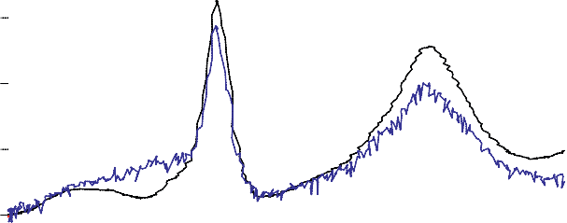5000
a)
4000

3000

2000

1000

0
5000
b)

4000
CO uptake, ppm
CO2 production, ppm
H2 uptake, ppm

3000

2000

1000

0
5000
c)
4000

3000

2000

1000

0

100 200 300 400

Temperature, °C

Fig. 10. H2 –CO TPR proﬁle of CeO2 –Fe (a), CuO/CeO2 –Fe (b), CuO/CeO2 (c). (For interpretation of the references to color in the text, the reader is referred to the web version of this article.)

of hydrogen at higher temperatures with respect to the unpro- moted catalyst. According to the characterization results reported in this work, the behavior recorded on CuO/CeO2–Fe is due to (1) the higher dispersion of copper with lower amount of larger CuO domains, related to hydrogen oxidation, and (2) a larger fraction of copper strongly interacting with ceria, responsible for carbon monoxide oxidation.
It should be underlined that by H2–CO TPR we were able to relate the modiﬁcations of reducibility to structural and catalytic properties on Fe-promoted sample; this is not allowed by studying reducibility by H2 TPR alone, as reported in [17].

Conclusions

The effect of iron addition to ceria used as support of copper- based catalyst for preferential oxidation of carbon monoxide in
hydrogen rich streams was studied. Fe-promoted sample showed improved catalytic performance, especially in terms of selectivity. As a consequence a complete characterization of the Fe-promoted catalyst was performed and the results were compared to that of CuO/CeO2.
The study of the physical characteristics of the samples revealed
that iron addition to ceria promotes copper dispersion. As a mat- ter of fact, surface copper concentration increased and, at the same time, copper oxide particle size reduced, both suggesting an increased number of copper sites in close contact with ceria (CO oxi- dation sites) and a reduced number of CuO clusters (H2 oxidation sites).
The study of the reducibility of the iron promoted cata- lyst through temperature programmed reduction under different reducing atmospheres showed that CuO/CeO2–Fe is reduced at relatively higher temperature with respect to the unpromoted cat-

alyst, independently of the reducing mixture. Nevertheless, some features can be related to the higher selectivity of the iron promoted catalyst and to its lower activity at low temperature. In particular, CO uptake at room temperature (not associated to CO2 evolution) and related to highly dispersed copper sites is higher on the pro- moted catalyst. In addition, the increased difference between the onset temperature of reduction with CO and H2 better deﬁnes con- ditions under which CO/H2 oxidation takes place under reaction. Accordingly, under reducing mixture containing both H2 and CO, hydrogen consumption is signiﬁcantly delayed on the iron pro- moted sample, conﬁrming that the higher selectivity of this catalyst is due to a reduced number of hydrogen oxidation sites showing a lower activity as well.
In conclusion, iron addition to ceria is an effective method to improve the copper dispersion in copper/ceria catalysts. The smaller copper oxide particle size obtained on the iron promoted catalyst guarantees a larger number of CO oxidation sites and con- sequently higher selectivity in the CO-PROX reaction.

Acknowledgements

This work was ﬁnancially supported by Italian MIUR (FIRB2010 “Futuro in Ricerca”, project no. RBFR10S4OW). J.Ll. is Serra Húnter Fellow and is grateful to ICREA Academia program.

References

[1] G. Sedmak, S. Hocevar, J. Levec, J. Catal. 213 (2003) 135–150.
[2] J.B. Wang, W.-H. Shih, T.J. Huang, Appl. Catal. A Gen. 203 (2000) 191–199.
[3] T. Caputo, L. Lisi, R. Pirone, G. Russo, Appl. Catal. A Gen. 348 (1) (2008) 42–53.

[4] W. Liu, M. Flytzani-Stephanopoulos, J. Catal. 153 (1995) 317–332.
[5] A. Martínez-Arias, A.B. Hungría, G. Munuera, D. Gamarra, Appl. Catal. B Environ. 65 (2006) 207–216.
[6] A. Martínez-Arias, D. Gamarra, M. Fernández-García, A. Hornés, P. Bera, Zs.
Koppány, Z. Schay, Catal. Today 143 (2009) 211–217.
[7] A. Martıı´nez-Arias, M. Fernández-Garcıı´a, O. Gálvez, J.M. Coronado, J.A. Anderson, J.C. Conesa, J. Soria, G. Munuera, J. Catal. 195 (2000) 207–216.
[8] X. Tang, B. Zhang, Y. Li, Y. Xu, Q. Xin, W. Shen, Catal. Today 93–95 (2004) 191–198.
[9] G. Avgouropoulos, T. Ioannides, H. Matralis, Appl. Catal. B Environ. 56 (2005) 87–93.
[10] Z. Liu, R. Zhou, X. Zheng, J. Nat. Gas Chem. 16 (2007) 167–172.
[11] Z. Liu, R. Zhou, X. Zheng, J. Nat. Gas Chem. 17 (2008) 283–287.
[12] L.H. Reddy, G.K. Reddy, D. Devaiah, B.M. Reddy, Appl. Catal. A Gen. 445–446 (2012) 297–305.
[13] A.A. Firsova, A.N. Ilichev, T.I. Khomenko, L.V. Gorobinskii, Yu V. Maksimov, I.P. Suzdalev, V.N. Korchak, Kinet. Catal. 48 (2) (2007) 282–291.
[14] H. Bao, X. Chen, J. Fang, Z. Jiang, W. Huang, Catal. Lett. 125 (2008) 160–167.
[15] K. Sirichaiprasert, A. Luengnaruemitchai, S. Pongstabodee, Int. J. Hydrog.
Energy 32 (2007) 915–926.
[16] S. Ma, G. Lu, Y. Shen, Y. Guo, Y. Wang, Y. Guo, Catal. Sci. Technol. 1 (2011) 669–674.
[17] Z. Lendzion-Bielun, M.M. Bettahar, S. Monteverdi, Catal. Commun. 11 (2010) 1137–1142.
[18] A. Di Benedetto, G. Landi, L. Lisi, G. Russo, Appl. Catal. B Environ. 142–143 (2013) 169–177.
[19] E. Aneggi, C. de Leitenburg, G. Dolcetti, A. Trovarelli, Catal. Today 114 (2006) 40–47.
[20] F.J. Perez-Alonso, M. Lopez Granados, M. Ojeda, P. Terreros, S. Rojas, T. Herranza, J.L.G. Fierro, M. Gracia, J.R. Gancedo, Chem. Mater. 17 (2005) 2329–2339.
[21] X. Liao, W. Chu, X. Dai, V. Pitchon, Appl. Catal. A Gen. 449 (2012) 131–138.
[22] G. Avgouropoulos, T. Ioannides, H. Matralis, J. Batista, S. Hocevar, Catal. Lett.
73 (2001) 33–40.
[23] S. Hocevar, U.O. Krasovec, B. Orel, A. Arico, H. Lim, Appl. Catal. B Environ. 28 (2000) 113–125.
[24] H. Zou, X. Dong, W. Lin, Appl. Surf. Sci. 253 (2006) 2893–2898.

