Bio/sonochemical conversion of fish backbones into bioactive fish protein hydrolysates nanospheres

Margarida M Fernandesª, Diana Riveraª, Antonio Franceskoª, Rasa Šližytė ^{b}, Revilija Mozuraitytė^{b}, Katariina Rommi^{c}, Raija Lantto^{c}, Tzanko Tzanovª

ª Grup de Biotecnologia Molecular i Industrial, Department d’Enginyeria Química, Universitat Politècnica de Catalunya, Rambla Sant Nebridi 22, 08222, España
^{b} SINTEF Fisheries and Aquaculture, Postboks 4762 Sluppen, N-7465 Trondheim, Norway
^{c} VTT Technical Research Centre of Finland Ltd, P.O. Box 1000, FI-02044 VTT, Finland

Abstract
Salmon backbones, co-streams of salmon processing industry, were transformed into stable, odour-free ingredients for cosmetics. First, the backbones were hydrolysed using commercial proteases (Bromelain+Papain, Trypsin, Corolase® 7089 and Protamex®) in order to accomplish the release of fish protein hydrolysates (FPH), which showed antioxidant activity and aptitude to inhibit skin-degrading and inflammatory enzymes. However, due to the FPH instability in aqueous solution and propensity for microbial contamination, their bioactive properties were entirely lost only after 24 h. To overcome the low stability and prevent the effect loss, a sonochemical technology was then employed to transform the FPH into stable tea tree oil-filled bioactive peptide-shell nanospheres (NS). Such transformation boosted the FPH antioxidant potential, which was further reflected in protection of fibroblasts from UV damage. In the form of NSs, the FPH resisted microbial contamination for more than 6 months and presented antimicrobial activity against Escherichia coli and Staphylococcus aureus. In addition, the fish odour was eliminated after the NSs processing, thus addressing this important challenge for using fish raw materials in cosmetics. This work suggests an alternative high value use of the fishery co-streams and expands their application potential beyond their current use as fish or animal feed.

Key words: salmon backbones, fish protein hydrolysates, biopeptides, nanospheres, anti-ageing

1. Introduction
Salmon processing industry creates large quantities of co-streams that include by-catch and parts of the fish that normally are not processed into food (heads, livers, guts, skins and bones). Despite the high content of valuable components such as proteins and lipids these co-streams contain, they are usually discarded or converted into low market-valued products, e.g. animal feed, fish meal and fertilizers [1]. Salmon backbones, in particular, represent a significant part of the cut offs from the fish filleting process that is currently processed into fish meal due to the high content of minerals that positively affect the growth and feed efficiency of aquaculture fishes [2]. Taking into consideration the proteinaceous nature of these still under-utilised rest materials, their alternative use as a resource for nutraceuticals and cosmoceuticals is a growing focus of interest [3,4]. New and valuable compounds can be extracted and purified from these co-streams and upgraded with technologies of varying complexity. One strategy that has been widely applied is the enzymatic hydrolysis of proteins. By cutting the protein into smaller fragments, peptides with enhanced biological activity may be obtained [4]. Fish protein hydrolysates (FPH) have been reported to present good amino acid balance [1] and nutritional properties [5–7] as well as antioxidative, antimicrobial, antihypertensive, anti-thrombotic and immunomodulatory activities [1]. However, the fish odour and low stability in aqueous medium, frequently associated with lipid oxidation and microbial contamination, pose a problem for their further exploitation [8].
Encapsulation techniques are commonly applied to address the stability challenge [9]. Multiple synthetic approaches are available to generate nanomaterials able to encapsulate bioactive compounds, but the use of methods such as the ultrasonic emulsification technique is gaining ground. This method involves mixing of a two-phase system at the oil/water interface with high intensity ultrasonic waves. An emulsion comprising oil-filled nanospheres (NSs) can be obtained in which the bioactive agent is found at the interface of the droplet, i.e. not encapsulated but the shell itself [10]. Besides maintaining the stability, nanospherisation in presence of oils assists the insertion of otherwise not penetrable bioactive agents in the dermis of the skin. In fact, the barrier function and lipophilic nature of the stratum corneum makes difficult the delivery of any large hydrophilic molecule into skin [11]. Thus, bioactive components processed into NSs may easily reach cellular proteins such as collagen and elastin as well as fibroblasts, all involved in the ageing process [12]. In addition, properties such as the small and uniform NSs size, large surface area to mass ratio and high reactivity aid to the desired application.
Skin is comprised of two main compartments: the avascular epidermis made up mostly by keranocytes and the vascularised matrix-rich dermis composed by sparsely distributed fibroblasts, which are responsible for the synthesis of dermal extracellular matrix (ECM) components [13]. With ageing, repetitive exposure to UV radiation or due to cutaneous inflammatory disease, major structural and functional changes occur in the ECM components, including the degradation of fibrillar collagens, elastic fibres (elastin and laminin) and loss of the oligosaccharide fraction [14]. Although known for their remarkable longevity, these biomolecules are affected by long-term and accumulated damage, which in turn results in the lowering of skin mechanical strength and elasticity [12,15]. The mechanisms that cause dermal damage ultimately lead to: i) the up-regulation of the ECM-degrading enzymes such as collagenases and elastases, and ii) cutaneous biomolecules damage that induces the overproduction of reactive oxidative species (ROS) and oxidative myeloperoxidase (MPO), which additionally damage proteins and DNA All these factors strongly contribute to skin ageing and/or development of many inflammatory skin disorders [14,16]. Therefore, an efficient strategy for skin care should comprise the control of collagenase, elastase and MPO activities, as well as the inhibition of free-radical formation and damage in fibroblasts.
This work aimed to obtain skin care ingredients from defatted salmon co-streams implementing a two-step valorisation process that combines enzymatic hydrolysis to enrich the mixture with bioactive peptides and sonochemical stabilisation of the bioactives via their nanospherisation. Being mainly used for nutritional purposes, residues from fish bones have never been applied in skin care. The generation of bioactive agents from fish co-streams has the advantage of adding value to something that is currently either discarded or turned into comparatively low-value products.

2. Materials and methods
2.1 Materials Fresh salmon (Salmo Salar) backbones were obtained from local fish shop in Trondheim (Norway) where fish was hand filleted. The raw materials were kept on ice before processing. Commercial protease products such as Corolase® 7089 (AB Enzymes GmbH), Protamex® (Novozymes A/S), Papain FG (Enzybel), Bromelain 400 GDU/g (Enzybel) and Trypsin (Sigma Aldrich) were received from the producer and used to produce FPHs. AlamarBlue® Cell Viability Reagent was purchased from Invitrogen, Life Technologies Corporation (Spain). Human foreskin fibroblasts cell line BJ-5ta (ATCC-CRL-4001) and bacteria strains of Escherichia coli (E. coli, ATCC 25922) and Staphylocoocus aureus (S. aureus, ATCC 35556) were purchased from American Type Culture Collection (LGC Standards S.L.U, Spain). All other chemicals were analytical/reagent or synthetic grade and were obtained from Sigma-Aldrich (Spain) and used without further purification.

2.2 Production of FPH Fresh salmon backbones were first minced and the oil fraction was separated by centrifugation after mild thermal treatment. The obtained mixture of soluble protein fraction and sediments was used for enzymatic hydrolysis using five commercially available proteolytic enzyme preparations: i) Corolase® 7089 (Source: Bacillus subtilisis, main activity: neutral metallloendopeptidase); ii) Protamex® (Source: Bacillus licheniformis, Bacillus amyloliquefaciens, main activity: alkaline serine endopeptidase); iii) Papain FG (Source: Carica papaya, main activity: cysteine endopeptidase); iv) Bromelain 400 GDU/g (Source: Ananas comosus, main activity: cysteine endopeptidase); and v) Trypsin (Source: Bovine pancreas, main activity: broad specificity endopeptidase). The enzyme treatments were carried out for 120 min at 50 °C in distilled water (1:1 of raw material mass), using an enzyme dosage of 0.1 % (w/w) of the raw material mixture. After heat inactivation of enzymes, the residual oil, emulsion, fish protein hydrolysate (FPH) and sludge fractions were separated by centrifugation. The FPH fractions were freeze-dried. Unhydrolyzed protein extract was used as a reference sample: it represents the profile obtained from the soluble protein fraction sample before the addition of commercial enzymes.

2.3 Characterization of FPH The protein content of FPH was determined using DC Protein Assay Kit (Bio-Rad) while the amount of amino acid cysteine was determined spectrophotometrically using 5,5′-dithiobis(2-nitrobenzoic acid) (Ellman’s reagent) following a procedure adapted from Ellman [17]. Briefly, 100 µL of a serial dilution of FPH in 0.5 M PB, pH 8.0, were added to 100 µL of Ellman’s reagent solution (0.3 mg/mL) in the same buffer in a 96-well plate. The samples were incubated for 1 h at room temperature in dark with gentle shaking. Absorbance was then measured at a wavelength of 412 nm, and the amount of free thiol groups were determined from a calibration curve obtained using L-cysteine standards. The degree of hydrolysis was evaluated as the proportion (%) of free α-amino nitrogen (i.e. peptides and free amino acids) with respect to the total N in the sample. Analyses were performed in duplicate. Protein was precipitated using sulfosalicylic acid and the supernatant was diluted using doubly distilled water. The samples were then analysed using reversed phase High Performance Liquid Chromatography (HPLC) (SIL-9A Auto Injector, LC-9A Liquid Chromatograph, RF-530 Fluorescence HPLC Monitor, Shimazdu). The results were used to calculate the content of the separate amino acids for each hydrolysate.

2.4 Sonochemical preparation of FPH NSs and characterization FPH NSs were prepared by an adaptation of Wong and Suslick method [18]. Briefly, a two-phase solution containing 70 % of a mixture of 2 g/L FPH aqueous solution and 0.05 % (w/w) poloxamer and 30 % of tea tree oil (organic phase) was prepared and placed into a thermostated (8 ºC ± 1 ºC) sonicator cell. The NSs were synthesized with a high-intensity ultrasonic probe (Sonic and Materials, VC-600, 20 kHz Ti horn at 40 % amplitude). The bottom of the probe was positioned at the aqueous-organic interface, employing a density of ~ 0.5 W/cm³ for 3 min using an ice-cooling bath to maintain the low temperature. The resulted emulsion was kept at 4 ºC for 24 h and the non-reacted organic solvent was removed by three washing cycles with water and centrifugation. After the synthesis, the NSs were separated from the unreacted biopolymer and tea tree oil by leaving the reaction mixture at 4 ºC for 24 h. The NSs were washed and separated with sufficient volumes of distilled water by centrifugation at 800 rpm for 15 min.
The nanospheres size was measured by DLS using DL135 Particle Size Analyzer (Cordouan Technologies, France). Three samples of each nanoparticle suspension were measured at room temperature, acquiring 5 measurement cycles with 1 % signal-to-noise ratio. The data were analysed using NanoQ 1.2.1.1 software to calculate the mean particle diameter. Finally, the morphology of nanoparticles was visualized by bright field microscopy using a NIKON Eclipse Ti microscope using a 100× oil-immersion objective. Images were acquired with a digital sight DS-U3 camera light microscope and processed with LAS AF Leica Microsystems software.

2.5 Myeloperoxidases (MPO) inhibition The inhibitory effect of fish hydrolysates on MPO activity was measured spectrophotometrically using guaiacol as a substrate. Fish hydrolysates were previously diluted in 50 mM PBS pH 6.6 to a final concentration of 1.1 mg/mL of extract. The samples (180 µL) were further incubated with 0.24 U MPO and 10 mM MPO in a 96 well plate at 37 ºC for 1 h. Thereafter, the reaction was initiated by adding H₂O₂. The final assay concentrations were: 0.24 U MPO, 10 mM guaiacol and 1 mM H₂O₂. The activity was determined by the increase on the absorbance rate (at 470 nm) per min and expressed as a percentage of MPO inhibition. All assays were performed in triplicate.

2.6 Pancreatic porcine elastase (PPE) inhibition Elastase activity was measured in the presence of different concentrations of fish hydrolysates, and the different slopes obtained could be fitted to a symmetrical sigmoidal curve using non-linear regression which allowed determining the IC50 value. To determine the IC50 values of fish hydrolysates against pancreatic porcine elastase, 100 µl of enzyme (180 µg/mL) were incubated with 175 µl of fish hydrolysates solutions prepared in 0.1 M Tris-HCl buffer pH 8 (10-60 mg/mL) for 30 min at 25 °C. The reaction was started after addition of 25 µl of 24 mM of the elastase substrate N-Succinyl-Ala-Ala-Ala-p-nitroanilide. The increase in optical density at 410 nm was monitored over 10 min using a microplate reader. All assays were done in triplicate and the results expressed as mean value ± S.D. IC50 was determined using the GraphPad Prism software.

2.7 DPPH radical scavenging activity The antioxidant activity of the rapeseed extracts was determined on the basis of their scavenging activity over the stable 1,1 diphenyl-2-picryl hydrazyl (DPPH) free radical. 0.1 ml of sample solution was added to 3.9 ml of DPPH free radical solution. After 1 h in the dark, the absorbance of the preparations were measured at 517 nm and compared to the corresponding absorbance of the blank (DPPH without sample). The % of inhibition was calculated by the following equation: % Radical scavenging activity= ((Abs₅₁₇ blank – Abs₅₁₇ scavenging activity sample)/( Abs₅₁₇ blank)) x 100

2.8 Antimicrobial activity The antimicrobial activity of the FPH NSs was determined by their ability to inhibit the growth of Gram-negative Escherichia coli and Gram-positive Staphylocoocus aureus, using a turbidity-based microdilution assay in Muller Hinton broth (MH). The FPH in solution and the NSs at a concentration of 0.02 mg/mL were incubated for 24 h with the bacteria (O.D.₆₀₀ = 0.01) and the growth inhibition in contact with the samples was determined based on the specific growth rates (min⁻¹), obtained from the exponential phases of the individual growth curves, and related to the specific growth rate of the negative control. The FPH in solution and FPH NSs microbial load at day 1 and day 3 was analysed by plating a drop of FPH in solution and FPH NSs on non-specific agar such as triptic soy agar. The growth of mesophile microorganisms will be visualized after overnight incubation at 37º.

2.9 Cell culture To determine the cellular antioxidant activity, the effect of UV light on cells or the potential toxicity against skin of the fish hydrolysates and NSs, BJ-5ta skin fibroblasts cells were used. The cells were maintained in 4 parts Dulbecco’s Modified Eagle’s Medium (DMEM) containing 4 mM L-glutamine, 4500 mg/L glucose, 1500 mg/L sodium bicarbonate, 1 mM sodium pyruvate and 1 part of Medium 199, supplemented with 10 % (v/v) of fetal bovine serum (FBS), and 10 g/mL Hygromycin B at 37 ºC, in a humidified atmosphere with 5 % CO₂, according to the recommendations of the manufacturer. The culture medium was replaced every 2 days. At pre-confluence, cells were harvested using trypsin-EDTA (ATCC-30-2101, 0.25 % (w/v) trypsin/0.53 mM EDTA solution in Hanks’ Balanced Salt solution (HBSS) without calcium or magnesium).

2.9.1 Cellular antioxidant activity : The fish hydrolysates antioxidant capacity was determined based on cellular antioxidant activity assay protocol described by Wolfe [19]. Briefly, BJ5ta cells were seeded at a density of 4.5 × 10⁴ /well on a black 96-well microplate in 100 μL of growth medium/well. Twenty-four hours after seeding, the growth medium was removed, and the wells were washed with 10 mL of PBS. Wells were treated in triplicate for 1h with 100 μL of treatment solution containing 10 mg/mL of FPHs and the tested fis diluted in DMEM plus 25 μM 2′,7′-dichlorofluorescin diacetate (DCFH-DA). Ascorbic acid (0.085 mg/mL) was used as a positive control for antioxidant activity. Wells were further washed with 100 μL of PBS and 600 μM 2,2′-azobis(2-methylpropionamidine) dihydrochloride (AAPH) was applied to the cells in 100 μL of HBSS, and the black 96-well microplate was placed into a TECAN infinite 200 (Tecan Group, Switzerland) at 37 °C. Emission at 538 nm was measured after excitation at 485 nm every 5 min for 1 h. After blank subtraction and subtraction of initial fluorescence values, the area under the curve for fluorescence versus time was integrated to calculate the CAA value of fish hydrolysates as follows:

where ∫SA is the integrated area under the sample fluorescence versus time curve and ∫CA is the integrated area from the control curve.

2.9.2 Biocompatibility: Cells were seeded at a density of 4.5 x 10⁴ cells/well on a 96-well tissue culture-treated polystyrene plate (Nunc) the day before experiments and exposed to 150 µL of 20 mg/mL, 10 mg/mL or 1 mg/mL of fish hydrolysates previously diluted in DMEM, and incubated at 37 ºC in a humidified atmosphere with 5 % CO₂. Cells were examined after 24 h and 48h for signs of toxicity, using Alamar Blue assay. Resazurin, the active ingredient of AlamarBlue® reagent, is a non-toxic, cell-permeable compound that is blue in colour and reduced to resorufin by viable cells, developing a red colour compound. After 24 h contact with cells, the fish hydrolysates were removed and the cells washed 2 times with PBS. 100 µL of 10 % (v/v) AlamarBlue® reagent in DMEM and after 4 h of incubation at 37º C, the absorbance at 570 nm was measured, using 600 nm as a reference wavelength, in a microplate reader (Infinite M 200 plate reader, Tecan). The quantity of resorufin formed is directly proportional to the number of viable cells. BJ5ta cells relative viability (%) was determined for each concentration of NBs and compared with that of cells incubated only with cell culture medium. H₂O₂ 500 µM was used as a positive control of cell death. All tests were performed in triplicate.

2.9.3 UV light induced morphological changes in fibroblasts: Cells were seeded at a density of 4.5 x 10⁴ cells/well on a 6-well tissue culture-treated polystyrene plate (Nunc) the day before experiments and then exposed to 2 mL of FPH hydrolysates and FPH NSs at 0.2 mg/mL previously diluted in DMEM. After 1h incubation the cells were exposed to UV light (254 nm) for 2h. The morphology of the cells before and after the UV exposure were further visualized using phase contrast microscopy with a NIKON Eclipse Ti microscope. Images were acquired with a digital sight DS-U3 camera light microscope and processed with LAS AF Leica Microsystems software.

3. Results and discussion
3.1 First step of valorisation: enzymatic hydrolysis of salmon backbones
The enzymatic hydrolysis of proteins is a commonly used technique to solubilise proteins and to generate a mixture of peptides with biological activities. The bioactivity of the peptides is preserved in the amino acid sequence of the starting protein and can be released in vitro by proteolytic enzymes [4]. Here, as a first step of valorisation, five commercially available proteolytic enzymes, Corolase® 7089 (Cor), Bromelain (Br), Papain FG (P), Trypsin (Try) and Protamex® (Pro) were applied either individually (Cor, Try, Pro) or combined (Br + P) to produce peptides from defatted salmon backbone proteins. These endopeptidases were selected over exopeptidases due to their capability to cleave peptide bonds in the middle parts of the polypeptide chains, effectively generating a large number of small and medium-size peptides rather than a mixture of large peptides [20]. Without additional purification steps, the obtained hydrolysates were further characterised and screened for bioactivities such as antioxidant, anti-inflammatory and anti-wrinkle properties.
3.1.1 Characterisation of the released FPH
To demonstrate the capability of the chosen enzymes to release peptides from the protein-rich salmon backbones (≈ 50 % dry matter (d.m.)), the degree of hydrolysis (DH) and amount of free amino acids (FAA) in the FPHs was evaluated (Table 1). The increase of FAA and DH levels in comparison with the non-hydrolysed protein extract (soluble protein fraction – Ref on Table 1), indicated that peptides and amino acids were liberated during the protease treatments. The hydrolysis was more pronounced when the microbial endopeptidases (Cor and Pro) or the animal digestive enzyme (Try) were applied individually, than when a combination of two plant cysteine endopeptidases (Br + P) was used. Pro, an alkaline protease, generated hydrolysates with higher DH, which could be explained by the mode of action of this enzyme. Alkaline proteases have greater capability to dissolve proteins than neutral and acidic proteases [21]. On the other hand, lower DH and FAA levels obtained by Br + P could be related to their source (plant-extracted) and specificity (cysteine endopeptidase).
FPHs contained between 75-81 % (d.m.) of protein, higher values than unhydrolysed soluble protein fraction (47 % d.m.) (Table 1), indicating that FPHs were richer in protein/peptides, probably due to their separation from water-insoluble components present in the material, including fats and bone minerals [22]. The increase on the free thiol group (due to presence of cysteine) was also observed in FPHs suggesting that the enzymes were able to reduce the disulphide bonds in cystines and generate peptides where cysteines are not dimerised/oxidised (Table 1).

Table 1. Characterization of FPH: degree of hydrolysis, concentration of free amino acids, protein content and free thiol groups content in the FPHs.
Sample | Degree of Hydrolysis (%) | FAA  (% w/w  mg/g_{FPH}) | Protein content (% w/w dry matter) | Free thiol groups (% w/w  mg/100mg_{FPH})
Reference | 13.4 | 20 | 46.4 ± 1.0 | 0.088 ± 0.006
Corolase® 7089 | 18.4 | 120 | 75.9 ± 1.8 | 0.32 ± 0.01
Protamex® | 21.3 | 118 | 74,7 ± 1.8 | 0.197 ± 0.003
Bromelain + Papain | 16.9 | 90 | 77.4 ± 1.2 | 0.322 ± 0.002
Trypsin | 18.2 | 125 | 81.2 ± 0.7 | 0.458 ± 0.007

3.1.2 Bioactivities of the FPHs:
Antioxidant activity: In recent years, FPHs have been demonstrated as potential sources of antioxidant activity [1]. This is because the peptide bond cleavage allows the release of bioactive peptides capable of sequestering oxygen radicals, chelating pro-oxidant metal ions and inhibiting lipid peroxidation [23]. Here, the antioxidant activity of FPHs against ROS species was measured in terms of cellular antioxidant activity (CAA), a bioassay that uses a biological system (here skin fibroblasts). This method allows for a screening of FPHs antioxidant activity in a more realistic way than any other chemical methods [19]. The assay consists in applying a permeable molecular probe (DCFH-DA) in the cells, which is deacetylated by cellular esterases to the non-permeable DCFH. Peroxyl radicals generated from AAPH lead to the oxidation of DCFH to fluorescent DCF, and the level of fluorescence measured is proportional to the level of oxidation. FPHs obtained from the hydrolysis by Br + P, Try, and Cor at a concentration of 10 mg/mL were able to quench the peroxyl radicals and inhibit the generation of DCF in more than 55 % (Fig. 1A). Pro-induced hydrolysates presented the lowest CAA among the FPHs (45 %), which could be related with the higher DH of this hydrolysate. Higher DHs are normally associated with the liberation of more free amino acids, which do not exhibit bioactive properties. The non-hydrolysed extract presented only around 11 % of DFC quenching activity, proving that the enzymatic treatment was able to release antioxidant peptides.
The improved antioxidant activity of these FPH correlated well with the higher free thiol content found in these hydrolysates (Table 1) suggesting that amino acid cysteine plays an important role in this effect. In fact, it has been shown that amino acids such as cysteine is able to scavenge radicals due to its structural characteristics that allows donating the sulphur hydrogen [1].
To qualitatively assess the antioxidant activity and corroborate the CAA results, the FHP solutions were placed in contact with small pieces of apple. The apple is easily oxidised in contact with air oxygen becoming brownish in a short period of time. As Fig. 1B shows, the treatment of the apple pieces with FPHs prevented their oxidation. The most effective extracts were those obtained from hydrolysis by Try, Cor and the combination of Br+P, which is in good agreement with CAA results depicted in Fig. 1A. The apple pieces presented similar colour as those treated with lemon, a potent and commonly used natural antioxidant. The less effective extracts were the non-hydrolysed sample (Ref) followed by the Pro hydrolysates.

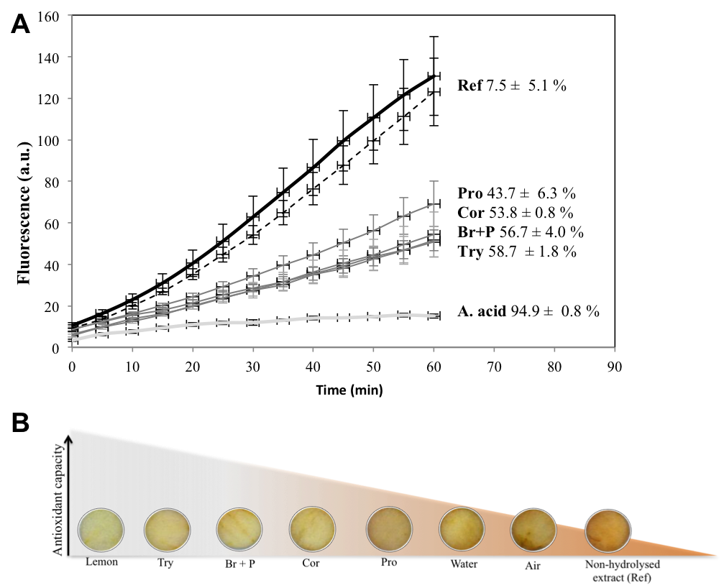
Figure 1. A) Cellular antioxidant activity of FPHs at a concentration of 10 mg/mL. Peroxyl radical-induced oxidation of DCFH to DCF (%released during time) in skin fibroblasts (BJ5-ta): without proteins/peptides (control - black line), upon contact with non-hydrolysed protein (Ref - black dash line); upon contact with FPHs (grey lines); and ascorbic acid 0.082 mg/mL (Asc. acid - light grey line) showing the corresponding CAA values at time 60 min; and B) Qualitative assessment of the antioxidant activity of FPHs in contact with apple pieces.

Anti-wrinkle and anti-inflammatory activity: The epidermal stem cells are responsible for the formation and regeneration of all cells in the epidermis, including the regeneration of the elastin and collagen fibres. With ageing, the number of epidermal stem cells decreases and the capacity of the skin to regenerate weakens, reducing the hydration and elasticity of the skin [14]. Moreover, the UV exposure also lead to the degeneration of the three-dimensional structure of elastic fibres [24], leading to loss of skin elasticity and formation of wrinkles. Central to this is elastase, an enzyme involved in the ECM degradation, which comprise fibrillar collagens, elastic fibres and proteoglycans that confer tensile strength, resilient and hydration to the skin, respectively [14].
Thus, the elastase inhibition by FPH was herein performed in order to determine the anti-ageing and skin reparation capacity of each FPH by preventing elastin from crosslinking. The inhibition was not significantly different between most of the FPHs and the non-hydrolysed sample, which presented one of the highest IC₅₀ value. The extract hydrolysed with the Br + P mixture, on the other hand, showed an improved ability to inhibit elastase (Table 2).
Recently, a large number of natural compounds, comprising phenolic compounds, terpenoids, fatty acids and carbohydrates have been reported as elastase inhibitors [25]. However, no study has been conducted so far to evaluate the potential of FPHs to act attenuate the elastase activity. It is possible that FPHs may act as competitive substrates for elastase, which would thus hydrolyse them and distract its activity from degrading elastin. Such explanation would justify the inhibitory activity values also found for the non-hydrolysed sample.
Apart from the antioxidant and anti-elastase activity, the peptides released during the enzymatic hydrolysis were also found to possess inhibitory activity towards another enzyme involved in skin damage: the oxidative MPO. This enzyme is involved in a wide range of body-regulating activities, including infection protection, but when overexpressed increases the susceptibility of skin to inflammation [26]. Previous studies have suggested that the presence of MPO in inflamed skin is much higher compared with normal skin, providing evidence for its role in the inflammatory processes [27]. Moreover, the MPO activity is commonly used as a measure of total infiltrating neutrophil content found in inflamed UV-irradiated skin [28].
Either the FPHs or non-hydrolysed extract were found to efficiently inhibit the MPO activity even at low concentrations (2 mg/mL). The effect significantly increased when the extracts were hydrolysed with Try (Table 2), enabling around 65 % MPO inhibition. According to the results in Table 1, Try digestion also resulted in the highest concentration of free thiol groups in the FPH, which suggest that apart from the effect of peptides and proteins on the inhibitory effect, the presence of specific amino acids with available free thiol group, such as cysteine, might have ruled the MPO inhibition extent. Thiol-containing molecules have been reported to be efficient on the inhibition of HClO (another ROS) production by MPO and thus inhibit the enzyme activity [29,30].

Table 2. Bioactivities of FPHs: Anti-wrinkle activity: IC₅₀ for porcine pancreatic elastase by the FPHs and anti-inflammatory activity: Myeloperoxidase inhibition induced by FPHs at a concentration of 1 mg/mL.
Sample | Elastase inhibition  IC50 (mg_{FPH}/mL) | MPO inhibition (%)
Reference | 20.64 ± 0.2 | 49.3 ± 3.7
Corolase® 7089 | 19.0 ± 1.1 | 47.0 ± 4.5
Protamex® | 22.3 ± 2.8 | 52.2 ± 3.8
Bromelain + Papain | 15.9 ± 0.7 | 54.8 ± 3.6
Trypsin | 20.4 ± 0.9 | 65.2 ± 1.1

Biocompatibility of fish protein hydrolysates: Aiming at cosmetic applications, the biocompatibility of FPH is one of the essential parameters to be assessed. It is important to ensure that the cosmetic ingredients do not cause adverse effects upon interaction with human cells. Cell culture based assays with human skin fibroblasts were used to understand the biological effects of FPHs towards human cells. At 20 mg/mL the extracts were found to induce slight toxicity onto skin fibroblasts after 24 h contact. However, at lower concentrations of 10 mg/mL the hydrolysates did not cause any harm to the cells and therefore can be applied for skin conditioning purposes at these concentrations (Fig. 2).
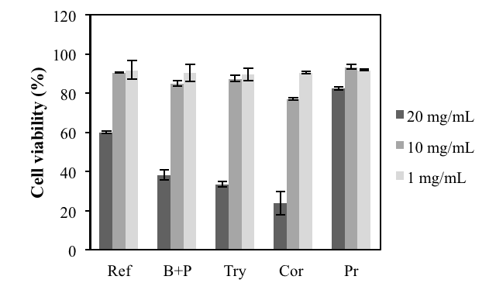
Figure 2. Relative cell viability in the presence of 20, 10 and 1 mg/mL of FPH after 24 h in contact with the cells.

3.2 Second step of valorisation: FPH stabilisation through nanospherisation
Although most of the FPHs possessed improved anti-oxidant, anti-inflammatory and anti-wrinkle activity when compared with the non-hydrolysed extract, after 24 h in aqueous medium they lost these bioactivities. As the plating on non-specific agar shows, the solution of FPH is prone to microbial contaminations both at day 1 and day 3 (Fig. 3, top images). Since the content of FPH is a substrate for microbes [31], it is probable that the mixture components are degraded and thus lose their activities within 24 h. This fact, together with the unpleasant fish odour poses a problem for any commercialisation of FPH. Therefore, in order to increase the stability and at the same time eliminate the undesirable odour, FPH NSs were generated using a sonochemical ultra-emulsification method.⁴⁵ This method involves mechanical mixing of the proteins with oil in a biphasic system and allows formation of oil-filled protein/peptide NSs. By using an essential oil with antibacterial properties, e.g. tea tree oil, as the oil phase in the system, odour-free FPH NSs that are resistant to microbial contamination could be obtained (Fig. 3, bottom images). The results showed that all the sonochemically generated FPH NSs are similar in terms of size and shape, probably because they originate from the same proteinaceous source. The cumulant (Z-average) hydrodynamic size was measured by dynamic light scattering (DLS) and was found to be around 300 nm (Fig. 4A). They were found to be spherical in shape (Fig. 4B) and with a moderate polidispersity index of around 0.250 (0.1 < PDI < 1) [33].
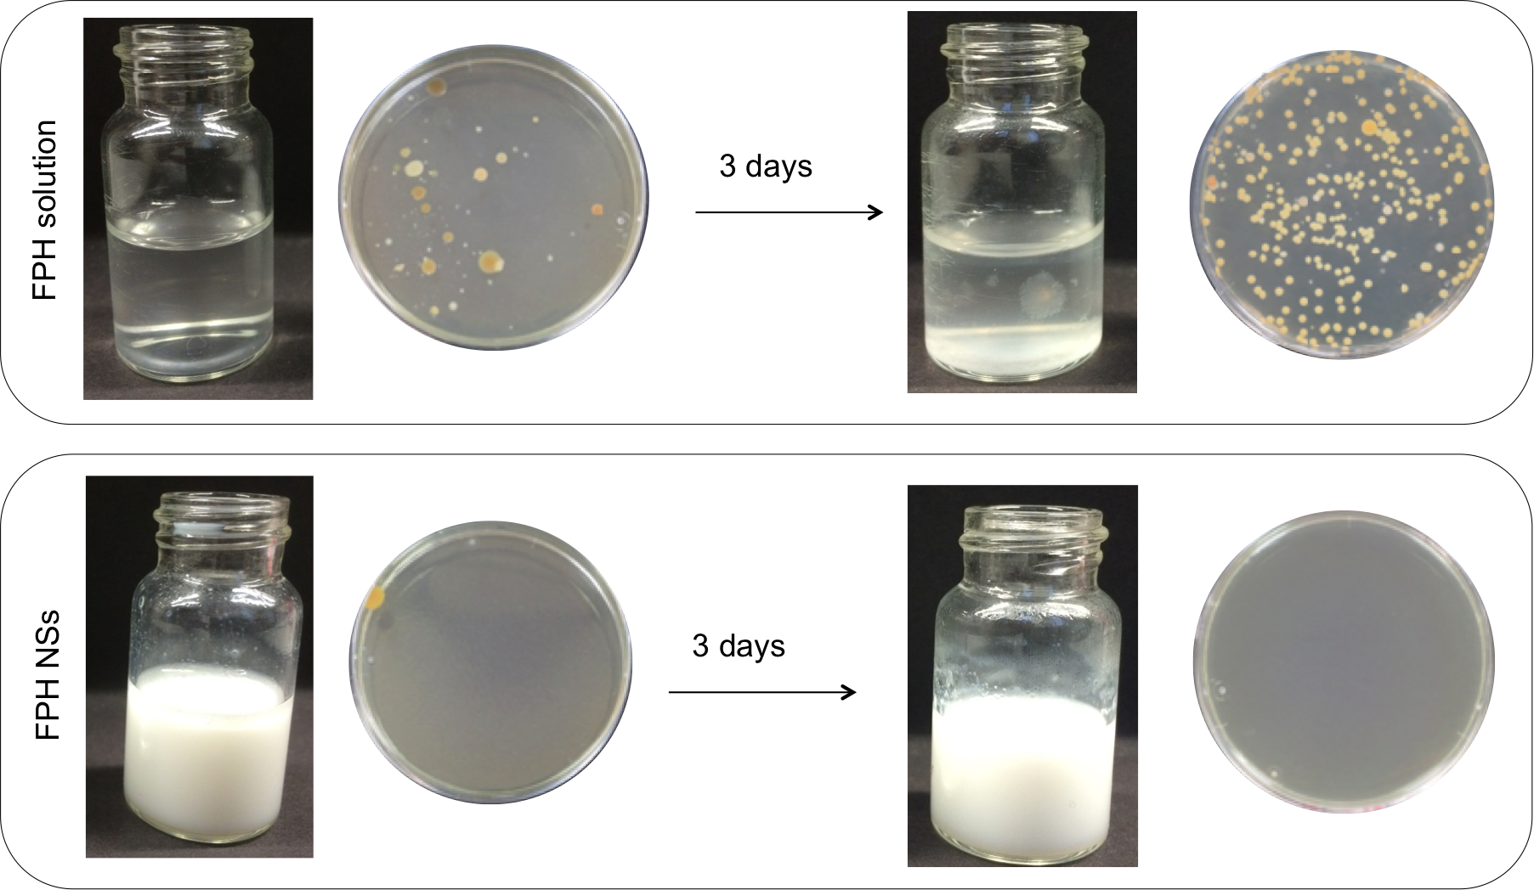
Figure 3. Visualization of contamination of FPHs in solution and FPH NSs and corresponding microbial load of the samples on non-specific agar at day 1 and day 3.

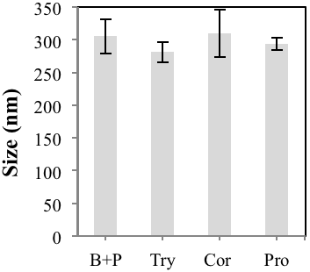 | 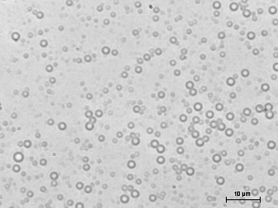 | 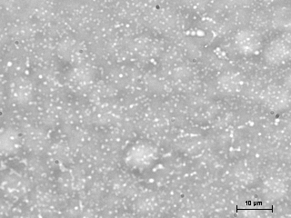
 | B+P | Try
 | 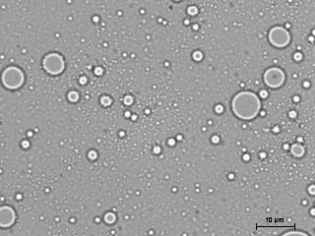 | 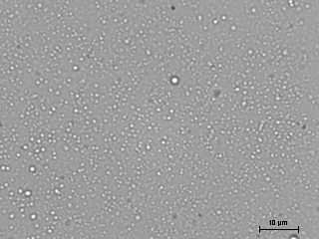
 | Cor | Pro

Figure 4. A) Cumulant (Z-average) hydrodynamic size of FPHs NSs measured by DLS and B) Bright field microscopy of FPHs NSs.

3.2.1 Bioactivities of FPH NSs
The anti-wrinkle, anti-inflammatory and antioxidant activity of the sonochemically generated FPH NSs were assessed and compared with the FPHs in solution to evaluate the effect of the spherisation on the FPHs bioactivities. The anti-wrinkle and anti-inflammatory activity of the NSs did not change after spherisation, revealing that the process did not influence these properties of FPH (results not shown). In contrast, their antioxidant activity (measured in terms of their capacity to scavenge cellular ROS and DPPH∙ free radicals) was boosted after being transformed into NSs (Fig. 5). By testing a concentration ten times lower than the one used to evaluate the cellular antioxidant activity of FPH in solution in Fig. 1, the results show that FPH NSs were able to increase the inhibition of DPPH∙ (in some cases by more than 35 %) compared to the FPHs in solution (Fig. 5A). This increase was even more pronounced (> 60 %) for inhibition of intracellular ROS (Fig. 5B). It is important to mention that the improved antioxidant activity was not due to the encapsulated tea tree oil, as no antioxidant activity was previously observed for this oil measured as DPPH scavenging activity (results not shown). The enhancement of the effect after the FPH spherisation could be rather related to the properties such as the large surface area to mass ratio in the spheres that facilitates the contact with free radicals and intracellular delivery. Indeed, previous studies suggested that nanospheres generated by this method possessed improved bioactivity when compared to their non-processed counterparts [34].
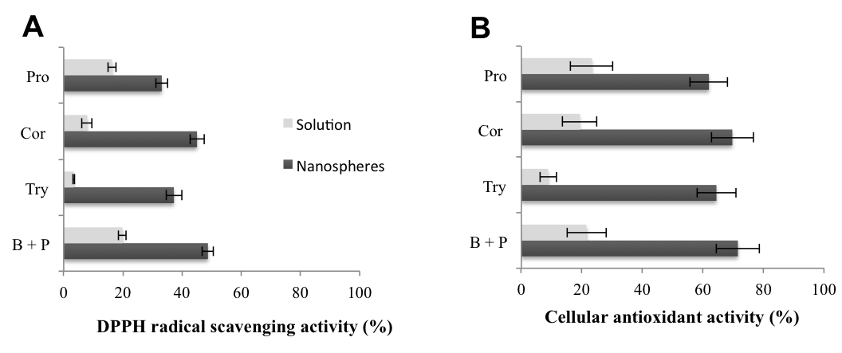
Figure 5. Antioxidant activity of FPH NSs and FPHs in solution at a concentration of 1 mg/mL measured by: A) DPPH radical scavenging, and B) cellular antioxidant activity.

As the NSs were shown to possess improved cellular antioxidant activity, an in vitro cell culture test was carried out to evaluate the possibility of both FPH NSs and FPHs in solution to protect skin fibroblasts from UV radiation. To understand the effect of UV radiation on cells, a control experiment was run in parallel, where the cells were treated with growth media and further exposed to UV radiation for 2 h. Before UV exposure, the cells presented good and typical elongated shape morphology and were well attached to a polystyrene plate. After exposure to UV light, the cells were much fewer and presented rounded morphology, characteristic for their detaching from the surface, thus confirming a damaging UV effect (Fig. 6A).
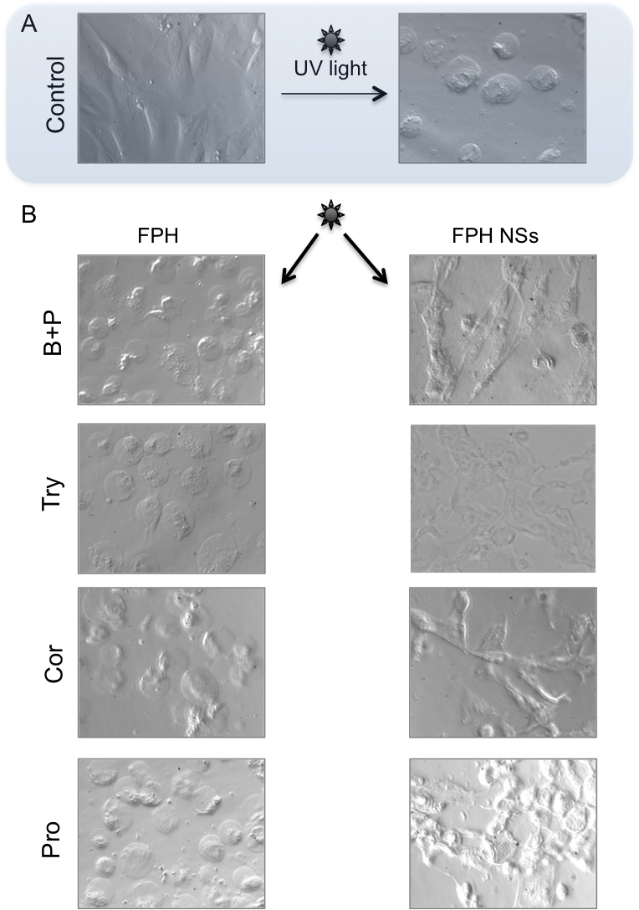
Figure 6. Phase contrast microscopy images of cultured human skin fibroblasts A) before and after 2h UV radiation and B) treated with 0.2 mg/mL FPH NSs and FPHs in solution after UV radiation for 2h

The same experiment was then performed with cells previously treated with FPH NSs and FPHs in solution. The cells treated with FPHs presented similar morphology to the control sample after UV treatment, meaning that the cells were not protected from the damaging UV effect (Fig. 6B). In contrast, when fibroblasts were treated the NSs, the elongated shape of the cells was maintained, proving the skin-protective properties of the NSs against UV damage. These results indicate that NSs obtained from FPHs generated with B+P, Cor, Pro and Try enzymes protected the cells from the UV light, which was associated with their improved antioxidant properties, and as such may be considered as potential ingredients of sunscreen products.
Nanomaterials are largely claimed to facilitate the intracellular delivery [12] thereby the load of FPHs internalised in cells once transformed into NSs is probably higher than FPHs in solution, thus exerting a more pronounced antioxidative effect. Moreover, it is now believed that cells respond to antioxidant agents mainly through direct interactions with receptors or enzymes involved in signal transduction, therefore modifying the redox status of the cell and triggering a series of redox-dependent reactions [35]. Due to their higher reactivity and intracellular delivery capacity, the NSs are thought to be more efficient in interacting with these cell components, which could explain the boosting effect on cellular antioxidant activity.
Besides avoiding the microbial contamination of the FPH, the NSs were also found to possess antimicrobial properties against Escherichia coli and Staphylococcus aureus, mainly because of the encapsulated tea tree oil in the spheres. Tea tree oil is a commonly used essential oil for anti-acne purposes in cosmetics due to its anti-bacterial properties. The Escherichia coli and Staphylococcus aureus growth was inhibited in more than 50 % and 40 %, respectively, in the presence of the NSs (Table 3). Thus, apart from the anti-ageing properties, a synergistic anti-bacterial and anti-acne effect can be obtained with the FPH nanoformulations.

Table 3. Escherichia coli and Staphylococcus aureus growth inhibition in the presence of FPH NSs.
Sample | Bacterial growth inhibition (%)
Sample | Escherichia coli | Staphylococcus aureus
Corolase® 7089 NSs | 44 ± 15 | 41 ± 8
Protamex® NSs | 70 ± 5 | 39 ± 5
Bromelain + Papain NSs | 62 ± 5 | 44 ± 2
Trypsin NSs | 49 ± 2 | 29 ± 2

4. Conclusions
The increasing interest in finding new bioactive compounds from marine organisms has turned the focus on valorisation of underutilised resources from seafood industry for the development of skin care formulations. In this work, a salmon backbone co-stream was transformed into potential cosmetic ingredients using a two-step strategy for valorisation. The backbones were first hydrolysed using different proteolytic enzymes to generate the FPH that efficiently inhibited skin-degrading and inflammatory enzymes, characteristic in damaged and aged skin, and counteracted the formation of cellular ROS in skin fibroblasts. Such properties were associated with the high peptide content and the amount of free thiol groups found in the hydrolysed extracts. In the second step of valorisation, the low stability of the FPHs was substantially improved by conversion into NSs via sonochemical technology, allowing the production of nano-sized bioactive carriers of the FPHs. The improved antioxidant activity of the FPH NSs in comparison with FPH in solution was correlated with a superior protection of the skin fibroblasts from the UV induced cell damage. Moreover, the sonochemical method used for generation of shell-bioactive NSs allowed the incorporation of other bioactive ingredients in their core, e.g. tea tree oil, which imparted antimicrobial properties to the spheres. Thus, odour free NSs with both shell-anti-ageing and core-antimicrobial properties were generated. Whereas evidences were provided that the FPH NSs possess an extended shelf life and are bioactive at the (skin) cellular level, further investigation on their transdermal delivery will give definitive answers about their safety and effectiveness as cosmetic ingredients. Nevertheless, this study demonstrated a clearly higher value alternative to the animal feed use of salmon backbone co-streams.

ACKNOWLEDGEMENTS
The research leading to these results has received funding from the European Community’s Seventh Framework Programme FP7/2007-2013 under grant agreement No. 289170 – APROPOS.

References
[1] Chalamaiah M, Dinesh Kumar B, Hemalatha R, Jyothirmayi T. Fish protein hydrolysates: Proximate composition, amino acid composition, antioxidant activities and applications: A review. Food Chem 2012;135:3020–38. doi:10.1016/j.foodchem.2012.06.100.
[2] Toppe J, Aksnes A, Hope B, Albrektsen S. Inclusion of fish bone and crab by-products in diets for Atlantic cod, Gadus morhua. Aquaculture 2006;253:636–45. doi:10.1016/j.aquaculture.2005.09.015.
[3] Piccirillo C, Rocha C, Tobaldi DM, Pullar RC, Labrincha JA, Ferreira MO, et al. A hydroxyapatite-Fe2O3 based material of natural origin as an active sunscreen filter. J Mater Chem B 2014;2:5999–6009. doi:10.1039/C4TB00984C.
[4] Ngo D-H, Vo T-S, Ngo D-N, Wijesekara I, Kim S-K. Biological activities and potential health benefits of bioactive peptides derived from marine organisms. Int J Biol Macromol 2012;51:378–83. doi:10.1016/j.ijbiomac.2012.06.001.
[5] Shahidi F, Han X-Q, Synowiecki J. Production and characteristics of protein hydrolysates from capelin (Mallotus villosus). Food Chem 1995;53:285–93. doi:10.1016/0308-8146(95)93934-J.
[6] Šližytė R, Daukšas E, Falch E, Storrø I, Rustad T. Characteristics of protein fractions generated from hydrolysed cod (Gadus morhua) by-products. Process Biochem 2005;40:2021–33. doi:10.1016/j.procbio.2004.07.016.
[7] Šližytė R, Daukšas E, Falch E, Storrø I, Rustad T. Yield and composition of different fractions obtained after enzymatic hydrolysis of cod (Gadus morhua) by-products. Process Biochem 2005;40:1415–24. doi:10.1016/j.procbio.2004.06.033.
[8] Yarnpakdee S, Benjakul S, Kristinsson HG. Lipid oxidation and fishy odour in protein hydrolysate derived from Nile tilapia (Oreochromis niloticus) protein isolate as influenced by haemoglobin. J Sci Food Agric 2014;94:219–26. doi:10.1002/jsfa.6235.
[9] Huebsch N, Mooney DJ. Inspiration and application in the evolution of biomaterials. Nature 2009;462:426–32.
[10] Gedanken A. Preparation and Properties of Proteinaceous Microspheres Made Sonochemically. Chem-Eur J 2008;14:3840–53.
[11] Cevc G, Vierl U. Nanotechnology and the transdermal routeA state of the art review and critical appraisal. J Control Release 2010;141:277–99. doi:10.1016/j.jconrel.2009.10.016.
[12] Bolzinger M-A, Briançon S, Pelletier J, Chevalier Y. Penetration of drugs through skin, a complex rate-controlling membrane. Curr Opin Colloid Interface Sci 2012;17:156–65. doi:10.1016/j.cocis.2012.02.001.
[13] Marte B, Finkelstein J, Anson L. Skin Biology. Nature 2007;445:833.
[14] Naylor EC, Watson REB, Sherratt MJ. Molecular aspects of skin ageing. Maturitas 2011;69:249–56. doi:10.1016/j.maturitas.2011.04.011.
[15] Bailey A. Molecular mechanisms of ageing in connective tissues. Mech Ageing Dev 2001;122:735–55. doi:10.1016/S0047-6374(01)00225-1.
[16] Bullen EC, Longaker MT, Updike DL, Benton R, Ladin D, Hou Z, et al. Tissue Inhibitor of Metalloproteinases-1 Is Decreased and Activated Gelatinases Are Increased in Chronic Wounds. J Investig Dermatol 1995;104:236–40.
[17] Ellman GL. Tissue sulfhydryl groups. Arch Biochem Biophys 1959;82:70–7.
[18] Wong M, Suslick KS. Sonochemically produced hemoglobin microbubbles. Mater Res Soc Symp Proc 1995;372:1195.
[19] Wolfe KL, Liu RH. Cellular Antioxidant Activity (CAA) Assay for Assessing Antioxidants, Foods, and Dietary Supplements. J Agric Food Chem 2007;55:8896–907. doi:10.1021/jf0715166.
[20] Bougatef A, Nedjar-Arroume N, Manni L, Ravallec R, Barkia A, Guillochon D, et al. Purification and identification of novel antioxidant peptides from enzymatic hydrolysates of sardinelle (Sardinella aurita) by-products proteins. Food Chem 2010;118:559–65.
[21] Zhao Q, Xiong H, Selomulya C, Chen XD, Zhong H, Wang S, et al. Enzymatic hydrolysis of rice dreg protein: effects of enzyme type on the functional properties and antioxidant activities of recovered proteins. Food Chem 2012;134:1360–7. doi:10.1016/j.foodchem.2012.03.033.
[22] Fan J, He J, Zhuang Y, Sun L. Purification and identification of antioxidant peptides from enzymatic hydrolysates of Tilapia (Oreochromis niloticus) frame protein. Molecules 2012;17:12836–50. doi:10.3390/molecules171112836.
[23] You L, Zhao M, Regenstein JM, Ren J. Purification and identification of antioxidative peptides from loach (Misgurnus anguillicaudatus) protein hydrolysate by consecutive chromatography and electrospray ionization-mass spectrometry. Food Res Int 2010;43:1167–73. doi:10.1016/j.foodres.2010.02.009.
[24] Imokawa G, Takema Y, Yorimoto Y, Tsukahara K, Kawai M, Imayama S. Degree of Ultraviolet-Induced Tortuosity of Elastic Fibers in Rat Skin Is Age Dependent. J Investig Dermatol 1995;105:254–8.
[25] Siedle B, Hrenn A, Merfort I. Natural compounds as inhibitors of human neutrophil elastase. Planta Med 2007;73:401—420. doi:10.1055/s-2007-967183.
[26] Díaz-González M, Francesko A, Fernandes MM, Tzanov T. Myeloperoxidase – a paradoxical enzyme – from host defense to disease. In: Lashinski EM, editor. Enzym. Enzym. Act. Struct. Biol. Clin. Significance. 1st ed., 2013, p. 1–38.
[27] Bradley PP, Priebat DA, Christensen RD, Rothstein G. Measurement of Cutaneous Inflammation: Estimation of Neutrophil Content with an Enzyme Marker. J Investig Dermatol 1982;78:206–9.
[28] Casagrande R, Georgetti SR, Verri Jr. WA, Dorta DJ, dos Santos A, Fonseca MJ V. Protective effect of topical formulations containing quercetin against UVB-induced oxidative stress in hairless mice. J Photochem Photobiol B Biol 2006;84:21–7. doi:10.1016/j.jphotobiol.2006.01.006.
[29] Francesko A, Soares da Costa D, Lisboa P, Reis RL, Pashkuleva I, Tzanov T. GAGs-thiolated chitosan assemblies for chronic wounds treatment: control of enzyme activity and cell attachment. J Mater Chem 2012;22:19438–46.
[30] Van Antwerpen P, Boudjeltia KZ, Babar S, Legssyer I, Moreau P, Moguilevsky N, et al. Thiol-containing molecules interact with the myeloperoxidase/H2O2/chloride system to inhibit LDL oxidation. Biochem Biophys Res Commun 2005;337:82–8.
[31] Dufossé L, De la Broise D, Guérard F. Fish protein hydrolysates as nitrogen sources for microbial growth and metabolite production. In: Pandalai SG, editor. Recent Res. Dev. Microbiol., Research Signpost; 1997, p. 365–81.
[32] Suslick KS, Grinstaff MW. Protein microencapsulation of nonaqueous liquids. J Am Chem Soc 1990;112:7807–9. doi:10.1021/ja00177a058.
[33] Lim J, Yeap SP, Che HX, Low SC. Characterization of magnetic nanoparticle by dynamic light scattering. Nanoscale Res Lett 2013;8:381. doi:10.1186/1556-276X-8-381.
[34] Fernandes MM, Francesko A, Torrent-Burgués A, Carrión-Fité FJ, Heinze T, Tzanov T. Sonochemically processed cationic nanocapsules: efficient antimicrobials with membrane disturbing capacity. Biomacromolecules 2014;15:1365–74. doi:0.1021/bm4018947.
[35] Scalbert A, Johnson IT, Saltmarsh M. Polyphenols: antioxidants and beyond. Am J Clin Nutr 2005;81:215S–217S.

Correspondence: Dr. Tzanko Tzanov, tel.: +34 93 739 85 70, fax: +34 93 739 82 25, e-mail: tzanko.tzanov@upc.edu

